

**MIT Art, Design and Technology University**

**MIT School of Computing, Pune**

**Department of Information Technology**

|  |
| --- |
| **Lab Manual** |

# **Practical – Cross Platform Development**

# **Class - T.Y (SEM-VI)**

# **Batch - SMAD**

# **Name of the Student**

# **Ms. GURNEET JUNEJA**

**A.Y. 2024 – 2025 (SEM-VI)**

|  |  |
| --- | --- |
| **Assignment No 1: Project Assignment based on Unit-I and Unit-II** | |
| **Project-I** | Project Title: ReactJS E-Commerce Website with Page RoutingProject Statement: Objective: Develop a fully functional E-commerce website using ReactJS that includes page routing functionality for smooth navigation between different sections like Home, Product Listing, Product Details, Cart, and Checkout. Project Features:  1. Navigation Bar with Routing:    * Create a Navigation Bar at the top of the website with links to:      + Home: Displays featured products and general information about the store.      + Products: Lists all available products for purchase.      + Cart: Displays the products added to the shopping cart.      + Checkout: Allows the user to review and complete the purchase.      + Profile: Displays user account information and order history.    * Implement React Router for routing between these pages. 2. Home Page:    * The Home page should showcase highlighted products or categories.    * Implement a product carousel or featured section.    * Include a search bar to allow users to search for products directly. 3. Product Listing Page:    * Create a Product Listing page that fetches products dynamically from an API or static JSON file.    * Each product in the list should show:      + Product image.      + Product name.      + Price.      + A button to add the product to the cart.    * Implement React Router links on product items to navigate to the Product Details page. 4. Product Details Page:    * When a user clicks on a product, navigate them to the Product Details page.    * The Product Details page should display:      + Full-size product image.      + Detailed product description.      + Price.      + Add to Cart button.    * Allow users to select product quantity before adding it to the cart. 5. Cart Page:    * Implement a Cart page that displays products added to the cart.    * Each cart item should include:      + Product name.      + Product quantity.      + Price per item and total cost for the item.      + A button to remove items from the cart.    * Display a total price for all items in the cart.    * Include buttons for Continue Shopping and Proceed to Checkout. 6. Checkout Page:    * Create a Checkout page where users can review their cart, enter shipping information, and confirm the order.    * Display an order summary with total cost, shipping details, and payment options.    * Provide a Place Order button to finalize the transaction. 7. User Profile Page:    * Create a Profile page where users can view their account information and order history.    * Include a form to update the profile details (name, email, shipping address). 8. State Management with Context API/Redux:    * Use React Context API or Redux to manage the global state of the cart, allowing users to add, remove, and update quantities of products across different pages.    * Ensure that the cart data is preserved during navigation between pages. 9. Responsive Design:    * Ensure the website is responsive and works well on both desktop and mobile devices using CSS Flexbox or CSS Grid.  Technical Requirements:ReactJS: For building the user interface.React Router: For implementing page routing functionality.State Management: Use React Context API or Redux to manage cart state and other global data.API Integration: Fetch products from a static JSON file or a mock API (e.g., JSONPlaceholder or a custom API).Responsive Styling: Use CSS/SCSS to ensure the website is mobile-friendly.Optional: Add localStorage or sessionStorage to persist cart data between page reloads.Expected Outcome: By completing this project, you will:   * Learn how to implement page routing in a ReactJS application using React Router. * Build a dynamic E-commerce website with features like product listings, cart management, and checkout functionality. * Gain experience with state management and ensuring the cart data persists across different pages. * Develop a responsive, user-friendly interface that functions well on both mobile and desktop screens. |
| **Assignment No 2: Project Assignment based on Unit-III, IV and V** | |
| **Project-II** | Project Title: React Native E-Commerce ApplicationProject Statement: Objective: Build a fully functional E-commerce mobile application using React Native that integrates navigation, core components, user interaction, dynamic list rendering, and state management. Project Features:  1. User Authentication:    * Implement a simple login screen where users can enter their credentials (username and password).    * After successful login, navigate to the Home Screen. 2. Navigation:    * Set up react-navigation to allow users to navigate between the following screens using StackNavigator:      + Home Screen: Displays a list of products.      + Product Details Screen: Shows details of the selected product.      + Cart Screen: Displays products added to the shopping cart.      + Profile Screen: Displays user profile details.      + Settings Screen: Allows the user to modify their account settings. 3. Core Components & UI:    * Use core React Native components such as View, Text, Image, StyleSheet, and Button to build a user-friendly interface.    * Apply Flexbox for layout, ensuring responsiveness across different screen sizes. 4. Product List and Cart:    * On the Home Screen, render the list of products using FlatList. Each item should display a product image, name, and price.    * Implement a button for each product to add it to the Cart. 5. Handling User Interactions:    * Implement touch events to handle interactions such as adding products to the cart, navigating to the product details, and updating the cart.    * Use onPress to trigger actions like adding a product to the cart or navigating between screens. 6. Cart Management:    * Use React Context API for global state management to handle the cart’s data (adding/removing products).    * Show the cart’s content and total price on the Cart Screen. 7. Product Details:    * When a user clicks on a product in the Home Screen, navigate to the Product Details Screen and display detailed information about the product, such as the description, image, and price. 8. Responsive Design:    * Ensure that the app is responsive, and elements adjust properly to different screen sizes using Flexbox. 9. Rendering Lists with SectionList:    * On the Home Screen, group products by categories (e.g., electronics, clothing) and use SectionList to render them in separate sections with headers.  Technical Requirements:React Native with Expo CLI for development and testing.React Navigation for screen transitions.State Management using React Context API or useState, useReducer.Dynamic data rendering using FlatList and SectionList.Styling using StyleSheet and Flexbox for layout.Expected Outcome: By completing this project, students will gain hands-on experience with:   * Setting up and using React Native and React Navigation. * Building a fully interactive mobile application with dynamic data rendering and state management. * Applying Flexbox for responsive layouts and managing user interactions. * Creating a simple e-commerce app with multi-screen navigation, product lists, and state-driven cart functionality. |

# 

## **Experiment No.1**

## **Project Title: ReactJS E-Commerce Website with Page Routing**

## **Problem Statement:**

In today’s digital economy, consumers expect fast, responsive, and interactive online shopping experiences. Traditional e-commerce websites often suffer from slow page reloads and disjointed navigation, leading to poor user engagement. This project addresses the need for a modern web-based e-commerce platform that provides seamless navigation, dynamic content updates, and a user-friendly interface using ReactJS and React Router. The website offers essential features such as product browsing, cart management, and user authentication without full-page reloads.

## **Objective:**

To develop a fully functional, responsive **E-Commerce Website** using **ReactJS** that integrates **client-side routing** for smooth navigation across pages including Home, Product Listing, Product Details, Cart, Checkout, About Us, Contact Us, Registration, and Login. The application aims to simulate a real-world online store with dynamic rendering and intuitive user interaction.

## **Theory:**

ReactJS is a component-based JavaScript library developed by Meta for building user interfaces. It allows developers to build reusable UI components and manage application state efficiently. The e-commerce application leverages:

* **ReactJS** for creating interactive UI components.
* **React Router DOM** for client-side routing and page transitions without refreshing the browser.
* **Props and State** for data handling and dynamic rendering.
* **JSX** for structuring UI logic in a declarative manner.
* **Hooks** like useState and useEffect for state and lifecycle management.
* **CSS/Styled Components** for styling and responsive design.

Each section of the application is modular, promoting separation of concerns and scalability.

## **Code:**

**Src>components>layout>footer.tsx:**

*import* React *from* 'react';

*import* { Link } *from* 'react-router-dom';

*import* { Facebook, Instagram, Twitter, Youtube, Mail, Phone, MapPin } *from* 'lucide-react';

const *Footer*: *React.FC* =()=>{

const *currentYear* =new *Date*()*.getFullYear*();

*return* (

<footer *className*="bg-primary-900 text-white pt-16 pb-8">

      <div *className*="container mx-auto px-4">

        <div *className*="grid grid-cols-1 md:grid-cols-2 lg:grid-cols-4 gap-8 mb-12">

          {*/* Company Info */*}

          <div>

            <h4 *className*="text-xl font-medium mb-4">ELYSIUM</h4>

            <p *className*="text-gray-300 mb-4 text-sm leading-relaxed">

              Discover premium quality products with our curated collection.

              Elevating your shopping experience since 2022.

            </p>

            <div *className*="flex space-x-4">

              <a *href*="#" *className*="text-gray-300 hover:text-white transition-colors">

                <Facebook *className*="w-5 h-5" />

              </a>

              <a *href*="#" *className*="text-gray-300 hover:text-white transition-colors">

                <Instagram *className*="w-5 h-5" />

              </a>

              <a *href*="#" *className*="text-gray-300 hover:text-white transition-colors">

                <Twitter *className*="w-5 h-5" />

              </a>

              <a *href*="#" *className*="text-gray-300 hover:text-white transition-colors">

                <Youtube *className*="w-5 h-5" />

              </a>

            </div>

          </div>

          {*/* Shop Links */*}

          <div>

            <h4 *className*="text-lg font-medium mb-4">Shop</h4>

            <ul *className*="space-y-2">

              <li>

                <Link *to*="/products?category=new-arrivals" *className*="text-gray-300 hover:text-white transition-colors text-sm">

                  New Arrivals

                </Link>

              </li>

              <li>

                <Link *to*="/products?category=best-sellers" *className*="text-gray-300 hover:text-white transition-colors text-sm">

                  Best Sellers

                </Link>

              </li>

              <li>

                <Link *to*="/products?category=sale" *className*="text-gray-300 hover:text-white transition-colors text-sm">

                  Sale Items

                </Link>

              </li>

              <li>

                <Link *to*="/products?category=clothing" *className*="text-gray-300 hover:text-white transition-colors text-sm">

                  Clothing

                </Link>

              </li>

              <li>

                <Link *to*="/products?category=accessories" *className*="text-gray-300 hover:text-white transition-colors text-sm">

                  Accessories

                </Link>

              </li>

            </ul>

          </div>

          {*/* Help Links */*}

          <div>

            <h4 *className*="text-lg font-medium mb-4">Help</h4>

            <ul *className*="space-y-2">

              <li>

                <Link *to*="/faq" *className*="text-gray-300 hover:text-white transition-colors text-sm">

                  FAQ

                </Link>

              </li>

              <li>

                <Link *to*="/shipping" *className*="text-gray-300 hover:text-white transition-colors text-sm">

                  Shipping & Returns

                </Link>

              </li>

              <li>

                <Link *to*="/privacy-policy" *className*="text-gray-300 hover:text-white transition-colors text-sm">

                  Privacy Policy

                </Link>

              </li>

              <li>

                <Link *to*="/terms" *className*="text-gray-300 hover:text-white transition-colors text-sm">

                  Terms & Conditions

                </Link>

              </li>

              <li>

                <Link *to*="/contact" *className*="text-gray-300 hover:text-white transition-colors text-sm">

                  Contact Us

                </Link>

              </li>

            </ul>

          </div>

          {*/* Contact Info */*}

          <div>

            <h4 *className*="text-lg font-medium mb-4">Contact Us</h4>

            <ul *className*="space-y-3">

              <li *className*="flex items-start">

                <MapPin *className*="w-5 h-5 text-gray-300 mr-2 mt-0.5" />

                <span *className*="text-gray-300 text-sm">123 Fashion Street, CA 90210, United States</span>

              </li>

              <li *className*="flex items-center">

                <Phone *className*="w-5 h-5 text-gray-300 mr-2" />

                <span *className*="text-gray-300 text-sm">+1 (888) 123-4567</span>

              </li>

              <li *className*="flex items-center">

                <Mail *className*="w-5 h-5 text-gray-300 mr-2" />

                <span *className*="text-gray-300 text-sm">support@elysium.com</span>

              </li>

            </ul>

          </div>

        </div>

        {*/* Newsletter */*}

        <div *className*="border-t border-gray-800 pt-8 pb-6">

          <div *className*="max-w-xl mx-auto text-center mb-6">

            <h5 *className*="text-lg font-medium mb-2">Subscribe to our newsletter</h5>

            <p *className*="text-gray-300 text-sm mb-4">Get updates on new arrivals, special offers and more.</p>

            <form *className*="flex">

              <input

*type*="email"

*placeholder*="Your email address"

*className*="flex-grow input bg-primary-800 border-primary-700 text-white placeholder-gray-400 focus:ring-accent-500"

              />

              <button *type*="submit" *className*="btn-accent ml-2 px-4 py-2">

                Subscribe

              </button>

            </form>

          </div>

        </div>

        {*/* Copyright */*}

        <div *className*="border-t border-gray-800 pt-6 text-sm text-gray-400 text-center">

          <p>&copy; {currentYear} Elysium. All rights reserved.</p>

        </div>

      </div>

    </footer>

);

};

*export* *default* Footer;

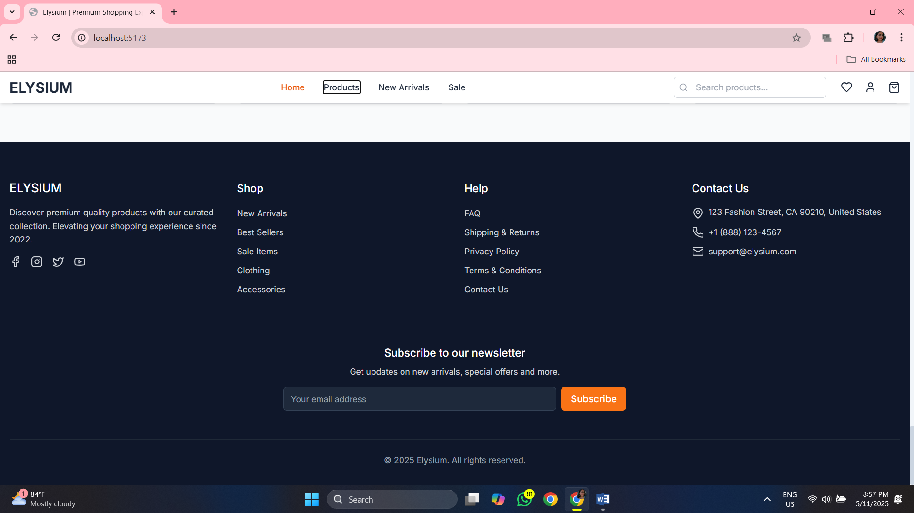

**Src>components>layout>layout.tsx:**

*import* React *from* 'react';

*import* { Outlet } *from* 'react-router-dom';

*import* Navbar *from* './Navbar';

*import* Footer *from* './Footer';

const *Layout*: *React.FC* =()=>{

*return* (

<div *className*="flex flex-col min-h-screen">

      <Navbar />

      <main *className*="flex-grow">

        <Outlet />

      </main>

      <Footer />

    </div>

);

};

*export* *default* Layout;

**Src>components>layout>navbar.tsx:**

*import* React, { useState, useEffect } *from* 'react';

*import* { Link, NavLink, useLocation } *from* 'react-router-dom';

*import* { Search, ShoppingBag, Heart, User, Menu, X } *from* 'lucide-react';

*import* { useCart } *from* '../../contexts/CartContext';

const *Navbar*: *React.FC* =()=>{

const[*isScrolled*, *setIsScrolled*]= *useState*(*false*);

const[*isMenuOpen*, *setIsMenuOpen*]= *useState*(*false*);

const[*searchQuery*, *setSearchQuery*]= *useState*('');

const{ *getTotalItems* }= *useCart*();

const *location* = *useLocation*();

const *toggleMenu* =()=>{

*setIsMenuOpen*(!*isMenuOpen*);

};

*// Close menu when changing routes*

*useEffect*(()=>{

*setIsMenuOpen*(*false*);

},[*location*]);

*// Add scroll event listener*

*useEffect*(()=>{

const *handleScroll* =()=>{

*if* (*window.scrollY* >20){

*setIsScrolled*(*true*);

} *else* {

*setIsScrolled*(*false*);

}

};

*window.addEventListener*('scroll', *handleScroll*);

*return* ()=>{

*window.removeEventListener*('scroll', *handleScroll*);

};

},[]);

const *navLinks* =[

{ *name*:'Home', *path*:'/'},

{ *name*:'Products', *path*:'/products'},

{ *name*:'New Arrivals', *path*:'/products?tag=new'},

{ *name*:'Sale', *path*:'/products?tag=sale'},

];

const *handleSearch* =(*e*: *React.FormEvent*)=>{

*e.preventDefault*();

*// Handle search logic*

*if* (*searchQuery.trim*()){

*window.location.href* =`*/products?search=*${*encodeURIComponent*(*searchQuery.trim*())}`;

}

};

*return* (

<header

*className*={`sticky top-0 z-50 w-full transition-all duration-300 ${

        isScrolled ? 'bg-white shadow-md py-2' : 'bg-transparent py-4'

      }`}

    >

      <div *className*="container mx-auto px-4">

        <div *className*="flex items-center justify-between">

          {*/* Logo */*}

          <Link *to*="/" *className*="text-2xl font-bold text-primary-800">

            ELYSIUM

          </Link>

          {*/* Desktop Navigation */*}

          <nav *className*="hidden md:flex items-center space-x-8">

            {navLinks*.map*((link) => (

              <NavLink

*key*={link*.*path}

*to*={link*.*path}

*className*={({ isActive }) =>

                  `text-sm font-medium transition-colors hover:text-accent-500 ${

                    isActive ? 'text-accent-600' : 'text-primary-800'

                  }`

                }

*end*={link*.*path === '/'}

              >

                {link*.*name}

              </NavLink>

            ))}

          </nav>

          {*/* Desktop Search & Icons */*}

          <div *className*="hidden md:flex items-center space-x-6">

            <form *onSubmit*={handleSearch} *className*="relative">

              <input

*type*="text"

*placeholder*="Search products..."

*className*="input w-40 lg:w-64 pl-9 h-9 text-sm"

*value*={searchQuery}

*onChange*={(e) => *setSearchQuery*(e*.target.*value)}

              />

              <Search *className*="absolute left-2 top-1/2 transform -translate-y-1/2 h-4 w-4 text-gray-400" />

            </form>

            <div *className*="flex items-center space-x-5">

              <NavLink *to*="/wishlist" *className*="relative text-primary-800 hover:text-accent-500 transition-colors">

                <Heart *className*="h-5 w-5" />

              </NavLink>

              <NavLink *to*="/account" *className*="text-primary-800 hover:text-accent-500 transition-colors">

                <User *className*="h-5 w-5" />

              </NavLink>

              <NavLink *to*="/cart" *className*="relative text-primary-800 hover:text-accent-500 transition-colors">

                <ShoppingBag *className*="h-5 w-5" />

                {*getTotalItems*() > 0 && (

                  <span *className*="absolute -top-2 -right-2 bg-accent-500 text-white text-xs h-5 w-5 flex items-center justify-center rounded-full">

                    {*getTotalItems*()}

                  </span>

                )}

              </NavLink>

            </div>

          </div>

          {*/* Mobile Menu Button */*}

          <div *className*="flex items-center space-x-4 md:hidden">

            <NavLink *to*="/cart" *className*="relative text-primary-800">

              <ShoppingBag *className*="h-5 w-5" />

              {*getTotalItems*() > 0 && (

                <span *className*="absolute -top-2 -right-2 bg-accent-500 text-white text-xs h-5 w-5 flex items-center justify-center rounded-full">

                  {*getTotalItems*()}

                </span>

              )}

            </NavLink>

            <button

*onClick*={toggleMenu}

*className*="text-primary-800 focus:outline-none"

            >

              {isMenuOpen ? <X *className*="h-6 w-6" /> : <Menu *className*="h-6 w-6" />}

            </button>

          </div>

        </div>

      </div>

      {*/* Mobile Menu */*}

      {isMenuOpen && (

        <div *className*="md:hidden bg-white shadow-lg animate-slide-down absolute w-full left-0 py-4 px-4">

          <form *onSubmit*={handleSearch} *className*="relative mb-6">

            <input

*type*="text"

*placeholder*="Search products..."

*className*="input w-full pl-9 h-10 text-sm"

*value*={searchQuery}

*onChange*={(e) => *setSearchQuery*(e*.target.*value)}

            />

            <Search *className*="absolute left-3 top-1/2 transform -translate-y-1/2 h-4 w-4 text-gray-400" />

          </form>

          <nav *className*="flex flex-col space-y-4 mb-6">

            {navLinks*.map*((link) => (

              <NavLink

*key*={link*.*path}

*to*={link*.*path}

*className*={({ isActive }) =>

                  `text-base font-medium transition-colors hover:text-accent-500 ${

                    isActive ? 'text-accent-600' : 'text-primary-800'

                  }`

                }

*end*={link*.*path === '/'}

              >

                {link*.*name}

              </NavLink>

            ))}

          </nav>

          <div *className*="flex justify-start space-x-8 pt-4 border-t border-gray-200">

            <NavLink *to*="/wishlist" *className*="flex items-center text-primary-800">

              <Heart *className*="h-5 w-5 mr-2" />

              <span>Wishlist</span>

            </NavLink>

            <NavLink *to*="/account" *className*="flex items-center text-primary-800">

              <User *className*="h-5 w-5 mr-2" />

              <span>Account</span>

            </NavLink>

          </div>

        </div>

      )}

    </header>

);

};

*export* *default* Navbar;

**Src>components>ui>button.tsx:**

*import* React, { ButtonHTMLAttributes } *from* 'react';

interface ButtonProps *extends* ButtonHTMLAttributes<HTMLButtonElement> {

  variant?: 'primary' | 'secondary' | 'accent' | 'outline' | 'ghost';

  size?: 'sm' | 'md' | 'lg';

  fullWidth?: boolean;

  isLoading?: boolean;

  leftIcon?: React*.*ReactNode;

  rightIcon?: React*.*ReactNode;

}

const *Button*: *React.FC*<*ButtonProps*>=({

*children*,

*variant* ='primary',

*size* ='md',

*fullWidth* = *false*,

*isLoading* = *false*,

*leftIcon*,

*rightIcon*,

*className* ='',

*disabled*,

...*props*

})=>{

const *baseClasses* ='inline-flex items-center justify-center rounded-md font-medium transition-colors focus-visible:outline-none focus-visible:ring-2 focus-visible:ring-offset-2 disabled:pointer-events-none disabled:opacity-50';

const *variantClasses* ={

*primary*:'bg-primary-700 text-white hover:bg-primary-800 focus-visible:ring-primary-500',

*secondary*:'bg-white text-primary-700 border border-gray-300 hover:bg-gray-50 focus-visible:ring-primary-500',

*accent*:'bg-accent-500 text-white hover:bg-accent-600 focus-visible:ring-accent-500',

*outline*:'border border-primary-600 text-primary-700 hover:bg-primary-50 focus-visible:ring-primary-500',

*ghost*:'text-primary-700 hover:bg-primary-50 focus-visible:ring-primary-500',

};

const *sizeClasses* ={

*sm*:'text-xs px-3 py-1.5',

*md*:'text-sm px-4 py-2',

*lg*:'text-base px-6 py-3',

};

const *widthClass* = *fullWidth* ?'w-full':'';

const *combinedClasses* =`

${*baseClasses*}

${*variantClasses*[*variant*]}

${*sizeClasses*[*size*]}

${*widthClass*}

${*className*}

`;

*return* (

<button

*className*={combinedClasses}

*disabled*={disabled || isLoading}

      {...props}

    >

      {isLoading && (

        <svg *className*="animate-spin -ml-1 mr-2 h-4 w-4 text-current" *xmlns*="http://www.w3.org/2000/svg" *fill*="none" *viewBox*="0 0 24 24">

          <circle *className*="opacity-25" *cx*="12" *cy*="12" *r*="10" *stroke*="currentColor" *strokeWidth*="4"></circle>

          <path *className*="opacity-75" *fill*="currentColor" *d*="M4 12a8 8 0 018-8V0C5.373 0 0 5.373 0 12h4zm2 5.291A7.962 7.962 0 014 12H0c0 3.042 1.135 5.824 3 7.938l3-2.647z"></path>

        </svg>

      )}

      {!isLoading && leftIcon && <span *className*="mr-2">{leftIcon}</span>}

      {children}

      {!isLoading && rightIcon && <span *className*="ml-2">{rightIcon}</span>}

    </button>

);

};

*export* *default* Button;

**Src>components>ui>productCard.tsx:**

*import* React *from* 'react';

*import* { Link } *from* 'react-router-dom';

*import* { Heart, ShoppingBag } *from* 'lucide-react';

*import* { useCart } *from* '../../contexts/CartContext';

*import* { Product } *from* '../../types/product';

*import* { useToast } *from* './Toast';

interface ProductCardProps {

  product: Product;

}

const *ProductCard*: *React.FC*<*ProductCardProps*>=({ *product* })=>{

const{ *addToCart* }= *useCart*();

const{ *showToast* }= *useToast*();

const *handleAddToCart* =(*e*: *React.MouseEvent*)=>{

*e.preventDefault*();

*e.stopPropagation*();

*addToCart*(*product*,1);

*showToast*('Product added to cart','success');

};

const *handleAddToWishlist* =(*e*: *React.MouseEvent*)=>{

*e.preventDefault*();

*e.stopPropagation*();

*// Wishlist functionality would be implemented here*

*showToast*('Product added to wishlist','success');

};

*// Calculate discount percentage*

const *discountPercentage* = *product.compareAtPrice*

? *Math.round*(((*product.compareAtPrice* - *product.price*)/ *product.compareAtPrice*)*100)

:0;

*return* (

<div *className*="card group animate-fade-in">

      <Link *to*={`/products/${product*.*id}`} *className*="block">

        <div *className*="relative overflow-hidden">

          {*/* Product Image */*}

          <div *className*="aspect-[3/4] overflow-hidden">

            <img

*src*={product*.*images[0]}

*alt*={product*.*title}

*className*="w-full h-full object-cover transition-transform duration-700 group-hover:scale-105"

            />

          </div>

          {*/* Sale Badge */*}

          {product*.*compareAtPrice && (

            <span *className*="absolute top-3 left-3 bg-accent-500 text-white text-xs font-medium px-2 py-1 rounded">

              {discountPercentage}% OFF

            </span>

          )}

          {*/* Quick Actions */*}

          <div *className*="absolute bottom-4 left-0 right-0 flex justify-center opacity-0 transform translate-y-4 transition-all duration-300 group-hover:opacity-100 group-hover:translate-y-0">

            <div *className*="flex gap-2 bg-white rounded-full shadow-md p-1">

              <button

*onClick*={handleAddToWishlist}

*className*="w-9 h-9 flex items-center justify-center rounded-full hover:bg-gray-100 transition-colors"

*title*="Add to wishlist"

              >

                <Heart *className*="h-5 w-5 text-primary-700" />

              </button>

              <button

*onClick*={handleAddToCart}

*className*="w-9 h-9 flex items-center justify-center rounded-full hover:bg-gray-100 transition-colors"

*title*="Add to cart"

              >

                <ShoppingBag *className*="h-5 w-5 text-primary-700" />

              </button>

            </div>

          </div>

        </div>

        {*/* Product Info */*}

        <div *className*="p-4">

          <h3 *className*="text-sm font-medium text-primary-800 mb-1 line-clamp-1">

            {product*.*title}

          </h3>

          <p *className*="text-xs text-gray-500 mb-2">{product*.*category}</p>

          <div *className*="flex items-center">

            <span *className*="font-medium text-primary-900">${product*.price.toFixed*(2)}</span>

            {product*.*compareAtPrice && (

              <span *className*="ml-2 text-sm text-gray-500 line-through">

                ${product*.compareAtPrice.toFixed*(2)}

              </span>

            )}

          </div>

        </div>

      </Link>

    </div>

);

};

*export* *default* ProductCard;

**Src>components>ui>toast.tsx:**

*import* React, { createContext, useContext, useState, useEffect, ReactNode } *from* 'react';

*import* { CheckCircle, AlertCircle, XCircle, X } *from* 'lucide-react';

type ToastType = 'success' | 'error' | 'info';

interface Toast {

  id: string;

  message: string;

  type: ToastType;

}

interface ToastContextType {

*showToast*: (message: string, type: ToastType) => void;

}

const *ToastContext* = *createContext*<*ToastContextType* | *undefined*>(*undefined*);

*export* const *ToastProvider*: *React.FC*<{ *children*: *ReactNode* }>=({ *children* })=>{

const[*toasts*, *setToasts*]= *useState*<*Toast*[]>([]);

const *showToast* =(*message*: *string*, *type*: *ToastType* ='info')=>{

const *id* = *Math.random*()*.toString*(36)*.substring*(2,9);

const *newToast* ={ *id*, *message*, *type* };

*setToasts*((*prev*)=>[...*prev*, *newToast*]);

*// Auto dismiss after 5 seconds*

*setTimeout*(()=>{

*dismissToast*(*id*);

},5000);

};

const *dismissToast* =(*id*: *string*)=>{

*setToasts*((*prev*)=> *prev.filter*((*toast*)=> *toast.id* !== *id*));

};

*return* (

<ToastContext.Provider *value*={{ showToast }}>

      {children}

      <div *className*="fixed bottom-4 right-4 z-50 flex flex-col gap-2">

        {toasts*.map*((toast) => (

          <div

*key*={toast*.*id}

*className*={`

              flex items-center gap-2 p-4 rounded-md shadow-md min-w-[300px] max-w-md animate-slide-up

              ${toast*.*type === 'success' ? 'bg-success-500 text-white' : ''}

              ${toast*.*type === 'error' ? 'bg-error-500 text-white' : ''}

              ${toast*.*type === 'info' ? 'bg-primary-600 text-white' : ''}

            `}

          >

            {toast*.*type === 'success' && <CheckCircle *className*="h-5 w-5" />}

            {toast*.*type === 'error' && <XCircle *className*="h-5 w-5" />}

            {toast*.*type === 'info' && <AlertCircle *className*="h-5 w-5" />}

            <span *className*="flex-1">{toast*.*message}</span>

            <button *onClick*={() => *dismissToast*(toast*.*id)} *className*="opacity-70 hover:opacity-100">

              <X *className*="h-4 w-4" />

            </button>

          </div>

        ))}

      </div>

    </ToastContext.Provider>

);

};

*export* const *useToast* =()=>{

const *context* = *useContext*(*ToastContext*);

*if* (*context* === *undefined*){

*throw* new *Error*('useToast must be used within a ToastProvider');

}

*return context*;

};

**Src>components>context>cartContext.tsx:**

*import* React, { createContext, useContext, useState, useEffect, ReactNode } *from* 'react';

*import* { Product } *from* '../types/product';

interface CartItem {

  product: Product;

  quantity: number;

}

interface CartContextType {

  items: CartItem[];

*addToCart*: (product: Product, quantity?: number) => void;

*removeFromCart*: (productId: number) => void;

*updateQuantity*: (productId: number, quantity: number) => void;

*clearCart*: () => void;

*getTotalItems*: () => number;

*getTotalPrice*: () => number;

}

const *CartContext* = *createContext*<*CartContextType* | *undefined*>(*undefined*);

*export* const *CartProvider* =({ *children* }:{ *children*: *ReactNode* })=>{

const[*items*, *setItems*]= *useState*<*CartItem*[]>([]);

*// Load cart from localStorage on mount*

*useEffect*(()=>{

const *savedCart* = *localStorage.getItem*('cart');

*if* (*savedCart*){

*try* {

*setItems*(*JSON.parse*(*savedCart*));

} *catch* (*error*){

*console.error*('Failed to parse cart from localStorage:', *error*);

}

}

},[]);

*// Save cart to localStorage when it changes*

*useEffect*(()=>{

*localStorage.setItem*('cart', *JSON.stringify*(*items*));

},[*items*]);

const *addToCart* =(*product*: *Product*, *quantity* =1)=>{

*setItems*(*prevItems* =>{

const *existingItemIndex* = *prevItems.findIndex*(*item* => *item.product.id* === *product.id*);

*if* (*existingItemIndex* >=0){

*// Item already exists, update quantity*

const *updatedItems* =[...*prevItems*];

*updatedItems*[*existingItemIndex*]={

...*updatedItems*[*existingItemIndex*],

*quantity*: *updatedItems*[*existingItemIndex*]*.quantity* + *quantity*

};

*return updatedItems*;

} *else* {

*// Item doesn't exist, add new item*

*return* [...*prevItems*,{ *product*, *quantity* }];

}

});

};

const *removeFromCart* =(*productId*: *number*)=>{

*setItems*(*prevItems* => *prevItems.filter*(*item* => *item.product.id* !== *productId*));

};

const *updateQuantity* =(*productId*: *number*, *quantity*: *number*)=>{

*if* (*quantity* <=0){

*removeFromCart*(*productId*);

*return*;

}

*setItems*(*prevItems* =>

*prevItems.map*(*item* =>

*item.product.id* === *productId*

?{...*item*, *quantity* }

: *item*

)

);

};

const *clearCart* =()=>{

*setItems*([]);

};

const *getTotalItems* =()=>{

*return items.reduce*((*total*, *item*)=> *total* + *item.quantity*,0);

};

const *getTotalPrice* =()=>{

*return items.reduce*(

(*total*, *item*)=> *total* + *item.product.price* * *item.quantity*,

0

);

};

*return* (

<CartContext.Provider *value*={{

      items,

      addToCart,

      removeFromCart,

      updateQuantity,

      clearCart,

      getTotalItems,

      getTotalPrice,

    }}>

      {children}

    </CartContext.Provider>

);

};

*export* const *useCart* =()=>{

const *context* = *useContext*(*CartContext*);

*if* (*context* === *undefined*){

*throw* new *Error*('useCart must be used within a CartProvider');

}

*return context*;

};

**Src>components>data>mockData.tsx:**

*import* { Product } *from* '../types/product';

*export* const *mockProducts*: *Product*[]=[

{

*id*:1,

*title*:"Premium Cotton T-Shirt",

*description*:"Experience ultimate comfort with our premium cotton t-shirt. Made from 100% organic cotton, this shirt offers a soft touch and durable wear. Perfect for everyday use, it features a classic cut that flatters all body types.",

*price*:29.99,

*compareAtPrice*:39.99,

*images*:[

"https://images.pexels.com/photos/5384423/pexels-photo-5384423.jpeg?auto=compress&cs=tinysrgb&w=1260&h=750",

"https://images.pexels.com/photos/5384424/pexels-photo-5384424.jpeg?auto=compress&cs=tinysrgb&w=1260&h=750",

"https://images.pexels.com/photos/5384425/pexels-photo-5384425.jpeg?auto=compress&cs=tinysrgb&w=1260&h=750"

],

*category*:"Clothing",

*tags*:["t-shirt","cotton","sale"],

*sizes*:["S","M","L","XL"],

*rating*:4.5,

*reviewCount*:128

},

{

*id*:2,

*title*:"Classic Denim Jeans",

*description*:"Our classic denim jeans combine style and comfort. Crafted from high-quality denim, they feature a traditional five-pocket design with a modern slim fit. The versatile dark wash transitions effortlessly from day to night.",

*price*:59.99,

*compareAtPrice*: *null*,

*images*:[

"https://images.pexels.com/photos/1598507/pexels-photo-1598507.jpeg?auto=compress&cs=tinysrgb&w=1260&h=750",

"https://images.pexels.com/photos/1705723/pexels-photo-1705723.jpeg?auto=compress&cs=tinysrgb&w=1260&h=750"

],

*category*:"Clothing",

*tags*:["jeans","denim","new"],

*sizes*:["28","30","32","34","36"],

*rating*:4.7,

*reviewCount*:95

},

{

*id*:3,

*title*:"Leather Weekend Bag",

*description*:"The perfect companion for your weekend getaways. This premium leather bag features a spacious main compartment, multiple organization pockets, and durable hardware. Its timeless design ensures it will never go out of style.",

*price*:149.99,

*compareAtPrice*:199.99,

*images*:[

"https://images.pexels.com/photos/1152077/pexels-photo-1152077.jpeg?auto=compress&cs=tinysrgb&w=1260&h=750",

"https://images.pexels.com/photos/934063/pexels-photo-934063.jpeg?auto=compress&cs=tinysrgb&w=1260&h=750"

],

*category*:"Accessories",

*tags*:["bag","leather","sale"],

*sizes*:["One Size"],

*rating*:4.8,

*reviewCount*:42

},

{

*id*:4,

*title*:"Minimalist Watch",

*description*:"Elegant simplicity meets precise timekeeping. Our minimalist watch features a clean dial with subtle hour markers, a premium leather strap, and Japanese quartz movement. Water-resistant up to 30 meters.",

*price*:89.99,

*compareAtPrice*: *null*,

*images*:[

"https://images.pexels.com/photos/190819/pexels-photo-190819.jpeg?auto=compress&cs=tinysrgb&w=1260&h=750",

"https://images.pexels.com/photos/1697214/pexels-photo-1697214.jpeg?auto=compress&cs=tinysrgb&w=1260&h=750"

],

*category*:"Accessories",

*tags*:["watch","premium","new"],

*sizes*:["One Size"],

*rating*:4.6,

*reviewCount*:76

},

{

*id*:5,

*title*:"Running Sneakers",

*description*:"Designed for performance and comfort, these running sneakers feature responsive cushioning, breathable mesh uppers, and a durable rubber outsole. Their lightweight construction makes every step feel effortless.",

*price*:119.99,

*compareAtPrice*:149.99,

*images*:[

"https://images.pexels.com/photos/2529148/pexels-photo-2529148.jpeg?auto=compress&cs=tinysrgb&w=1260&h=750",

"https://images.pexels.com/photos/1478442/pexels-photo-1478442.jpeg?auto=compress&cs=tinysrgb&w=1260&h=750"

],

*category*:"Shoes",

*tags*:["sneakers","running","sale"],

*sizes*:["7","8","9","10","11","12"],

*rating*:4.9,

*reviewCount*:112

},

{

*id*:6,

*title*:"Cashmere Scarf",

*description*:"Wrap yourself in luxury with our 100% cashmere scarf. Incredibly soft and warm, it's the perfect accessory for chilly days. Available in a range of timeless colors to complement any outfit.",

*price*:79.99,

*compareAtPrice*: *null*,

*images*:[

"https://images.pexels.com/photos/45924/pexels-photo-45924.jpeg?auto=compress&cs=tinysrgb&w=1260&h=750"

],

*category*:"Accessories",

*tags*:["scarf","cashmere","premium"],

*sizes*:["One Size"],

*rating*:4.7,

*reviewCount*:58

},

{

*id*:7,

*title*:"Wireless Headphones",

*description*:"Immerse yourself in superior sound quality with our wireless headphones. Featuring active noise cancellation, 30-hour battery life, and memory foam ear cushions for extended comfort. Includes a premium carry case.",

*price*:199.99,

*compareAtPrice*:249.99,

*images*:[

"https://images.pexels.com/photos/577769/pexels-photo-577769.jpeg?auto=compress&cs=tinysrgb&w=1260&h=750",

"https://images.pexels.com/photos/1649771/pexels-photo-1649771.jpeg?auto=compress&cs=tinysrgb&w=1260&h=750"

],

*category*:"Electronics",

*tags*:["headphones","wireless","sale"],

*sizes*:["One Size"],

*rating*:4.8,

*reviewCount*:203

},

{

*id*:8,

*title*:"Leather Wallet",

*description*:"Crafted from full-grain leather, our slim wallet combines functionality with classic style. It features card slots, a bill compartment, and RFID blocking technology to protect your personal information.",

*price*:49.99,

*compareAtPrice*: *null*,

*images*:[

"https://images.pexels.com/photos/47401/pexels-photo-47401.jpeg?auto=compress&cs=tinysrgb&w=1260&h=750"

],

*category*:"Accessories",

*tags*:["wallet","leather","new"],

*sizes*:["One Size"],

*rating*:4.5,

*reviewCount*:87

},

{

*id*:9,

*title*:"Floral Summer Dress",

*description*:"Embrace the season with our light and airy floral dress. The flattering A-line silhouette and breathable fabric make it perfect for warm days. Dress it up with heels or down with sandals for versatile styling.",

*price*:69.99,

*compareAtPrice*:89.99,

*images*:[

"https://images.pexels.com/photos/1126993/pexels-photo-1126993.jpeg?auto=compress&cs=tinysrgb&w=1260&h=750",

"https://images.pexels.com/photos/1143793/pexels-photo-1143793.jpeg?auto=compress&cs=tinysrgb&w=1260&h=750"

],

*category*:"Clothing",

*tags*:["dress","summer","sale"],

*sizes*:["XS","S","M","L"],

*rating*:4.6,

*reviewCount*:74

},

{

*id*:10,

*title*:"Classic Aviator Sunglasses",

*description*:"Protect your eyes in style with our classic aviator sunglasses. Featuring UV400 protection lenses and a durable metal frame, they offer both fashion and function. Includes a protective case and microfiber cleaning cloth.",

*price*:129.99,

*compareAtPrice*: *null*,

*images*:[

"https://images.pexels.com/photos/46710/pexels-photo-46710.jpeg?auto=compress&cs=tinysrgb&w=1260&h=750"

],

*category*:"Accessories",

*tags*:["sunglasses","premium","new"],

*sizes*:["One Size"],

*rating*:4.7,

*reviewCount*:63

},

{

*id*:11,

*title*:"Knit Beanie Hat",

*description*:"Stay warm and stylish with our chunky knit beanie. Made from soft acrylic yarn, it provides comfort and insulation during cold weather. The classic design pairs easily with any winter outfit.",

*price*:24.99,

*compareAtPrice*:34.99,

*images*:[

"https://images.pexels.com/photos/4533327/pexels-photo-4533327.jpeg?auto=compress&cs=tinysrgb&w=1260&h=750"

],

*category*:"Accessories",

*tags*:["hat","winter","sale"],

*sizes*:["One Size"],

*rating*:4.5,

*reviewCount*:49

},

{

*id*:12,

*title*:"Portable Bluetooth Speaker",

*description*:"Take your music anywhere with our waterproof Bluetooth speaker. Delivering rich, clear sound for up to 12 hours on a single charge, it's perfect for outdoor adventures. The compact design fits easily in your bag.",

*price*:79.99,

*compareAtPrice*:99.99,

*images*:[

"https://images.pexels.com/photos/1279107/pexels-photo-1279107.jpeg?auto=compress&cs=tinysrgb&w=1260&h=750"

],

*category*:"Electronics",

*tags*:["speaker","bluetooth","sale"],

*sizes*:["One Size"],

*rating*:4.6,

*reviewCount*:118

}

];

**Src>components>pages>account.tsx:**

*import* React, { useState } *from* 'react';

*import* { User, ShoppingBag, Heart, Settings, LogOut } *from* 'lucide-react';

*import* Button *from* '../components/ui/Button';

const *Account*: *React.FC* =()=>{

const[*activeTab*, *setActiveTab*]= *useState*<*string*>('profile');

*// Mock user data*

const *user* ={

*name*:'John Doe',

*email*:'john.doe@example.com',

*phone*:'+1 (555) 123-4567',

*address*:'123 Main Street, Apt 4B',

*city*:'New York',

*state*:'NY',

*zip*:'10001',

*country*:'United States',

};

*// Mock order data*

const *orders* =[

{

*id*:'ORD-12345',

*date*:'2025-04-15',

*status*:'Delivered',

*total*:129.99,

*items*:3

},

{

*id*:'ORD-12346',

*date*:'2025-04-02',

*status*:'Processing',

*total*:89.99,

*items*:2

},

{

*id*:'ORD-12347',

*date*:'2025-03-20',

*status*:'Delivered',

*total*:59.99,

*items*:1

}

];

*return* (

<div *className*="min-h-screen bg-gray-50 py-8 animate-fade-in">

      <div *className*="container mx-auto px-4">

        <h1 *className*="text-3xl font-medium text-primary-900 mb-8">My Account</h1>

        <div *className*="grid grid-cols-1 lg:grid-cols-4 gap-8">

          {*/* Sidebar */*}

          <div *className*="lg:col-span-1">

            <div *className*="bg-white rounded-lg shadow-sm overflow-hidden sticky top-24">

              <div *className*="p-6">

                <div *className*="flex items-center mb-6">

                  <div *className*="w-12 h-12 rounded-full bg-primary-100 flex items-center justify-center mr-4">

                    <User *className*="h-6 w-6 text-primary-700" />

                  </div>

                  <div>

                    <h3 *className*="font-medium text-primary-900">{user*.*name}</h3>

                    <p *className*="text-sm text-gray-500">{user*.*email}</p>

                  </div>

                </div>

                <nav *className*="space-y-1">

                  <button

*className*={`flex items-center w-full px-3 py-2 text-sm font-medium rounded-md transition-colors ${

                      activeTab === 'profile'

                        ? 'bg-primary-700 text-white'

                        : 'text-primary-800 hover:bg-primary-50'

                    }`}

*onClick*={() => *setActiveTab*('profile')}

                  >

                    <User *className*="h-5 w-5 mr-3" />

                    Profile

                  </button>

                  <button

*className*={`flex items-center w-full px-3 py-2 text-sm font-medium rounded-md transition-colors ${

                      activeTab === 'orders'

                        ? 'bg-primary-700 text-white'

                        : 'text-primary-800 hover:bg-primary-50'

                    }`}

*onClick*={() => *setActiveTab*('orders')}

                  >

                    <ShoppingBag *className*="h-5 w-5 mr-3" />

                    Orders

                  </button>

                  <button

*className*={`flex items-center w-full px-3 py-2 text-sm font-medium rounded-md transition-colors ${

                      activeTab === 'wishlist'

                        ? 'bg-primary-700 text-white'

                        : 'text-primary-800 hover:bg-primary-50'

                    }`}

*onClick*={() => *setActiveTab*('wishlist')}

                  >

                    <Heart *className*="h-5 w-5 mr-3" />

                    Wishlist

                  </button>

                  <button

*className*={`flex items-center w-full px-3 py-2 text-sm font-medium rounded-md transition-colors ${

                      activeTab === 'settings'

                        ? 'bg-primary-700 text-white'

                        : 'text-primary-800 hover:bg-primary-50'

                    }`}

*onClick*={() => *setActiveTab*('settings')}

                  >

                    <Settings *className*="h-5 w-5 mr-3" />

                    Settings

                  </button>

                  <button

*className*="flex items-center w-full px-3 py-2 text-sm font-medium text-red-600 hover:bg-red-50 rounded-md transition-colors"

                  >

                    <LogOut *className*="h-5 w-5 mr-3" />

                    Logout

                  </button>

                </nav>

              </div>

            </div>

          </div>

          {*/* Content */*}

          <div *className*="lg:col-span-3">

            <div *className*="bg-white rounded-lg shadow-sm overflow-hidden">

              {activeTab === 'profile' && (

                <div *className*="p-6 animate-fade-in">

                  <h2 *className*="text-xl font-medium text-primary-900 mb-6">Profile Information</h2>

                  <div *className*="grid grid-cols-1 md:grid-cols-2 gap-6 mb-8">

                    <div>

                      <label *className*="block text-sm font-medium text-gray-500 mb-1">

                        Full Name

                      </label>

                      <input

*type*="text"

*value*={user*.*name}

*className*="input w-full"

                      />

                    </div>

                    <div>

                      <label *className*="block text-sm font-medium text-gray-500 mb-1">

                        Email Address

                      </label>

                      <input

*type*="email"

*value*={user*.*email}

*className*="input w-full"

                      />

                    </div>

                    <div>

                      <label *className*="block text-sm font-medium text-gray-500 mb-1">

                        Phone Number

                      </label>

                      <input

*type*="tel"

*value*={user*.*phone}

*className*="input w-full"

                      />

                    </div>

                    <div>

                      <label *className*="block text-sm font-medium text-gray-500 mb-1">

                        Address

                      </label>

                      <input

*type*="text"

*value*={user*.*address}

*className*="input w-full"

                      />

                    </div>

                    <div>

                      <label *className*="block text-sm font-medium text-gray-500 mb-1">

                        City

                      </label>

                      <input

*type*="text"

*value*={user*.*city}

*className*="input w-full"

                      />

                    </div>

                    <div>

                      <label *className*="block text-sm font-medium text-gray-500 mb-1">

                        State

                      </label>

                      <input

*type*="text"

*value*={user*.*state}

*className*="input w-full"

                      />

                    </div>

                    <div>

                      <label *className*="block text-sm font-medium text-gray-500 mb-1">

                        ZIP Code

                      </label>

                      <input

*type*="text"

*value*={user*.*zip}

*className*="input w-full"

                      />

                    </div>

                    <div>

                      <label *className*="block text-sm font-medium text-gray-500 mb-1">

                        Country

                      </label>

                      <input

*type*="text"

*value*={user*.*country}

*className*="input w-full"

                      />

                    </div>

                  </div>

                  <Button *variant*="accent">

                    Save Changes

                  </Button>

                </div>

              )}

              {activeTab === 'orders' && (

                <div *className*="p-6 animate-fade-in">

                  <h2 *className*="text-xl font-medium text-primary-900 mb-6">Order History</h2>

                  {orders*.*length > 0 ? (

                    <div *className*="overflow-x-auto">

                      <table *className*="min-w-full divide-y divide-gray-200">

                        <thead *className*="bg-gray-50">

                          <tr>

                            <th *scope*="col" *className*="px-6 py-3 text-left text-xs font-medium text-gray-500 uppercase tracking-wider">

                              Order ID

                            </th>

                            <th *scope*="col" *className*="px-6 py-3 text-left text-xs font-medium text-gray-500 uppercase tracking-wider">

                              Date

                            </th>

                            <th *scope*="col" *className*="px-6 py-3 text-left text-xs font-medium text-gray-500 uppercase tracking-wider">

                              Status

                            </th>

                            <th *scope*="col" *className*="px-6 py-3 text-left text-xs font-medium text-gray-500 uppercase tracking-wider">

                              Items

                            </th>

                            <th *scope*="col" *className*="px-6 py-3 text-left text-xs font-medium text-gray-500 uppercase tracking-wider">

                              Total

                            </th>

                            <th *scope*="col" *className*="px-6 py-3 text-left text-xs font-medium text-gray-500 uppercase tracking-wider">

                              Actions

                            </th>

                          </tr>

                        </thead>

                        <tbody *className*="bg-white divide-y divide-gray-200">

                          {orders*.map*((order) => (

                            <tr *key*={order*.*id}>

                              <td *className*="px-6 py-4 whitespace-nowrap text-sm font-medium text-primary-800">

                                {order*.*id}

                              </td>

                              <td *className*="px-6 py-4 whitespace-nowrap text-sm text-gray-500">

                                {new *Date*(order*.*date)*.toLocaleDateString*()}

                              </td>

                              <td *className*="px-6 py-4 whitespace-nowrap text-sm">

                                <span *className*={`px-2 py-1 rounded-full text-xs font-medium ${

                                  order*.*status === 'Delivered'

                                    ? 'bg-green-100 text-green-800'

                                    : order*.*status === 'Processing'

                                    ? 'bg-blue-100 text-blue-800'

                                    : 'bg-yellow-100 text-yellow-800'

                                }`}>

                                  {order*.*status}

                                </span>

                              </td>

                              <td *className*="px-6 py-4 whitespace-nowrap text-sm text-gray-500">

                                {order*.*items}

                              </td>

                              <td *className*="px-6 py-4 whitespace-nowrap text-sm text-gray-500">

                                ${order*.total.toFixed*(2)}

                              </td>

                              <td *className*="px-6 py-4 whitespace-nowrap text-sm">

                                <button *className*="text-primary-700 hover:text-primary-800">

                                  View Details

                                </button>

                              </td>

                            </tr>

                          ))}

                        </tbody>

                      </table>

                    </div>

                  ) : (

                    <div *className*="text-center py-12">

                      <ShoppingBag *className*="h-12 w-12 text-gray-300 mx-auto mb-4" />

                      <h3 *className*="text-lg font-medium text-primary-800 mb-2">No Orders Yet</h3>

                      <p *className*="text-gray-500 mb-6">You haven't placed any orders yet.</p>

                      <Button *variant*="accent" *as*="a" *href*="/products">

                        Start Shopping

                      </Button>

                    </div>

                  )}

                </div>

              )}

              {activeTab === 'wishlist' && (

                <div *className*="p-6 animate-fade-in">

                  <h2 *className*="text-xl font-medium text-primary-900 mb-6">Wishlist</h2>

                  <div *className*="text-center py-12">

                    <Heart *className*="h-12 w-12 text-gray-300 mx-auto mb-4" />

                    <h3 *className*="text-lg font-medium text-primary-800 mb-2">Your Wishlist is Empty</h3>

                    <p *className*="text-gray-500 mb-6">Add items to your wishlist to save them for later.</p>

                    <Button *variant*="accent" *as*="a" *href*="/products">

                      Explore Products

                    </Button>

                  </div>

                </div>

              )}

              {activeTab === 'settings' && (

                <div *className*="p-6 animate-fade-in">

                  <h2 *className*="text-xl font-medium text-primary-900 mb-6">Account Settings</h2>

                  <div *className*="space-y-8">

                    <div>

                      <h3 *className*="text-lg font-medium text-primary-800 mb-4">Password</h3>

                      <div *className*="grid grid-cols-1 md:grid-cols-2 gap-6 mb-4">

                        <div>

                          <label *className*="block text-sm font-medium text-gray-500 mb-1">

                            Current Password

                          </label>

                          <input

*type*="password"

*className*="input w-full"

                          />

                        </div>

                        <div *className*="md:col-span-2">

                          <div *className*="grid grid-cols-1 md:grid-cols-2 gap-6">

                            <div>

                              <label *className*="block text-sm font-medium text-gray-500 mb-1">

                                New Password

                              </label>

                              <input

*type*="password"

*className*="input w-full"

                              />

                            </div>

                            <div>

                              <label *className*="block text-sm font-medium text-gray-500 mb-1">

                                Confirm New Password

                              </label>

                              <input

*type*="password"

*className*="input w-full"

                              />

                            </div>

                          </div>

                        </div>

                      </div>

                      <Button *variant*="accent">

                        Update Password

                      </Button>

                    </div>

                    <div *className*="border-t border-gray-200 pt-8">

                      <h3 *className*="text-lg font-medium text-primary-800 mb-4">Preferences</h3>

                      <div *className*="space-y-4">

                        <div *className*="flex items-center">

                          <input

*id*="email-notifications"

*type*="checkbox"

*className*="h-4 w-4 text-primary-600 focus:ring-primary-500 border-gray-300 rounded"

                          />

                          <label *htmlFor*="email-notifications" *className*="ml-3 text-sm text-gray-700">

                            Receive email notifications about orders and promotions

                          </label>

                        </div>

                        <div *className*="flex items-center">

                          <input

*id*="newsletter"

*type*="checkbox"

*className*="h-4 w-4 text-primary-600 focus:ring-primary-500 border-gray-300 rounded"

                          />

                          <label *htmlFor*="newsletter" *className*="ml-3 text-sm text-gray-700">

                            Subscribe to newsletter

                          </label>

                        </div>

                      </div>

                    </div>

                    <div *className*="border-t border-gray-200 pt-8">

                      <h3 *className*="text-lg font-medium text-red-600 mb-4">Danger Zone</h3>

                      <p *className*="text-sm text-gray-500 mb-4">

                        Once you delete your account, there is no going back. Please be certain.

                      </p>

                      <Button *variant*="secondary" *className*="border-red-300 text-red-600 hover:bg-red-50">

                        Delete Account

                      </Button>

                    </div>

                  </div>

                </div>

              )}

            </div>

          </div>

        </div>

      </div>

    </div>

);

};

*export* *default* Account;

**Src>components>pages>cart.tsx:**

*import* React *from* 'react';

*import* { Link } *from* 'react-router-dom';

*import* { Trash2, ShoppingBag, ArrowRight, TruckIcon } *from* 'lucide-react';

*import* Button *from* '../components/ui/Button';

*import* { useCart } *from* '../contexts/CartContext';

const *Cart*: *React.FC* =()=>{

const{ *items*, *removeFromCart*, *updateQuantity*, *getTotalPrice* }= *useCart*();

*if* (*items.length* ===0){

*return* (

<div *className*="min-h-screen bg-gray-50 py-16 animate-fade-in">

        <div *className*="container mx-auto px-4 text-center">

          <div *className*="max-w-md mx-auto">

            <div *className*="flex justify-center mb-6">

              <ShoppingBag *className*="h-16 w-16 text-gray-400" />

            </div>

            <h1 *className*="text-3xl font-medium text-primary-900 mb-4">Your cart is empty</h1>

            <p *className*="text-gray-600 mb-8">

              Looks like you haven't added any products to your cart yet.

            </p>

            <Button

*variant*="accent"

*size*="lg"

*as*={Link}

*to*="/products"

            >

              Start Shopping

            </Button>

          </div>

        </div>

      </div>

);

}

*return* (

<div *className*="min-h-screen bg-gray-50 py-8 animate-fade-in">

      <div *className*="container mx-auto px-4">

        <h1 *className*="text-3xl font-medium text-primary-900 mb-8">Your Shopping Cart</h1>

        <div *className*="grid grid-cols-1 lg:grid-cols-3 gap-8">

          {*/* Cart Items */*}

          <div *className*="lg:col-span-2">

            <div *className*="bg-white rounded-lg shadow-sm overflow-hidden mb-6">

              <div *className*="p-6">

                <div *className*="hidden md:grid md:grid-cols-12 text-sm font-medium text-gray-500 mb-4">

                  <div *className*="md:col-span-6">Product</div>

                  <div *className*="md:col-span-2 text-center">Price</div>

                  <div *className*="md:col-span-2 text-center">Quantity</div>

                  <div *className*="md:col-span-2 text-right">Total</div>

                </div>

                <div *className*="divide-y divide-gray-200">

                  {items*.map*((item) => (

                    <div *key*={item*.product.*id} *className*="py-6 first:pt-0 last:pb-0">

                      <div *className*="flex flex-col md:grid md:grid-cols-12 md:gap-6">

                        {*/* Product */*}

                        <div *className*="md:col-span-6 flex">

                          <div *className*="h-20 w-16 flex-shrink-0 overflow-hidden rounded-md border border-gray-200">

                            <img

*src*={item*.product.*images[0]}

*alt*={item*.product.*title}

*className*="h-full w-full object-cover object-center"

                            />

                          </div>

                          <div *className*="ml-4 flex flex-col flex-grow">

                            <h3 *className*="text-base font-medium text-primary-800">

                              <Link *to*={`/products/${item*.product.*id}`}>

                                {item*.product.*title}

                              </Link>

                            </h3>

                            <p *className*="text-sm text-gray-500">{item*.product.*category}</p>

                            <p *className*="text-sm text-gray-500">Size: {item*.product.*sizes[0]}</p>

                            <button

*onClick*={() => *removeFromCart*(item*.product.*id)}

*className*="text-accent-500 hover:text-accent-600 text-sm flex items-center w-fit mt-auto md:hidden"

                            >

                              <Trash2 *className*="h-4 w-4 mr-1" />

                              Remove

                            </button>

                          </div>

                        </div>

                        {*/* Price */*}

                        <div *className*="md:col-span-2 flex items-center justify-between mt-4 md:mt-0 md:justify-center">

                          <span *className*="md:hidden text-sm text-gray-500">Price:</span>

                          <span *className*="text-sm font-medium text-primary-800">

                            ${item*.product.price.toFixed*(2)}

                          </span>

                        </div>

                        {*/* Quantity */*}

                        <div *className*="md:col-span-2 flex items-center justify-between mt-4 md:mt-0 md:justify-center">

                          <span *className*="md:hidden text-sm text-gray-500">Quantity:</span>

                          <div *className*="flex items-center border border-gray-300 rounded">

                            <button

*className*="px-2 py-1 text-gray-500 hover:text-primary-800"

*onClick*={() => *updateQuantity*(item*.product.*id, item*.*quantity - 1)}

*disabled*={item*.*quantity <= 1}

                            >

                              -

                            </button>

                            <span *className*="px-2 py-1 text-sm">{item*.*quantity}</span>

                            <button

*className*="px-2 py-1 text-gray-500 hover:text-primary-800"

*onClick*={() => *updateQuantity*(item*.product.*id, item*.*quantity + 1)}

                            >

                              +

                            </button>

                          </div>

                        </div>

                        {*/* Total */*}

                        <div *className*="md:col-span-2 flex items-center justify-between mt-4 md:mt-0 md:justify-end">

                          <span *className*="md:hidden text-sm text-gray-500">Total:</span>

                          <div *className*="flex items-center">

                            <span *className*="text-sm font-medium text-primary-800 mr-2 md:mr-0">

                              ${(item*.product.*price * item*.*quantity)*.toFixed*(2)}

                            </span>

                            <button

*onClick*={() => *removeFromCart*(item*.product.*id)}

*className*="text-gray-400 hover:text-accent-500 hidden md:block"

                            >

                              <Trash2 *className*="h-4 w-4" />

                            </button>

                          </div>

                        </div>

                      </div>

                    </div>

                  ))}

                </div>

              </div>

            </div>

            <div *className*="flex justify-between">

              <Link

*to*="/products"

*className*="text-primary-700 hover:text-primary-800 flex items-center"

              >

                <ArrowRight *className*="h-4 w-4 mr-1 rotate-180" />

                Continue Shopping

              </Link>

            </div>

          </div>

          {*/* Order Summary */*}

          <div *className*="lg:col-span-1">

            <div *className*="bg-white rounded-lg shadow-sm overflow-hidden sticky top-24">

              <div *className*="p-6">

                <h2 *className*="text-lg font-medium text-primary-900 mb-4">Order Summary</h2>

                <div *className*="space-y-4 mb-6">

                  <div *className*="flex justify-between text-sm">

                    <span *className*="text-gray-600">Subtotal</span>

                    <span *className*="font-medium text-primary-900">${*getTotalPrice*()*.toFixed*(2)}</span>

                  </div>

                  <div *className*="flex justify-between text-sm">

                    <span *className*="text-gray-600">Shipping</span>

                    <span *className*="font-medium text-primary-900">Calculated at checkout</span>

                  </div>

                  <div *className*="flex justify-between text-sm">

                    <span *className*="text-gray-600">Tax</span>

                    <span *className*="font-medium text-primary-900">Calculated at checkout</span>

                  </div>

                  <div *className*="border-t border-gray-200 pt-4 flex justify-between">

                    <span *className*="font-medium text-primary-900">Total</span>

                    <span *className*="font-medium text-primary-900">${*getTotalPrice*()*.toFixed*(2)}</span>

                  </div>

                </div>

                <Button

*variant*="accent"

*size*="lg"

*fullWidth*

*as*={Link}

*to*="/checkout"

*className*="mb-4"

                >

                  Proceed to Checkout

                </Button>

                <div *className*="text-xs text-gray-500 space-y-2">

                  <div *className*="flex items-center">

                    <TruckIcon *className*="h-4 w-4 mr-2 text-green-600" />

                    <span>Free shipping on orders over $50</span>

                  </div>

                  <p>Taxes and shipping calculated at checkout</p>

                </div>

              </div>

            </div>

          </div>

        </div>

      </div>

    </div>

);

};

*export* *default* Cart;

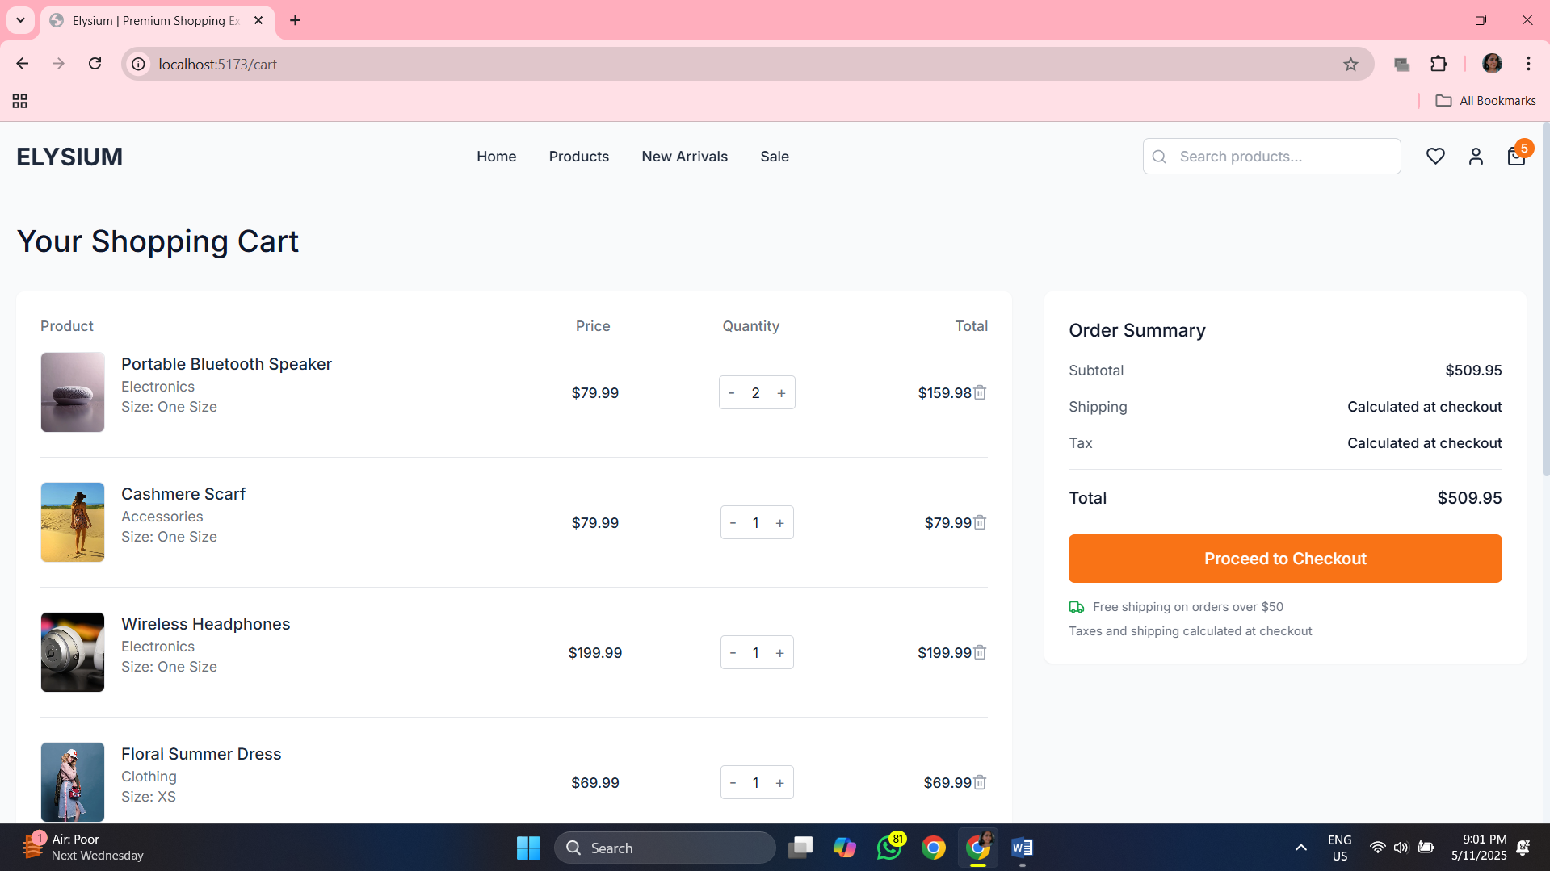

**Src>components>pages>checkout.tsx:**

*import* React, { useState } *from* 'react';

*import* { Link, useNavigate } *from* 'react-router-dom';

*import* { ArrowLeft, CreditCard, Shield, Truck } *from* 'lucide-react';

*import* Button *from* '../components/ui/Button';

*import* { useCart } *from* '../contexts/CartContext';

interface FormData {

  firstName: string;

  lastName: string;

  email: string;

  address: string;

  city: string;

  state: string;

  zip: string;

  country: string;

  cardName: string;

  cardNumber: string;

  expDate: string;

  cvv: string;

}

const *Checkout*: *React.FC* =()=>{

const *navigate* = *useNavigate*();

const{ *items*, *getTotalPrice*, *clearCart* }= *useCart*();

const[*currentStep*, *setCurrentStep*]= *useState*<*number*>(1);

const[*isProcessing*, *setIsProcessing*]= *useState*<*boolean*>(*false*);

const[*formData*, *setFormData*]= *useState*<*FormData*>({

*firstName*:'',

*lastName*:'',

*email*:'',

*address*:'',

*city*:'',

*state*:'',

*zip*:'',

*country*:'US',

*cardName*:'',

*cardNumber*:'',

*expDate*:'',

*cvv*:'',

});

*// Handle empty cart*

*if* (*items.length* ===0){

*return* (

<div *className*="min-h-screen bg-gray-50 py-16 animate-fade-in">

        <div *className*="container mx-auto px-4 text-center">

          <div *className*="max-w-md mx-auto">

            <h1 *className*="text-3xl font-medium text-primary-900 mb-4">Your cart is empty</h1>

            <p *className*="text-gray-600 mb-8">

              You need to add items to your cart before proceeding to checkout.

            </p>

            <Button

*variant*="accent"

*size*="lg"

*as*={Link}

*to*="/products"

            >

              Shop Now

            </Button>

          </div>

        </div>

      </div>

);

}

const *handleChange* =(*e*: *React.ChangeEvent*<*HTMLInputElement* | *HTMLSelectElement*>)=>{

const{ *name*, *value* }= *e.target*;

*setFormData*(*prev* =>({...*prev*,[*name*]: *value* }));

};

const *handleSubmit* =(*e*: *React.FormEvent*)=>{

*e.preventDefault*();

*if* (*currentStep* ===1){

*setCurrentStep*(2);

*window.scrollTo*(0,0);

} *else* {

*// Submit order*

*setIsProcessing*(*true*);

*// Simulate order processing*

*setTimeout*(()=>{

*setIsProcessing*(*false*);

*clearCart*();

*navigate*('/order-confirmation');

},2000);

}

};

*return* (

<div *className*="min-h-screen bg-gray-50 py-8 animate-fade-in">

      <div *className*="container mx-auto px-4">

        <div *className*="mb-8 flex items-center justify-between">

          <h1 *className*="text-3xl font-medium text-primary-900">Checkout</h1>

          <button

*onClick*={() => *navigate*(-1)}

*className*="flex items-center text-primary-700"

          >

            <ArrowLeft *className*="h-4 w-4 mr-1" />

            Back

          </button>

        </div>

        {*/* Checkout Steps */*}

        <div *className*="flex justify-center mb-8">

          <div *className*="flex items-center w-full max-w-md">

            <div *className*={`flex-1 text-center ${currentStep === 1 ? 'font-medium text-primary-800' : 'text-gray-500'}`}>

              <div *className*={`w-8 h-8 mx-auto flex items-center justify-center rounded-full border-2 mb-2

                ${currentStep === 1 ? 'border-primary-600 bg-primary-600 text-white' : 'border-gray-300 bg-white text-gray-500'}`}

              >

                1

              </div>

              <span *className*="text-sm">Shipping</span>

            </div>

            <div *className*="flex-1 border-t-2 border-gray-300"></div>

            <div *className*={`flex-1 text-center ${currentStep === 2 ? 'font-medium text-primary-800' : 'text-gray-500'}`}>

              <div *className*={`w-8 h-8 mx-auto flex items-center justify-center rounded-full border-2 mb-2

                ${currentStep === 2 ? 'border-primary-600 bg-primary-600 text-white' : 'border-gray-300 bg-white text-gray-500'}`}

              >

                2

              </div>

              <span *className*="text-sm">Payment</span>

            </div>

          </div>

        </div>

        <div *className*="grid grid-cols-1 lg:grid-cols-3 gap-8">

          {*/* Checkout Form */*}

          <div *className*="lg:col-span-2">

            <div *className*="bg-white rounded-lg shadow-sm overflow-hidden">

              <form *onSubmit*={handleSubmit} *className*="p-6">

                {currentStep === 1 ? (

*/* Shipping Information */*

                  <div *className*="animate-fade-in">

                    <h2 *className*="text-lg font-medium text-primary-900 mb-6">Shipping Information</h2>

                    <div *className*="grid grid-cols-1 md:grid-cols-2 gap-6 mb-6">

                      <div>

                        <label *htmlFor*="firstName" *className*="block text-sm font-medium text-gray-700 mb-1">

                          First Name*

                        </label>

                        <input

*type*="text"

*id*="firstName"

*name*="firstName"

*value*={formData*.*firstName}

*onChange*={handleChange}

*required*

*className*="input w-full"

                        />

                      </div>

                      <div>

                        <label *htmlFor*="lastName" *className*="block text-sm font-medium text-gray-700 mb-1">

                          Last Name*

                        </label>

                        <input

*type*="text"

*id*="lastName"

*name*="lastName"

*value*={formData*.*lastName}

*onChange*={handleChange}

*required*

*className*="input w-full"

                        />

                      </div>

                    </div>

                    <div *className*="mb-6">

                      <label *htmlFor*="email" *className*="block text-sm font-medium text-gray-700 mb-1">

                        Email*

                      </label>

                      <input

*type*="email"

*id*="email"

*name*="email"

*value*={formData*.*email}

*onChange*={handleChange}

*required*

*className*="input w-full"

                      />

                    </div>

                    <div *className*="mb-6">

                      <label *htmlFor*="address" *className*="block text-sm font-medium text-gray-700 mb-1">

                        Address*

                      </label>

                      <input

*type*="text"

*id*="address"

*name*="address"

*value*={formData*.*address}

*onChange*={handleChange}

*required*

*className*="input w-full"

                      />

                    </div>

                    <div *className*="grid grid-cols-2 md:grid-cols-4 gap-6 mb-6">

                      <div *className*="col-span-2">

                        <label *htmlFor*="city" *className*="block text-sm font-medium text-gray-700 mb-1">

                          City*

                        </label>

                        <input

*type*="text"

*id*="city"

*name*="city"

*value*={formData*.*city}

*onChange*={handleChange}

*required*

*className*="input w-full"

                        />

                      </div>

                      <div>

                        <label *htmlFor*="state" *className*="block text-sm font-medium text-gray-700 mb-1">

                          State*

                        </label>

                        <input

*type*="text"

*id*="state"

*name*="state"

*value*={formData*.*state}

*onChange*={handleChange}

*required*

*className*="input w-full"

                        />

                      </div>

                      <div>

                        <label *htmlFor*="zip" *className*="block text-sm font-medium text-gray-700 mb-1">

                          ZIP Code*

                        </label>

                        <input

*type*="text"

*id*="zip"

*name*="zip"

*value*={formData*.*zip}

*onChange*={handleChange}

*required*

*className*="input w-full"

                        />

                      </div>

                    </div>

                    <div *className*="mb-6">

                      <label *htmlFor*="country" *className*="block text-sm font-medium text-gray-700 mb-1">

                        Country*

                      </label>

                      <select

*id*="country"

*name*="country"

*value*={formData*.*country}

*onChange*={handleChange}

*required*

*className*="input w-full"

                      >

                        <option *value*="US">United States</option>

                        <option *value*="CA">Canada</option>

                        <option *value*="UK">United Kingdom</option>

                        <option *value*="AU">Australia</option>

                      </select>

                    </div>

                    <div *className*="flex justify-end">

                      <Button

*type*="submit"

*variant*="accent"

*size*="lg"

                      >

                        Continue to Payment

                      </Button>

                    </div>

                  </div>

                ) : (

*/* Payment Information */*

                  <div *className*="animate-fade-in">

                    <h2 *className*="text-lg font-medium text-primary-900 mb-6">Payment Information</h2>

                    <div *className*="mb-6">

                      <label *htmlFor*="cardName" *className*="block text-sm font-medium text-gray-700 mb-1">

                        Name on Card*

                      </label>

                      <input

*type*="text"

*id*="cardName"

*name*="cardName"

*value*={formData*.*cardName}

*onChange*={handleChange}

*required*

*className*="input w-full"

                      />

                    </div>

                    <div *className*="mb-6">

                      <label *htmlFor*="cardNumber" *className*="block text-sm font-medium text-gray-700 mb-1">

                        Card Number*

                      </label>

                      <div *className*="relative">

                        <input

*type*="text"

*id*="cardNumber"

*name*="cardNumber"

*value*={formData*.*cardNumber}

*onChange*={handleChange}

*placeholder*="1234 5678 9012 3456"

*required*

*className*="input w-full pl-10"

                        />

                        <CreditCard *className*="absolute left-3 top-1/2 transform -translate-y-1/2 h-5 w-5 text-gray-400" />

                      </div>

                    </div>

                    <div *className*="grid grid-cols-2 gap-6 mb-8">

                      <div>

                        <label *htmlFor*="expDate" *className*="block text-sm font-medium text-gray-700 mb-1">

                          Expiration Date*

                        </label>

                        <input

*type*="text"

*id*="expDate"

*name*="expDate"

*value*={formData*.*expDate}

*onChange*={handleChange}

*placeholder*="MM/YY"

*required*

*className*="input w-full"

                        />

                      </div>

                      <div>

                        <label *htmlFor*="cvv" *className*="block text-sm font-medium text-gray-700 mb-1">

                          CVV*

                        </label>

                        <input

*type*="text"

*id*="cvv"

*name*="cvv"

*value*={formData*.*cvv}

*onChange*={handleChange}

*placeholder*="123"

*required*

*className*="input w-full"

                        />

                      </div>

                    </div>

                    <div *className*="flex items-center mb-8">

                      <Shield *className*="h-5 w-5 text-green-600 mr-2" />

                      <span *className*="text-sm text-gray-600">

                        Your payment information is encrypted and secure.

                      </span>

                    </div>

                    <div *className*="flex justify-between">

                      <Button

*type*="button"

*variant*="secondary"

*onClick*={() => *setCurrentStep*(1)}

                      >

                        Back to Shipping

                      </Button>

                      <Button

*type*="submit"

*variant*="accent"

*size*="lg"

*isLoading*={isProcessing}

                      >

                        {isProcessing ? 'Processing Order...' : 'Place Order'}

                      </Button>

                    </div>

                  </div>

                )}

              </form>

            </div>

          </div>

          {*/* Order Summary */*}

          <div *className*="lg:col-span-1">

            <div *className*="bg-white rounded-lg shadow-sm overflow-hidden sticky top-24">

              <div *className*="p-6">

                <h2 *className*="text-lg font-medium text-primary-900 mb-4">Order Summary</h2>

                <div *className*="max-h-80 overflow-y-auto mb-6">

                  {items*.map*((item) => (

                    <div *key*={item*.product.*id} *className*="flex py-4 first:pt-0 border-b border-gray-100 last:border-0">

                      <div *className*="h-16 w-16 flex-shrink-0 overflow-hidden rounded-md border border-gray-200">

                        <img

*src*={item*.product.*images[0]}

*alt*={item*.product.*title}

*className*="h-full w-full object-cover object-center"

                        />

                      </div>

                      <div *className*="ml-4 flex flex-1 flex-col">

                        <div>

                          <div *className*="flex justify-between text-sm font-medium text-primary-800">

                            <h3 *className*="line-clamp-1">{item*.product.*title}</h3>

                            <p *className*="ml-4">${(item*.product.*price * item*.*quantity)*.toFixed*(2)}</p>

                          </div>

                          <p *className*="mt-1 text-sm text-gray-500">Qty {item*.*quantity}</p>

                        </div>

                      </div>

                    </div>

                  ))}

                </div>

                <div *className*="space-y-4 mb-6">

                  <div *className*="flex justify-between text-sm">

                    <span *className*="text-gray-600">Subtotal</span>

                    <span *className*="font-medium text-primary-900">${*getTotalPrice*()*.toFixed*(2)}</span>

                  </div>

                  <div *className*="flex justify-between text-sm">

                    <span *className*="text-gray-600">Shipping</span>

                    <span *className*="font-medium text-primary-900">

                      {*getTotalPrice*() >= 50 ? 'Free' : '$5.99'}

                    </span>

                  </div>

                  <div *className*="flex justify-between text-sm">

                    <span *className*="text-gray-600">Tax (8%)</span>

                    <span *className*="font-medium text-primary-900">

                      ${(*getTotalPrice*() * 0.08)*.toFixed*(2)}

                    </span>

                  </div>

                  <div *className*="border-t border-gray-200 pt-4 flex justify-between">

                    <span *className*="font-medium text-primary-900">Total</span>

                    <span *className*="font-medium text-primary-900">

                      ${(*getTotalPrice*() + (*getTotalPrice*() >= 50 ? 0 : 5.99) + (*getTotalPrice*() * 0.08))*.toFixed*(2)}

                    </span>

                  </div>

                </div>

                <div *className*="text-xs text-gray-500 space-y-2">

                  <div *className*="flex items-center">

                    <Truck *className*="h-4 w-4 mr-2 text-green-600" />

                    <span>Free shipping on orders over $50</span>

                  </div>

                </div>

              </div>

            </div>

          </div>

        </div>

      </div>

    </div>

);

};

*export* *default* Checkout;

**Src>components>pages>Home.tsx:**

*import* React *from* 'react';

*import* { Link } *from* 'react-router-dom';

*import* { ArrowRight, ShoppingBag, TruckIcon, CreditCard, LifeBuoy } *from* 'lucide-react';

*import* ProductCard *from* '../components/ui/ProductCard';

*import* Button *from* '../components/ui/Button';

*import* { mockProducts } *from* '../data/mockData';

const *Home*: *React.FC* =()=>{

*// Featured products (first 8 products)*

const *featuredProducts* = *mockProducts.slice*(0,8);

*// Categories*

const *categories* =[

{ *name*:'Clothing', *image*:'https://images.pexels.com/photos/1126993/pexels-photo-1126993.jpeg?auto=compress&cs=tinysrgb&w=1260&h=750', *link*:'/products?category=clothing'},

{ *name*:'Shoes', *image*:'https://images.pexels.com/photos/2529148/pexels-photo-2529148.jpeg?auto=compress&cs=tinysrgb&w=1260&h=750', *link*:'/products?category=shoes'},

{ *name*:'Accessories', *image*:'https://images.pexels.com/photos/1152077/pexels-photo-1152077.jpeg?auto=compress&cs=tinysrgb&w=1260&h=750', *link*:'/products?category=accessories'},

];

*return* (

<div *className*="animate-fade-in">

      {*/* Hero Section */*}

      <section *className*="relative min-h-[80vh] flex items-center">

        <div *className*="absolute inset-0 z-0">

          <img

*src*="https://images.pexels.com/photos/6348105/pexels-photo-6348105.jpeg?auto=compress&cs=tinysrgb&w=1260&h=750"

*alt*="Hero background"

*className*="w-full h-full object-cover brightness-90"

          />

          <div *className*="absolute inset-0 bg-gradient-to-r from-black/40 to-black/10"></div>

        </div>

        <div *className*="container mx-auto px-4 relative z-10">

          <div *className*="max-w-xl">

            <h1 *className*="text-5xl md:text-6xl font-bold text-white leading-tight mb-4">

              Elevate Your Style

            </h1>

            <p *className*="text-xl text-white/80 mb-8">

              Discover our new collection and find your unique style. Quality meets luxury at Elysium.

            </p>

            <div *className*="flex flex-wrap gap-4">

              <Button

*variant*="accent"

*size*="lg"

*rightIcon*={<ShoppingBag *className*="h-5 w-5" />}

*as*={Link}

*to*="/products"

              >

                Shop Now

              </Button>

              <Button

*variant*="outline"

*size*="lg"

*className*="bg-white/10 backdrop-blur-sm border-white/30 text-white hover:bg-white/20"

*as*={Link}

*to*="/products?tag=new"

              >

                New Arrivals

              </Button>

            </div>

          </div>

        </div>

      </section>

      {*/* Categories Section */*}

      <section *className*="py-16 bg-gray-50">

        <div *className*="container mx-auto px-4">

          <h2 *className*="text-3xl font-medium text-center text-primary-900 mb-12">

            Shop by Category

          </h2>

          <div *className*="grid grid-cols-1 md:grid-cols-3 gap-8">

            {categories*.map*((category) => (

              <Link

*key*={category*.*name}

*to*={category*.*link}

*className*="group relative rounded-lg overflow-hidden shadow-md transition-all duration-300 hover:shadow-xl"

              >

                <div *className*="aspect-[4/5]">

                  <img

*src*={category*.*image}

*alt*={category*.*name}

*className*="w-full h-full object-cover transition-transform duration-700 group-hover:scale-105"

                  />

                </div>

                <div *className*="absolute inset-0 bg-gradient-to-t from-black/70 via-black/20 to-transparent flex items-end">

                  <div *className*="p-6 w-full">

                    <h3 *className*="text-xl text-white font-medium mb-2">{category*.*name}</h3>

                    <div *className*="flex items-center text-white/80 group-hover:text-accent-500 transition-colors">

                      <span *className*="text-sm mr-1">Shop now</span>

                      <ArrowRight *className*="h-4 w-4" />

                    </div>

                  </div>

                </div>

              </Link>

            ))}

          </div>

        </div>

      </section>

      {*/* Featured Products Section */*}

      <section *className*="py-16">

        <div *className*="container mx-auto px-4">

          <div *className*="flex justify-between items-center mb-12">

            <h2 *className*="text-3xl font-medium text-primary-900">

              Featured Products

            </h2>

            <Link

*to*="/products"

*className*="text-primary-700 hover:text-accent-500 transition-colors flex items-center"

            >

              View All <ArrowRight *className*="ml-1 h-4 w-4" />

            </Link>

          </div>

          <div *className*="grid grid-cols-1 sm:grid-cols-2 md:grid-cols-3 lg:grid-cols-4 gap-6">

            {featuredProducts*.map*((product) => (

              <ProductCard *key*={product*.*id} *product*={product} />

            ))}

          </div>

        </div>

      </section>

      {*/* Promotional Banner */*}

      <section *className*="py-16 bg-primary-800 text-white">

        <div *className*="container mx-auto px-4">

          <div *className*="flex flex-col md:flex-row md:items-center">

            <div *className*="md:w-1/2 mb-8 md:mb-0">

              <h2 *className*="text-3xl md:text-4xl font-medium mb-4">

                Summer Sale

              </h2>

              <p *className*="text-xl text-white/80 mb-6">

                Get up to 50% off on selected items. Limited time offer.

              </p>

              <Button

*variant*="accent"

*size*="lg"

*as*={Link}

*to*="/products?tag=sale"

              >

                Shop the Sale

              </Button>

            </div>

            <div *className*="md:w-1/2 md:pl-8">

              <img

*src*="https://images.pexels.com/photos/5935738/pexels-photo-5935738.jpeg?auto=compress&cs=tinysrgb&w=1260&h=750"

*alt*="Summer sale"

*className*="rounded-lg w-full h-auto object-cover shadow-xl"

              />

            </div>

          </div>

        </div>

      </section>

      {*/* Benefits Section */*}

      <section *className*="py-16">

        <div *className*="container mx-auto px-4">

          <div *className*="grid grid-cols-1 md:grid-cols-2 lg:grid-cols-4 gap-8">

            <div *className*="text-center p-6 border border-gray-200 rounded-lg hover:border-accent-300 transition-colors">

              <div *className*="flex justify-center mb-4">

                <TruckIcon *className*="h-10 w-10 text-accent-500" />

              </div>

              <h3 *className*="text-lg font-medium text-primary-800 mb-2">Free Shipping</h3>

              <p *className*="text-gray-600 text-sm">On orders over $50</p>

            </div>

            <div *className*="text-center p-6 border border-gray-200 rounded-lg hover:border-accent-300 transition-colors">

              <div *className*="flex justify-center mb-4">

                <CreditCard *className*="h-10 w-10 text-accent-500" />

              </div>

              <h3 *className*="text-lg font-medium text-primary-800 mb-2">Secure Payment</h3>

              <p *className*="text-gray-600 text-sm">100% secure checkout</p>

            </div>

            <div *className*="text-center p-6 border border-gray-200 rounded-lg hover:border-accent-300 transition-colors">

              <div *className*="flex justify-center mb-4">

                <ShoppingBag *className*="h-10 w-10 text-accent-500" />

              </div>

              <h3 *className*="text-lg font-medium text-primary-800 mb-2">Easy Returns</h3>

              <p *className*="text-gray-600 text-sm">30 days return policy</p>

            </div>

            <div *className*="text-center p-6 border border-gray-200 rounded-lg hover:border-accent-300 transition-colors">

              <div *className*="flex justify-center mb-4">

                <LifeBuoy *className*="h-10 w-10 text-accent-500" />

              </div>

              <h3 *className*="text-lg font-medium text-primary-800 mb-2">24/7 Support</h3>

              <p *className*="text-gray-600 text-sm">Always here to help</p>

            </div>

          </div>

        </div>

      </section>

    </div>

);

};

*export* *default* Home;

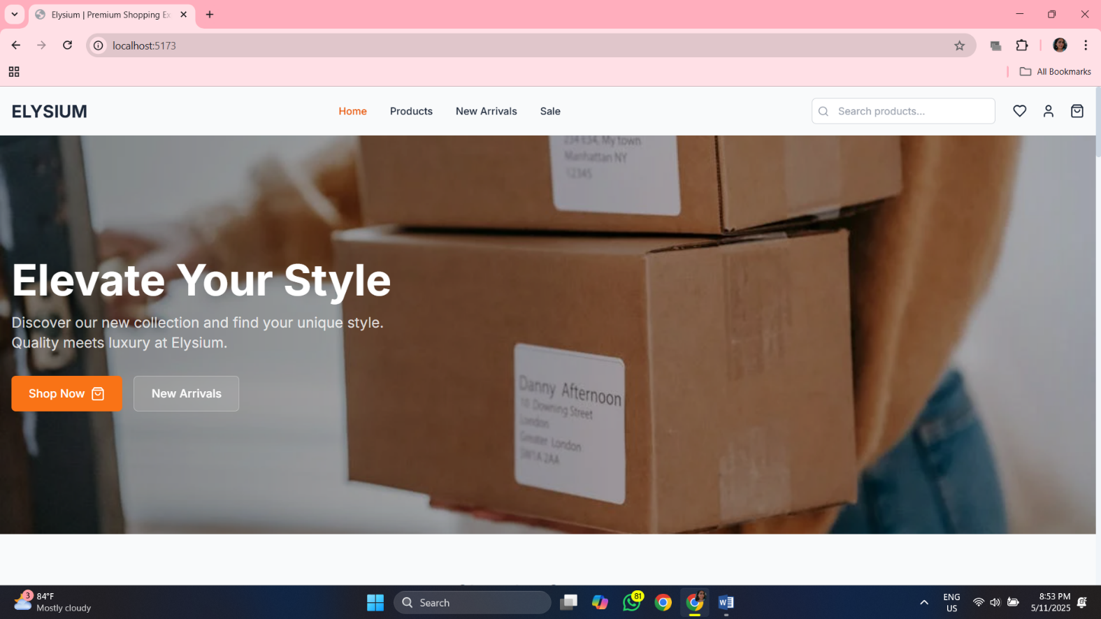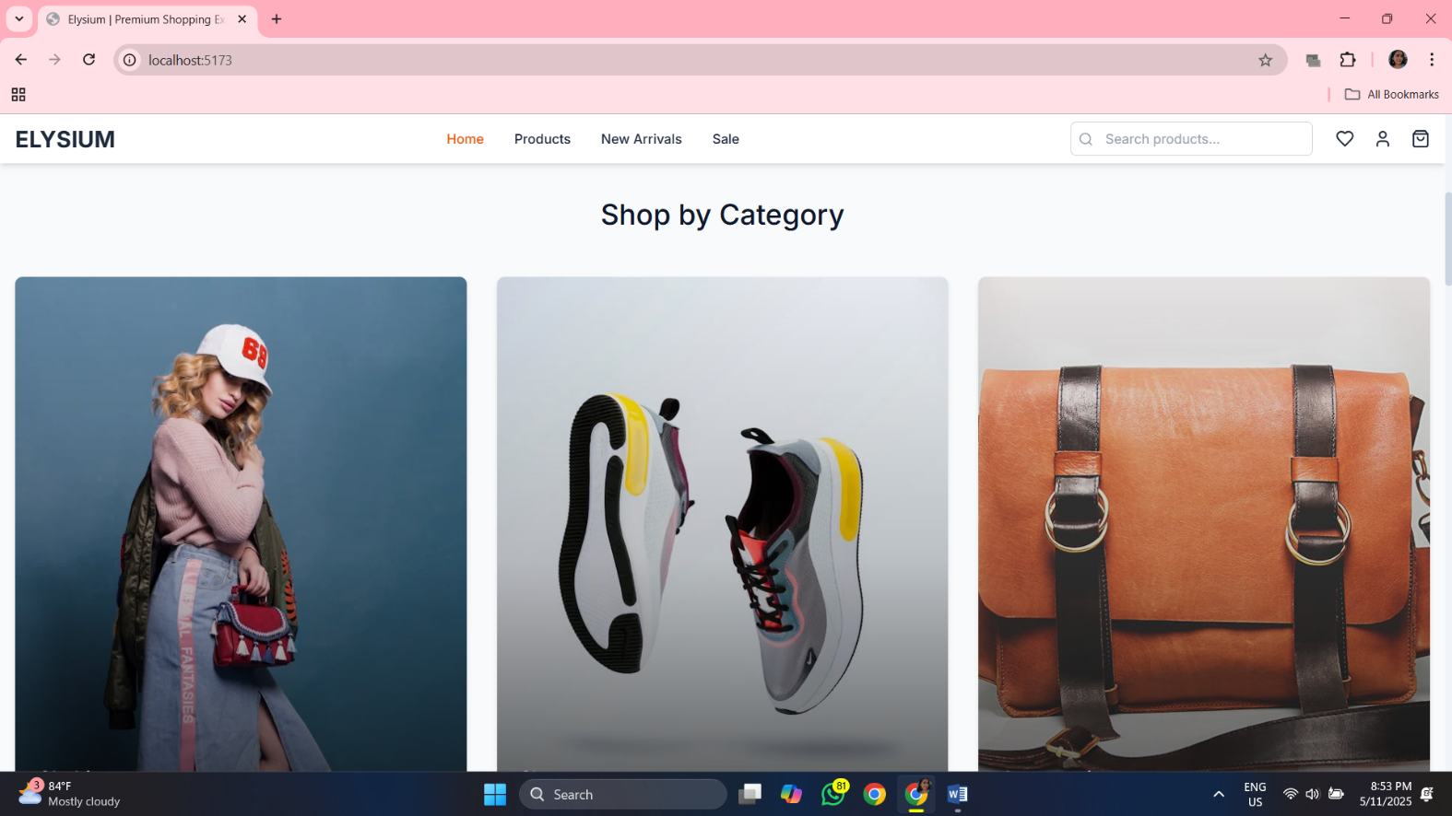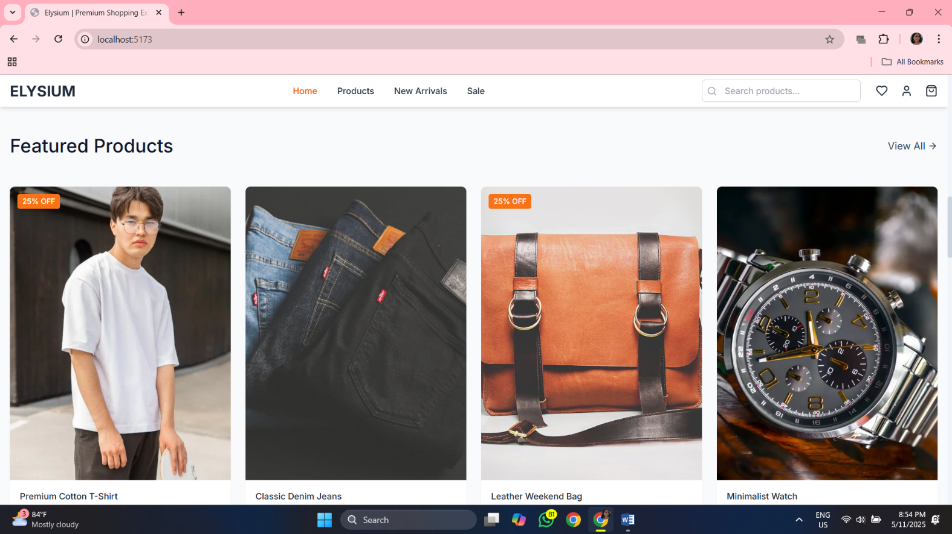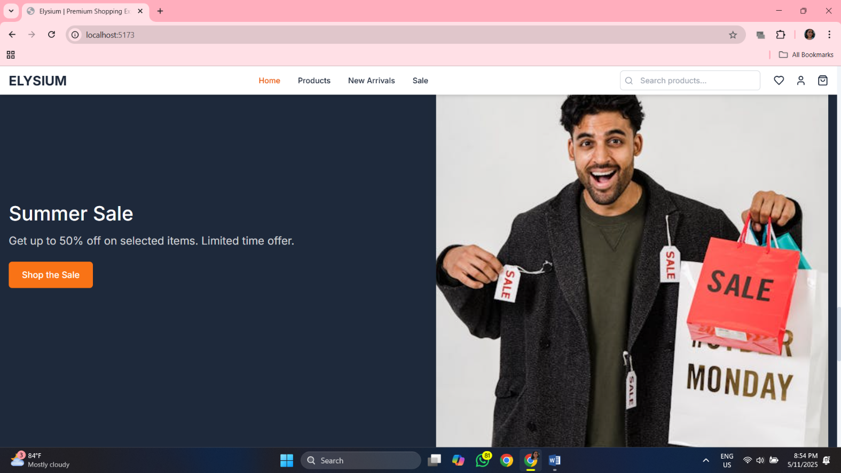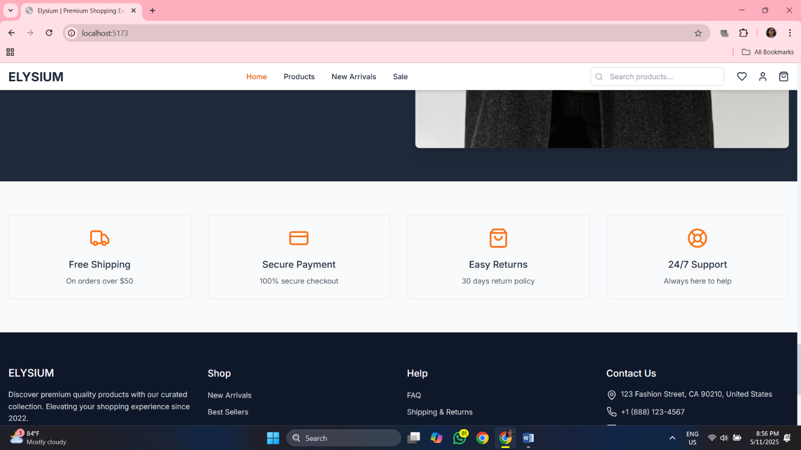

**Src>components>pages>NotFound.tsx:**

*import* React *from* 'react';

*import* { Link } *from* 'react-router-dom';

*import* Button *from* '../components/ui/Button';

const *NotFound*: *React.FC* =()=>{

*return* (

<div *className*="min-h-screen flex items-center justify-center bg-gray-50 py-12 px-4 animate-fade-in">

      <div *className*="max-w-md w-full text-center">

        <h1 *className*="text-9xl font-bold text-primary-800 mb-4">404</h1>

        <h2 *className*="text-3xl font-medium text-primary-900 mb-2">Page Not Found</h2>

        <p *className*="text-gray-600 mb-8">

          The page you're looking for doesn't exist or has been moved.

        </p>

        <div *className*="flex flex-col sm:flex-row justify-center gap-4">

          <Button

*variant*="accent"

*size*="lg"

*as*={Link}

*to*="/"

          >

            Go Home

          </Button>

          <Button

*variant*="secondary"

*size*="lg"

*as*={Link}

*to*="/products"

          >

            View Products

          </Button>

        </div>

      </div>

    </div>

);

};

*export* *default* NotFound;

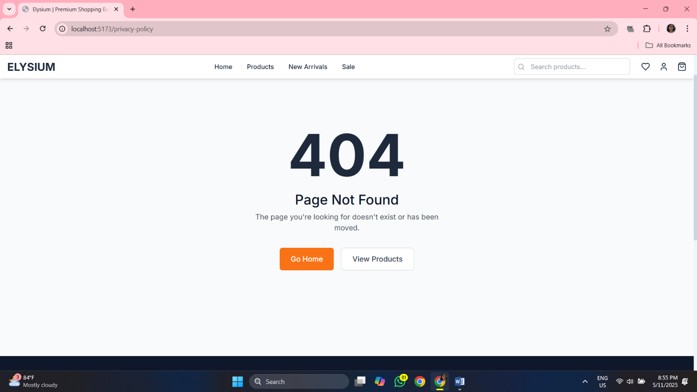

**Src>components>pages>ProductDetails.tsx:**

*import* React, { useState, useEffect } *from* 'react';

*import* { useParams, Link, useNavigate } *from* 'react-router-dom';

*import* {

  Star,

  Truck,

  Clock,

  ArrowLeft,

  ChevronRight,

  Heart,

  Share2,

  MinusCircle,

  PlusCircle,

  ShoppingBag

} *from* 'lucide-react';

*import* Button *from* '../components/ui/Button';

*import* ProductCard *from* '../components/ui/ProductCard';

*import* { mockProducts } *from* '../data/mockData';

*import* { Product } *from* '../types/product';

*import* { useCart } *from* '../contexts/CartContext';

*import* { useToast } *from* '../components/ui/Toast';

const *ProductDetail*: *React.FC* =()=>{

const{ *id* }= *useParams*<{ *id*: *string* }>();

const *navigate* = *useNavigate*();

const{ *addToCart* }= *useCart*();

const{ *showToast* }= *useToast*();

const[*product*, *setProduct*]= *useState*<*Product* | *null*>(*null*);

const[*relatedProducts*, *setRelatedProducts*]= *useState*<*Product*[]>([]);

const[*selectedImage*, *setSelectedImage*]= *useState*<*string*>('');

const[*quantity*, *setQuantity*]= *useState*<*number*>(1);

const[*selectedSize*, *setSelectedSize*]= *useState*<*string*>('');

const[*loading*, *setLoading*]= *useState*<*boolean*>(*true*);

*useEffect*(()=>{

*setLoading*(*true*);

*// In a real app, you would fetch the product from an API*

const *productId* = *Number*(*id*);

const *foundProduct* = *mockProducts.find*(*p* => *p.id* === *productId*);

*if* (*foundProduct*){

*setProduct*(*foundProduct*);

*setSelectedImage*(*foundProduct.images*[0]);

*setSelectedSize*(*foundProduct.sizes*[0]);

*// Get related products from the same category*

const *related* = *mockProducts*

*.filter*(*p* => *p.category* === *foundProduct.category* && *p.id* !== *productId*)

*.slice*(0,4);

*setRelatedProducts*(*related*);

} *else* {

*// Product not found*

*navigate*('/products');

}

*setLoading*(*false*);

},[*id*, *navigate*]);

const *incrementQuantity* =()=>{

*setQuantity*(*prev* => *prev* +1);

};

const *decrementQuantity* =()=>{

*if* (*quantity* >1){

*setQuantity*(*prev* => *prev* -1);

}

};

const *handleAddToCart* =()=>{

*if* (*product*){

*addToCart*(*product*, *quantity*);

*showToast*('Added to cart successfully','success');

}

};

const *handleAddToWishlist* =()=>{

*showToast*('Added to wishlist','success');

};

*if* (*loading*){

*return* (

<div *className*="min-h-screen flex items-center justify-center">

        <div *className*="animate-spin h-12 w-12 border-4 border-primary-600 rounded-full border-t-transparent"></div>

      </div>

);

}

*if* (!*product*){

*return* (

<div *className*="min-h-screen flex items-center justify-center">

        <div *className*="text-center">

          <h2 *className*="text-2xl font-medium text-primary-800 mb-4">Product Not Found</h2>

          <p *className*="text-gray-600 mb-6">The product you're looking for doesn't exist or has been removed.</p>

          <Button *variant*="accent" *as*={Link} *to*="/products">

            Back to Products

          </Button>

        </div>

      </div>

);

}

*// Calculate discount percentage*

const *discountPercentage* = *product.compareAtPrice*

? *Math.round*(((*product.compareAtPrice* - *product.price*)/ *product.compareAtPrice*)*100)

:0;

*return* (

<div *className*="min-h-screen bg-gray-50 animate-fade-in py-8">

      <div *className*="container mx-auto px-4">

        {*/* Breadcrumbs */*}

        <div *className*="flex items-center text-sm text-gray-500 mb-8">

          <Link *to*="/" *className*="hover:text-primary-700">Home</Link>

          <ChevronRight *className*="h-4 w-4 mx-2" />

          <Link *to*="/products" *className*="hover:text-primary-700">Products</Link>

          <ChevronRight *className*="h-4 w-4 mx-2" />

          <Link *to*={`/products?category=${product*.*category}`} *className*="hover:text-primary-700">

            {product*.*category}

          </Link>

          <ChevronRight *className*="h-4 w-4 mx-2" />

          <span *className*="text-primary-700 truncate">{product*.*title}</span>

        </div>

        {*/* Back button (mobile only) */*}

        <button

*onClick*={() => *navigate*(-1)}

*className*="md:hidden flex items-center text-primary-700 mb-4"

        >

          <ArrowLeft *className*="h-4 w-4 mr-1" />

          Back

        </button>

        <div *className*="bg-white rounded-lg shadow-sm overflow-hidden mb-16">

          <div *className*="grid grid-cols-1 md:grid-cols-2 lg:grid-cols-5 gap-8 p-6">

            {*/* Product Images - Desktop */*}

            <div *className*="hidden lg:block lg:col-span-1">

              <div *className*="space-y-4">

                {product*.images.map*((image, index) => (

                  <div

*key*={index}

*className*={`border rounded-md overflow-hidden cursor-pointer

                      ${selectedImage === image ? 'border-accent-500 ring-2 ring-accent-200' : 'border-gray-200'}`}

*onClick*={() => *setSelectedImage*(image)}

                  >

                    <img

*src*={image}

*alt*={`${product*.*title} - view ${index + 1}`}

*className*="w-full h-20 object-cover"

                    />

                  </div>

                ))}

              </div>

            </div>

            {*/* Main Product Image */*}

            <div *className*="lg:col-span-2">

              <div *className*="relative aspect-[4/5] rounded-lg overflow-hidden mb-4">

                <img

*src*={selectedImage}

*alt*={product*.*title}

*className*="w-full h-full object-cover"

                />

                {*/* Sale Badge */*}

                {product*.*compareAtPrice && (

                  <span *className*="absolute top-4 left-4 bg-accent-500 text-white text-sm font-medium px-2 py-1 rounded">

                    {discountPercentage}% OFF

                  </span>

                )}

              </div>

              {*/* Product Thumbnails - Mobile */*}

              <div *className*="flex lg:hidden gap-2 overflow-x-auto pb-2 -mx-1 px-1">

                {product*.images.map*((image, index) => (

                  <div

*key*={index}

*className*={`border rounded-md overflow-hidden cursor-pointer flex-shrink-0

                      ${selectedImage === image ? 'border-accent-500 ring-2 ring-accent-200' : 'border-gray-200'}`}

*onClick*={() => *setSelectedImage*(image)}

                  >

                    <img

*src*={image}

*alt*={`${product*.*title} - view ${index + 1}`}

*className*="w-16 h-16 object-cover"

                    />

                  </div>

                ))}

              </div>

            </div>

            {*/* Product Info */*}

            <div *className*="lg:col-span-2">

              <h1 *className*="text-2xl md:text-3xl font-medium text-primary-900 mb-2">

                {product*.*title}

              </h1>

              <div *className*="flex items-center gap-2 mb-4">

                <div *className*="flex items-center">

                  {[1, 2, 3, 4, 5]*.map*((star) => (

                    <Star

*key*={star}

*className*={`h-4 w-4 ${star <= product*.*rating ? 'text-yellow-400 fill-yellow-400' : 'text-gray-300'}`}

                    />

                  ))}

                </div>

                <span *className*="text-sm text-gray-500">

                  {product*.*reviewCount} reviews

                </span>

              </div>

              <div *className*="flex items-center gap-2 mb-6">

                <span *className*="text-2xl font-medium text-primary-900">

                  ${product*.price.toFixed*(2)}

                </span>

                {product*.*compareAtPrice && (

                  <span *className*="text-lg text-gray-500 line-through">

                    ${product*.compareAtPrice.toFixed*(2)}

                  </span>

                )}

              </div>

              <p *className*="text-gray-600 mb-6">

                {product*.*description}

              </p>

              {*/* Size Selection */*}

              <div *className*="mb-6">

                <h3 *className*="text-sm font-medium text-primary-800 mb-2">Size</h3>

                <div *className*="flex flex-wrap gap-2">

                  {product*.sizes.map*((size) => (

                    <button

*key*={size}

*className*={`px-4 py-2 border rounded-md text-sm font-medium transition-colors

                        ${selectedSize === size

                          ? 'bg-primary-700 text-white border-primary-700'

                          : 'border-gray-300 text-gray-700 hover:border-primary-500'

                        }`}

*onClick*={() => *setSelectedSize*(size)}

                    >

                      {size}

                    </button>

                  ))}

                </div>

              </div>

              {*/* Quantity Selection */*}

              <div *className*="mb-6">

                <h3 *className*="text-sm font-medium text-primary-800 mb-2">Quantity</h3>

                <div *className*="flex items-center">

                  <button

*onClick*={decrementQuantity}

*className*="text-gray-500 hover:text-primary-700 disabled:opacity-50"

*disabled*={quantity <= 1}

                  >

                    <MinusCircle *className*="h-6 w-6" />

                  </button>

                  <span *className*="mx-4 w-10 text-center font-medium">{quantity}</span>

                  <button

*onClick*={incrementQuantity}

*className*="text-gray-500 hover:text-primary-700"

                  >

                    <PlusCircle *className*="h-6 w-6" />

                  </button>

                </div>

              </div>

              {*/* Action Buttons */*}

              <div *className*="flex flex-col sm:flex-row gap-4 mb-8">

                <Button

*variant*="accent"

*size*="lg"

*fullWidth*

*leftIcon*={<ShoppingBag *className*="h-5 w-5" />}

*onClick*={handleAddToCart}

                >

                  Add to Cart

                </Button>

                <Button

*variant*="secondary"

*size*="lg"

*leftIcon*={<Heart *className*="h-5 w-5" />}

*onClick*={handleAddToWishlist}

                >

                  Wishlist

                </Button>

              </div>

              {*/* Product Info */*}

              <div *className*="space-y-4 pt-4 border-t border-gray-200">

                <div *className*="flex items-center text-sm text-gray-600">

                  <Truck *className*="h-5 w-5 mr-2 text-green-600" />

                  <span>Free shipping on orders over $50</span>

                </div>

                <div *className*="flex items-center text-sm text-gray-600">

                  <Clock *className*="h-5 w-5 mr-2 text-blue-600" />

                  <span>Estimated delivery: 3-5 business days</span>

                </div>

              </div>

              {*/* Share */*}

              <div *className*="mt-8 pt-4 border-t border-gray-200">

                <button *className*="flex items-center text-primary-700 hover:text-primary-800">

                  <Share2 *className*="h-4 w-4 mr-2" />

                  <span>Share this product</span>

                </button>

              </div>

            </div>

          </div>

        </div>

        {*/* Related Products */*}

        {relatedProducts*.*length > 0 && (

          <div *className*="mb-16">

            <h2 *className*="text-2xl font-medium text-primary-900 mb-8">

              You may also like

            </h2>

            <div *className*="grid grid-cols-1 sm:grid-cols-2 md:grid-cols-3 lg:grid-cols-4 gap-6">

              {relatedProducts*.map*((product) => (

                <ProductCard *key*={product*.*id} *product*={product} />

              ))}

            </div>

          </div>

        )}

      </div>

    </div>

);

};

*export* *default* ProductDetail;

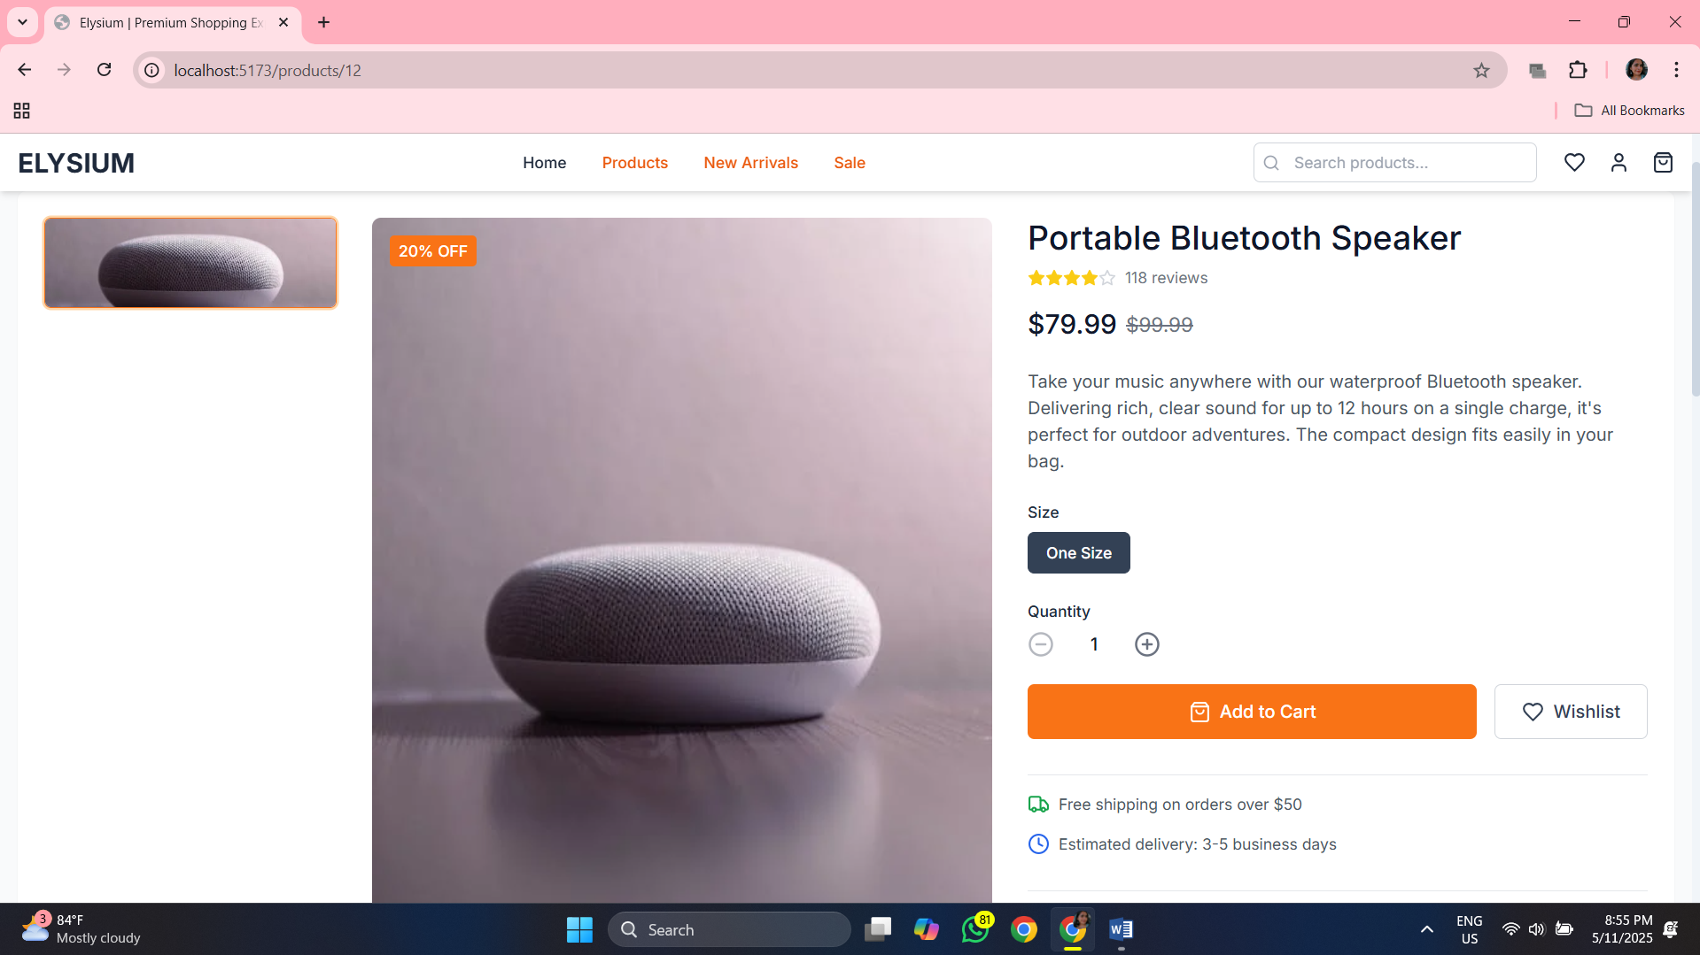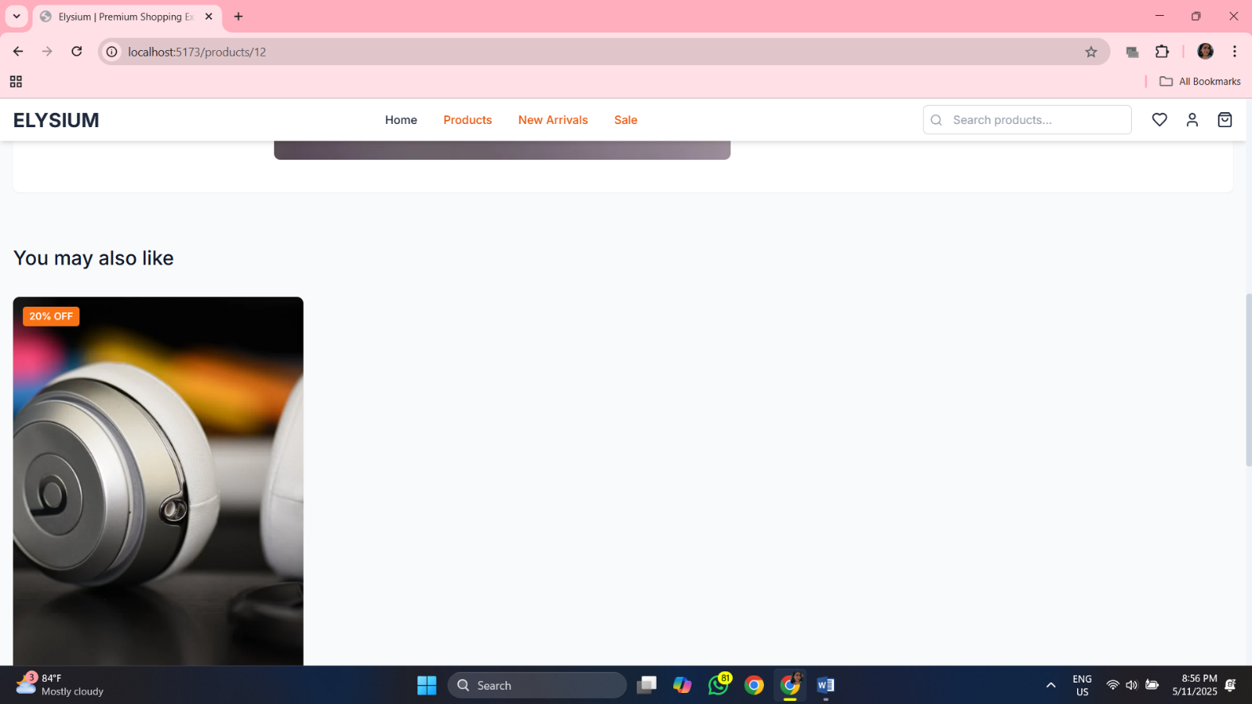

**Src>components>pages>products.tsx:**

*import* React, { useState, useEffect } *from* 'react';

*import* { useSearchParams } *from* 'react-router-dom';

*import* { Filter, SlidersHorizontal, Search, X } *from* 'lucide-react';

*import* ProductCard *from* '../components/ui/ProductCard';

*import* Button *from* '../components/ui/Button';

*import* { mockProducts } *from* '../data/mockData';

*import* { Product } *from* '../types/product';

const *Products*: *React.FC* =()=>{

const[*searchParams*]= *useSearchParams*();

const[*products*, *setProducts*]= *useState*<*Product*[]>([]);

const[*filteredProducts*, *setFilteredProducts*]= *useState*<*Product*[]>([]);

const[*isFiltersOpen*, *setIsFiltersOpen*]= *useState*(*false*);

*// Filters*

const[*selectedCategories*, *setSelectedCategories*]= *useState*<*string*[]>([]);

const[*priceRange*, *setPriceRange*]= *useState*<[*number*, *number*]>([0,1000]);

const[*sortBy*, *setSortBy*]= *useState*<*string*>('newest');

const[*searchTerm*, *setSearchTerm*]= *useState*<*string*>('');

*// Get categories from products*

const *allCategories* =[...new *Set*(*mockProducts.map*(*product* => *product.category*))];

*// Initialize from URL params*

*useEffect*(()=>{

const *category* = *searchParams.get*('category');

const *tag* = *searchParams.get*('tag');

const *search* = *searchParams.get*('search');

*if* (*category*){

*setSelectedCategories*([*category*]);

}

*if* (*search*){

*setSearchTerm*(*search*);

}

*// Load products*

let *initialProducts* =[...*mockProducts*];

*if* (*tag* ==='new'){

*initialProducts* = *initialProducts.filter*(*p* => *p.tags.includes*('new'));

} *else if* (*tag* ==='sale'){

*initialProducts* = *initialProducts.filter*(*p* => *p.compareAtPrice* !== *null*);

}

*setProducts*(*initialProducts*);

},[*searchParams*]);

*// Apply filters*

*useEffect*(()=>{

let *filtered* =[...*products*];

*// Filter by category*

*if* (*selectedCategories.length* >0){

*filtered* = *filtered.filter*(*p* =>

*selectedCategories.includes*(*p.category*)

);

}

*// Filter by price*

*filtered* = *filtered.filter*(*p* =>

*p.price* >= *priceRange*[0]&& *p.price* <= *priceRange*[1]

);

*// Filter by search term*

*if* (*searchTerm*){

const *term* = *searchTerm.toLowerCase*();

*filtered* = *filtered.filter*(*p* =>

*p.title.toLowerCase*()*.includes*(*term*)||

*p.description.toLowerCase*()*.includes*(*term*)

);

}

*// Sort products*

*if* (*sortBy* ==='newest'){

*filtered.sort*((*a*, *b*)=> *b.id* - *a.id*);

} *else if* (*sortBy* ==='price-low'){

*filtered.sort*((*a*, *b*)=> *a.price* - *b.price*);

} *else if* (*sortBy* ==='price-high'){

*filtered.sort*((*a*, *b*)=> *b.price* - *a.price*);

}

*setFilteredProducts*(*filtered*);

},[*products*, *selectedCategories*, *priceRange*, *sortBy*, *searchTerm*]);

const *toggleCategory* =(*category*: *string*)=>{

*if* (*selectedCategories.includes*(*category*)){

*setSelectedCategories*(*selectedCategories.filter*(*c* => *c* !== *category*));

} *else* {

*setSelectedCategories*([...*selectedCategories*, *category*]);

}

};

const *handlePriceChange* =(*min*: *number*, *max*: *number*)=>{

*setPriceRange*([*min*, *max*]);

};

const *clearFilters* =()=>{

*setSelectedCategories*([]);

*setPriceRange*([0,1000]);

*setSortBy*('newest');

*setSearchTerm*('');

};

const *handleSearchSubmit* =(*e*: *React.FormEvent*)=>{

*e.preventDefault*();

*// Search logic is already handled in the useEffect*

};

*return* (

<div *className*="bg-gray-50 min-h-screen animate-fade-in">

      <div *className*="container mx-auto px-4 py-8">

        {*/* Page Header */*}

        <div *className*="mb-8">

          <h1 *className*="text-3xl md:text-4xl font-medium text-primary-900 mb-2">

            {searchTerm ? `Search: ${searchTerm}` : 'All Products'}

          </h1>

          <p *className*="text-gray-600">

            {filteredProducts*.*length} products found

          </p>

        </div>

        {*/* Mobile Filter Button */*}

        <div *className*="lg:hidden mb-6">

          <Button

*onClick*={() => *setIsFiltersOpen*(true)}

*variant*="secondary"

*leftIcon*={<Filter *className*="h-4 w-4" />}

          >

            Filters

          </Button>

        </div>

        <div *className*="flex flex-col lg:flex-row gap-8">

          {*/* Filters Sidebar - Desktop */*}

          <div *className*="hidden lg:block w-64 flex-shrink-0">

            <div *className*="bg-white rounded-lg shadow-sm p-6 sticky top-24">

              <div *className*="flex justify-between items-center mb-6">

                <h3 *className*="font-medium text-lg text-primary-800">Filters</h3>

                <button

*onClick*={clearFilters}

*className*="text-sm text-accent-600 hover:text-accent-700"

                >

                  Clear all

                </button>

              </div>

              {*/* Search */*}

              <div *className*="mb-6">

                <h4 *className*="font-medium text-sm text-primary-800 mb-3">Search</h4>

                <form *onSubmit*={handleSearchSubmit} *className*="relative">

                  <input

*type*="text"

*placeholder*="Search products..."

*className*="input w-full pl-9 text-sm"

*value*={searchTerm}

*onChange*={(e) => *setSearchTerm*(e*.target.*value)}

                  />

                  <Search *className*="absolute left-3 top-1/2 transform -translate-y-1/2 h-4 w-4 text-gray-400" />

                </form>

              </div>

              {*/* Categories */*}

              <div *className*="mb-6">

                <h4 *className*="font-medium text-sm text-primary-800 mb-3">Categories</h4>

                <div *className*="space-y-2">

                  {allCategories*.map*((category) => (

                    <label *key*={category} *className*="flex items-center">

                      <input

*type*="checkbox"

*checked*={selectedCategories*.includes*(category)}

*onChange*={() => *toggleCategory*(category)}

*className*="rounded text-accent-500 mr-2"

                      />

                      <span *className*="text-gray-700">{category}</span>

                    </label>

                  ))}

                </div>

              </div>

              {*/* Price Range */*}

              <div *className*="mb-6">

                <h4 *className*="font-medium text-sm text-primary-800 mb-3">Price Range</h4>

                <div *className*="space-y-4">

                  <div *className*="flex justify-between">

                    <span *className*="text-sm text-gray-600">${priceRange[0]}</span>

                    <span *className*="text-sm text-gray-600">${priceRange[1]}</span>

                  </div>

                  <input

*type*="range"

*min*="0"

*max*="1000"

*step*="10"

*value*={priceRange[1]}

*onChange*={(e) => *handlePriceChange*(priceRange[0], *Number*(e*.target.*value))}

*className*="w-full"

                  />

                </div>

              </div>

              {*/* Sort By */*}

              <div>

                <h4 *className*="font-medium text-sm text-primary-800 mb-3">Sort By</h4>

                <select

*value*={sortBy}

*onChange*={(e) => *setSortBy*(e*.target.*value)}

*className*="input w-full text-sm"

                >

                  <option *value*="newest">Newest</option>

                  <option *value*="price-low">Price: Low to High</option>

                  <option *value*="price-high">Price: High to Low</option>

                </select>

              </div>

            </div>

          </div>

          {*/* Mobile Filters Sidebar */*}

          {isFiltersOpen && (

            <div *className*="lg:hidden fixed inset-0 z-50 bg-white overflow-auto animate-slide-up">

              <div *className*="p-4 border-b">

                <div *className*="flex justify-between items-center">

                  <h3 *className*="font-medium text-lg text-primary-800">Filters</h3>

                  <button *onClick*={() => *setIsFiltersOpen*(false)}>

                    <X *className*="h-6 w-6 text-gray-500" />

                  </button>

                </div>

              </div>

              <div *className*="p-6">

                {*/* Search */*}

                <div *className*="mb-8">

                  <h4 *className*="font-medium text-sm text-primary-800 mb-3">Search</h4>

                  <form *onSubmit*={handleSearchSubmit} *className*="relative">

                    <input

*type*="text"

*placeholder*="Search products..."

*className*="input w-full pl-9 text-sm"

*value*={searchTerm}

*onChange*={(e) => *setSearchTerm*(e*.target.*value)}

                    />

                    <Search *className*="absolute left-3 top-1/2 transform -translate-y-1/2 h-4 w-4 text-gray-400" />

                  </form>

                </div>

                {*/* Categories */*}

                <div *className*="mb-8">

                  <h4 *className*="font-medium text-sm text-primary-800 mb-3">Categories</h4>

                  <div *className*="space-y-2">

                    {allCategories*.map*((category) => (

                      <label *key*={category} *className*="flex items-center">

                        <input

*type*="checkbox"

*checked*={selectedCategories*.includes*(category)}

*onChange*={() => *toggleCategory*(category)}

*className*="rounded text-accent-500 mr-2"

                        />

                        <span *className*="text-gray-700">{category}</span>

                      </label>

                    ))}

                  </div>

                </div>

                {*/* Price Range */*}

                <div *className*="mb-8">

                  <h4 *className*="font-medium text-sm text-primary-800 mb-3">Price Range</h4>

                  <div *className*="space-y-4">

                    <div *className*="flex justify-between">

                      <span *className*="text-sm text-gray-600">${priceRange[0]}</span>

                      <span *className*="text-sm text-gray-600">${priceRange[1]}</span>

                    </div>

                    <input

*type*="range"

*min*="0"

*max*="1000"

*step*="10"

*value*={priceRange[1]}

*onChange*={(e) => *handlePriceChange*(priceRange[0], *Number*(e*.target.*value))}

*className*="w-full"

                    />

                  </div>

                </div>

                {*/* Sort By */*}

                <div *className*="mb-8">

                  <h4 *className*="font-medium text-sm text-primary-800 mb-3">Sort By</h4>

                  <select

*value*={sortBy}

*onChange*={(e) => *setSortBy*(e*.target.*value)}

*className*="input w-full text-sm"

                  >

                    <option *value*="newest">Newest</option>

                    <option *value*="price-low">Price: Low to High</option>

                    <option *value*="price-high">Price: High to Low</option>

                  </select>

                </div>

                <div *className*="flex gap-4">

                  <Button

*variant*="accent"

*fullWidth*

*onClick*={() => *setIsFiltersOpen*(false)}

                  >

                    Apply Filters

                  </Button>

                  <Button

*variant*="secondary"

*fullWidth*

*onClick*={() => {

*clearFilters*();

*setIsFiltersOpen*(false);

                    }}

                  >

                    Clear All

                  </Button>

                </div>

              </div>

            </div>

          )}

          {*/* Products Grid */*}

          <div *className*="flex-grow">

            {*/* Sort By - Mobile View */*}

            <div *className*="flex justify-between items-center mb-6 lg:hidden">

              <div *className*="flex items-center">

                <SlidersHorizontal *className*="h-4 w-4 text-gray-600 mr-2" />

                <span *className*="text-sm text-gray-600">Sort by:</span>

              </div>

              <select

*value*={sortBy}

*onChange*={(e) => *setSortBy*(e*.target.*value)}

*className*="border-none bg-transparent text-sm font-medium text-primary-800"

              >

                <option *value*="newest">Newest</option>

                <option *value*="price-low">Price: Low to High</option>

                <option *value*="price-high">Price: High to Low</option>

              </select>

            </div>

            {*/* Active Filters */*}

            {(selectedCategories*.*length > 0 || searchTerm) && (

              <div *className*="flex flex-wrap gap-2 mb-6">

                {selectedCategories*.map*((category) => (

                  <div *key*={category} *className*="flex items-center bg-gray-100 rounded-full px-3 py-1">

                    <span *className*="text-sm text-gray-700 mr-1">{category}</span>

                    <button *onClick*={() => *toggleCategory*(category)}>

                      <X *className*="h-3.5 w-3.5 text-gray-500" />

                    </button>

                  </div>

                ))}

                {searchTerm && (

                  <div *className*="flex items-center bg-gray-100 rounded-full px-3 py-1">

                    <span *className*="text-sm text-gray-700 mr-1">"{searchTerm}"</span>

                    <button *onClick*={() => *setSearchTerm*('')}>

                      <X *className*="h-3.5 w-3.5 text-gray-500" />

                    </button>

                  </div>

                )}

                <button

*onClick*={clearFilters}

*className*="text-sm text-accent-600 hover:text-accent-700 ml-2"

                >

                  Clear all

                </button>

              </div>

            )}

            {filteredProducts*.*length > 0 ? (

              <div *className*="grid grid-cols-1 sm:grid-cols-2 lg:grid-cols-3 xl:grid-cols-4 gap-6">

                {filteredProducts*.map*((product) => (

                  <ProductCard *key*={product*.*id} *product*={product} />

                ))}

              </div>

            ) : (

              <div *className*="text-center py-12">

                <p *className*="text-gray-500 mb-4">No products found matching your criteria.</p>

                <Button *variant*="accent" *onClick*={clearFilters}>

                  Clear Filters

                </Button>

              </div>

            )}

          </div>

        </div>

      </div>

    </div>

);

};

*export* *default* Products;

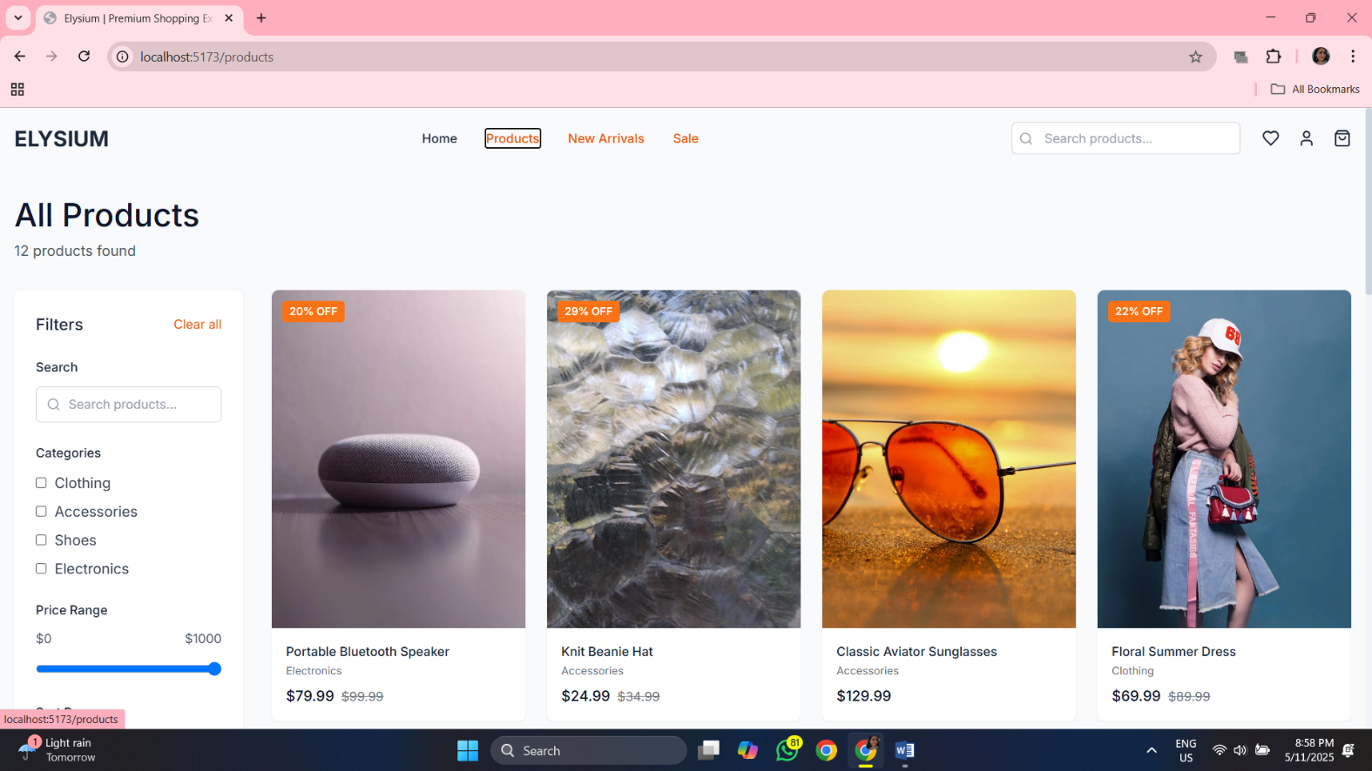

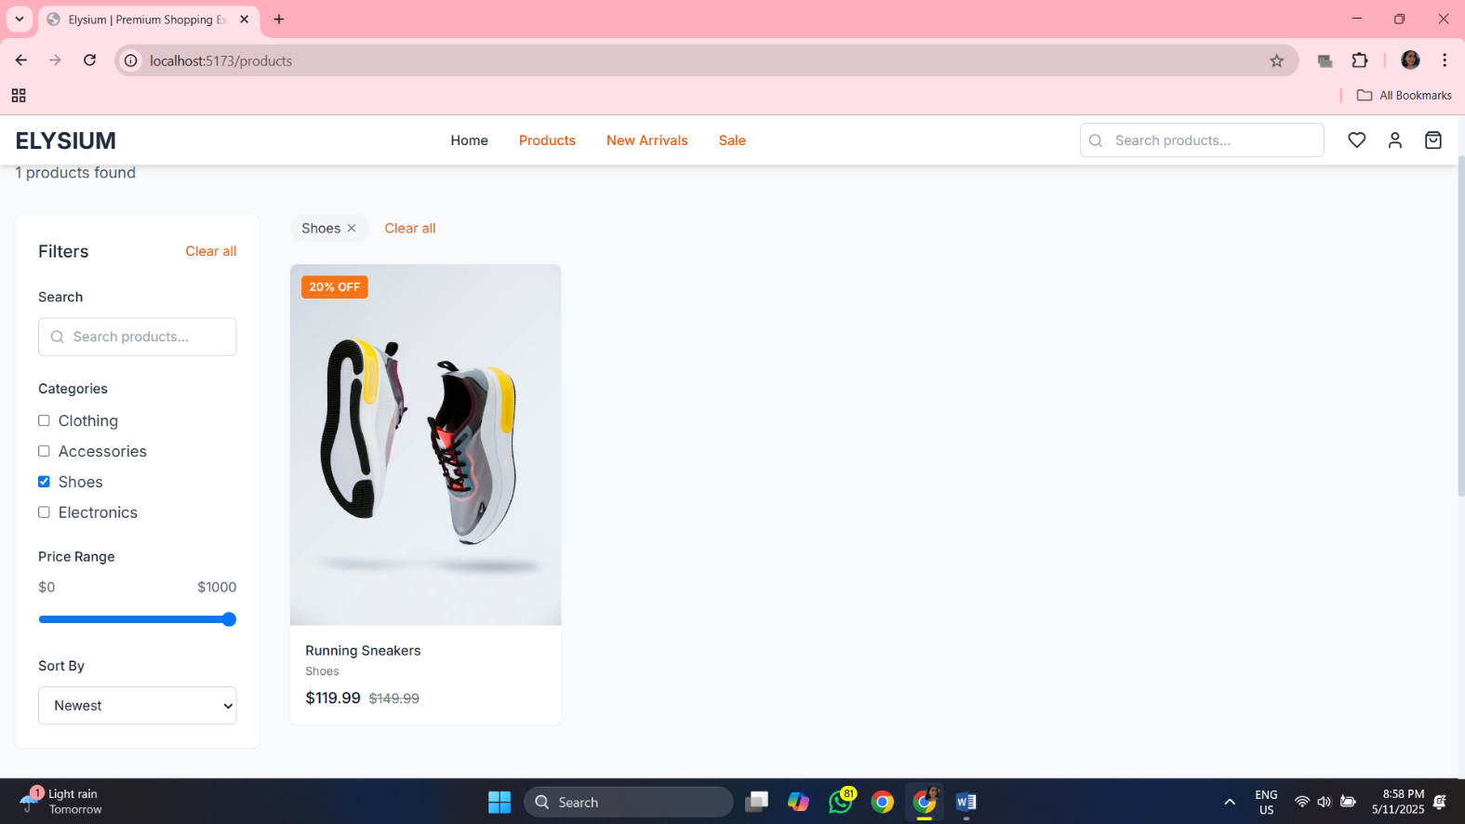

**Src>components>pages>whishlist.tsx:**

*import* React *from* 'react';

*import* { Link } *from* 'react-router-dom';

*import* { Heart, Trash2, ShoppingBag } *from* 'lucide-react';

*import* Button *from* '../components/ui/Button';

*import* { useToast } *from* '../components/ui/Toast';

*import* { mockProducts } *from* '../data/mockData';

const *Wishlist*: *React.FC* =()=>{

const{ *showToast* }= *useToast*();

*// Mock wishlist data (first 3 products)*

const *wishlistItems* = *mockProducts.slice*(0,3);

const *handleRemoveFromWishlist* =(*productId*: *number*)=>{

*showToast*('Product removed from wishlist','info');

};

const *handleMoveToCart* =(*productId*: *number*)=>{

*showToast*('Product added to cart','success');

};

*if* (*wishlistItems.length* ===0){

*return* (

<div *className*="min-h-screen bg-gray-50 py-16 animate-fade-in">

        <div *className*="container mx-auto px-4 text-center">

          <div *className*="max-w-md mx-auto">

            <div *className*="flex justify-center mb-6">

              <Heart *className*="h-16 w-16 text-gray-400" />

            </div>

            <h1 *className*="text-3xl font-medium text-primary-900 mb-4">Your wishlist is empty</h1>

            <p *className*="text-gray-600 mb-8">

              Items added to your wishlist will be saved here for you to view later.

            </p>

            <Button

*variant*="accent"

*size*="lg"

*as*={Link}

*to*="/products"

            >

              Explore Products

            </Button>

          </div>

        </div>

      </div>

);

}

*return* (

<div *className*="min-h-screen bg-gray-50 py-8 animate-fade-in">

      <div *className*="container mx-auto px-4">

        <h1 *className*="text-3xl font-medium text-primary-900 mb-8">My Wishlist</h1>

        <div *className*="bg-white rounded-lg shadow-sm overflow-hidden mb-8">

          <div *className*="p-6">

            <div *className*="hidden md:grid md:grid-cols-12 text-sm font-medium text-gray-500 mb-4">

              <div *className*="md:col-span-6">Product</div>

              <div *className*="md:col-span-2 text-center">Price</div>

              <div *className*="md:col-span-4 text-right">Actions</div>

            </div>

            <div *className*="divide-y divide-gray-200">

              {wishlistItems*.map*((product) => (

                <div *key*={product*.*id} *className*="py-6 first:pt-0 last:pb-0">

                  <div *className*="flex flex-col md:grid md:grid-cols-12 md:gap-6">

                    {*/* Product */*}

                    <div *className*="md:col-span-6 flex">

                      <div *className*="h-20 w-16 flex-shrink-0 overflow-hidden rounded-md border border-gray-200">

                        <img

*src*={product*.*images[0]}

*alt*={product*.*title}

*className*="h-full w-full object-cover object-center"

                        />

                      </div>

                      <div *className*="ml-4 flex flex-col">

                        <h3 *className*="text-base font-medium text-primary-800">

                          <Link *to*={`/products/${product*.*id}`}>

                            {product*.*title}

                          </Link>

                        </h3>

                        <p *className*="text-sm text-gray-500">{product*.*category}</p>

                        {*/* Mobile Price */*}

                        <div *className*="md:hidden mt-2">

                          <span *className*="font-medium text-primary-800">

                            ${product*.price.toFixed*(2)}

                          </span>

                          {product*.*compareAtPrice && (

                            <span *className*="ml-2 text-sm text-gray-500 line-through">

                              ${product*.compareAtPrice.toFixed*(2)}

                            </span>

                          )}

                        </div>

                        {*/* Mobile Actions */*}

                        <div *className*="md:hidden flex mt-4 space-x-2">

                          <Button

*variant*="secondary"

*size*="sm"

*onClick*={() => *handleMoveToCart*(product*.*id)}

*leftIcon*={<ShoppingBag *className*="h-4 w-4" />}

                          >

                            Add to Cart

                          </Button>

                          <button

*onClick*={() => *handleRemoveFromWishlist*(product*.*id)}

*className*="p-2 text-gray-400 hover:text-accent-500 border border-gray-200 rounded-md"

                          >

                            <Trash2 *className*="h-4 w-4" />

                          </button>

                        </div>

                      </div>

                    </div>

                    {*/* Desktop Price */*}

                    <div *className*="hidden md:flex md:col-span-2 items-center justify-center">

                      <div>

                        <span *className*="font-medium text-primary-800">

                          ${product*.price.toFixed*(2)}

                        </span>

                        {product*.*compareAtPrice && (

                          <span *className*="block text-sm text-gray-500 line-through">

                            ${product*.compareAtPrice.toFixed*(2)}

                          </span>

                        )}

                      </div>

                    </div>

                    {*/* Desktop Actions */*}

                    <div *className*="hidden md:flex md:col-span-4 items-center justify-end space-x-4">

                      <Button

*variant*="accent"

*size*="sm"

*onClick*={() => *handleMoveToCart*(product*.*id)}

*leftIcon*={<ShoppingBag *className*="h-4 w-4" />}

                      >

                        Add to Cart

                      </Button>

                      <button

*onClick*={() => *handleRemoveFromWishlist*(product*.*id)}

*className*="text-gray-400 hover:text-accent-500"

*title*="Remove from wishlist"

                      >

                        <Trash2 *className*="h-5 w-5" />

                      </button>

                    </div>

                  </div>

                </div>

              ))}

            </div>

          </div>

        </div>

        <div *className*="flex justify-between">

          <Link

*to*="/products"

*className*="text-primary-700 hover:text-primary-800"

          >

            Continue Shopping

          </Link>

          <Button

*variant*="secondary"

*onClick*={() => {

*// Add all to cart*

*showToast*('All items added to cart', 'success');

            }}

          >

            Add All to Cart

          </Button>

        </div>

      </div>

    </div>

);

};

*export* *default* Wishlist;

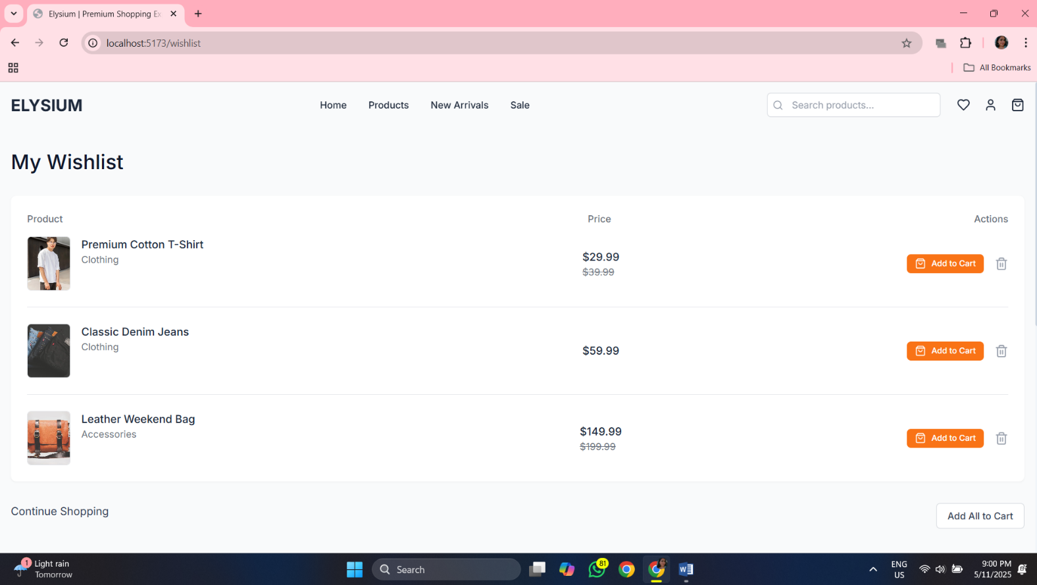

**Src>components>types>product.tsx:**

*export* interface Product {

  id: number;

  title: string;

  description: string;

  price: number;

  compareAtPrice: number | null;

  images: string[];

  category: string;

  tags: string[];

  sizes: string[];

  rating: number;

  reviewCount: number;

}

**App.tsx:**

*import* React *from* 'react';

*import* { Routes, Route } *from* 'react-router-dom';

*import* { ToastProvider } *from* './components/ui/Toast';

*import* Layout *from* './components/layout/Layout';

*import* Home *from* './pages/Home';

*import* Products *from* './pages/Products';

*import* ProductDetail *from* './pages/ProductDetail';

*import* Cart *from* './pages/Cart';

*import* Checkout *from* './pages/Checkout';

*import* NotFound *from* './pages/NotFound';

*import* Account *from* './pages/Account';

*import* Wishlist *from* './pages/Wishlist';

function *App*() {

*return* (

    <ToastProvider>

      <Routes>

        <Route *path*="/" *element*={<Layout />}>

          <Route *index* *element*={<Home />} />

          <Route *path*="products" *element*={<Products />} />

          <Route *path*="products/:id" *element*={<ProductDetail />} />

          <Route *path*="cart" *element*={<Cart />} />

          <Route *path*="checkout" *element*={<Checkout />} />

          <Route *path*="account" *element*={<Account />} />

          <Route *path*="wishlist" *element*={<Wishlist />} />

          <Route *path*="*" *element*={<NotFound />} />

        </Route>

      </Routes>

    </ToastProvider>

  );

}

*export* *default* App;

**index.css:**

@*tailwind* base;

@*tailwind* components;

@*tailwind* utilities;

@*layer* base {

  html {

    font-family: Inter, system-ui, sans-serif;

    -webkit-font-smoothing: antialiased;

    -moz-osx-font-smoothing: grayscale;

  }

  body {

    @apply bg-gray-50 text-gray-900;

  }

  h1,h2,h3,h4,h5,h6 {

    @apply font-medium leading-tight;

  }

  h1 {

    @apply text-4xl md:text-5xl;

  }

  h2 {

    @apply text-3xl md:text-4xl;

  }

  h3 {

    @apply text-2xl md:text-3xl;

  }

  h4 {

    @apply text-xl md:text-2xl;

  }

}

@*layer* components {

  .*btn* {

    @apply inline-flex items-center justify-center rounded-md font-medium transition-colors focus-visible:outline-none focus-visible:ring-2 focus-visible:ring-offset-2 disabled:pointer-events-none disabled:opacity-50;

  }

  .*btn-primary* {

    @apply btn bg-primary-700 text-white hover:bg-primary-800 focus-visible:ring-primary-500;

  }

  .*btn-secondary* {

    @apply btn bg-white text-primary-700 border border-gray-300 hover:bg-gray-50 focus-visible:ring-primary-500;

  }

  .*btn-accent* {

    @apply btn bg-accent-500 text-white hover:bg-accent-600 focus-visible:ring-accent-500;

  }

  .*card* {

    @apply bg-white rounded-lg shadow-sm overflow-hidden transition-all duration-200 hover:shadow-md;

  }

  .*input* {

    @apply h-10 rounded-md border border-gray-300 px-3 py-2 text-sm

           focus:outline-none focus:ring-2 focus:ring-primary-500 focus:border-transparent

           disabled:opacity-50 disabled:bg-gray-100;

  }

}

*/* Add a smooth page transition */*

.*page-transition-enter* {

  opacity: 0;

  transform: translateY(10px);

}

.*page-transition-enter-active* {

  opacity: 1;

  transform: translateY(0);

  transition: opacity 300ms, transform 300ms;

}

.*page-transition-exit* {

  opacity: 1;

}

.*page-transition-exit-active* {

  opacity: 0;

  transition: opacity 300ms;

}

*/* Add custom scrollbar */*

::*-webkit-scrollbar* {

  width: 8px;

  height: 8px;

}

::*-webkit-scrollbar-track* {

  background: #f1f5f9;

}

::*-webkit-scrollbar-thumb* {

  background-color: #cbd5e1;

  border-radius: 4px;

}

::*-webkit-scrollbar-thumb*:*hover* {

  background-color: #94a3b8;

}

**Main.tsx:**

*import* { StrictMode } *from* 'react';

*import* { createRoot } *from* 'react-dom/client';

*import* { BrowserRouter } *from* 'react-router-dom';

*import* App *from* './App';

*import* './index.css';

*import* { CartProvider } *from* './contexts/CartContext';

*createRoot*(document*.getElementById*('root')!)*.render*(

  <StrictMode>

    <BrowserRouter>

      <CartProvider>

        <App />

      </CartProvider>

    </BrowserRouter>

  </StrictMode>

);

**Src>components>ui>button.tsx:**

**Src>components>ui>button.tsx:**

**Src>components>ui>button.tsx:**

## **Conclusion:**

This project demonstrates the power and flexibility of **ReactJS** in building a responsive and modular **e-commerce website**. By utilizing **React Router**, the site delivers a seamless navigation experience across multiple pages. The modular design ensures maintainability and scalability, while dynamic rendering enhances interactivity. The skills gained from this project include component structuring, state management, routing, and form handling, laying a strong foundation for full-stack web development.

## **Experiment No.2**

**Project Title: React Native Book Reviewing Application**

## **Problem Statement:**

## With the rise in mobile users and the popularity of reading on digital platforms, there is a growing demand for book reviewing and recommendation systems. Most book review applications are either cluttered or lack features like real-time interaction and user-friendly interfaces. This project aims to solve the problem by building a clean, responsive, and interactive mobile app where users can browse, review, and rate books seamlessly.

## **Objective:**

## The goal is to build a mobile-based **Book Reviewing Application** using **React Native** that includes core app functionalities such as navigation, dynamic rendering, user input handling, state management, and modular design. The app will include pages like Home, Book List (Product/Menu), Cart, About Us, Contact Us, Registration, and Login.

## **Theory:** React Native is an open-source framework developed by Facebook that allows developers to build mobile applications using JavaScript and React. It enables cross-platform development (iOS and Android) with near-native performance. The application leverages:

## Core React Native Components like View, Text, Button, TextInput, ScrollView, etc.

## Navigation using libraries like react-navigation.

## State management using React's useState and useEffect hooks.

## List rendering using FlatList.

## Form handling for login and registration.

## Styling with StyleSheet.

## Each screen (component) represents a logical part of the app’s UI and behavior.

## **Code**

**App.js:**

*import* React, { Component } *from* 'react';

*import* logo *from* './logo.svg';

*import* './App.css';

class App *extends* Component {

    state = { loading: false };

*componentDidMount*() {

*// 测试 devServer 的代理功能*

*// fetch('/api/category')*

*//     .then(resp => resp.json())*

*//     .then(res => console.log('here here', res));*

    }

*render*() {

*return* (

            <div *className*="App">

                <div *className*="App-header">

                    <img *src*={logo} *className*="App-logo" *alt*="logo" />

                    <h2>Welcome to React</h2>

                </div>

                <p>{ *this.state.loading.toString*() }</p>

                <p *className*="App-intro">

          To get started, edit <code>src/App.js</code> and save to reload.

        </p>

            </div>

        );

    }

}

*export* *default* App;

**App.css:**

.*App* {

  text-align: center;

}

.*App-logo* {

  animation: App-logo-spin infinite 20s linear;

  height: 80px;

}

.*App-header* {

  background-color: #222;

  height: 150px;

  padding: 20px;

  color: white;

}

.*App-intro* {

  font-size: large;

}

@*keyframes* App-logo-spin {

  from { transform: rotate(0deg); }

  to { transform: rotate(360deg); }

}

**Index.js:**

import React from 'react';

import ReactDOM from 'react-dom';

import App from './App';

import './index.css';

ReactDOM.render(

    <App />,

    document.getElementById('root'),

);

**Index.css:**

body {

  margin: 0;

  padding: 0px;

  font-family: sans-serif;

}

**App.test.js:**

*import* React *from* 'react';

*import* ReactDOM *from* 'react-dom';

*import* App *from* './App';

*it*('renders without crashing', () => {

    const *div* = *document.createElement*('div');

*ReactDOM.render*(<App />, div);

});

**Tabs> _layout.tsk:**

*import* { Tabs } *from* 'expo-router';

*import* { Chrome *as* Home, Search, BookOpen, User } *from* 'lucide-react-native';

*export* *default* function *TabLayout*() {

*return* (

    <Tabs

*screenOptions*={{

        tabBarActiveTintColor: '#800020',

        tabBarInactiveTintColor: '#6B7280',

        tabBarStyle: {

          backgroundColor: '#FFFFFF',

          borderTopColor: '#E5E7EB',

          elevation: 0,

          shadowOpacity: 0,

        },

        headerShown: false,

      }}>

      <Tabs.Screen

*name*="index"

*options*={{

          title: 'Home',

*tabBarIcon*: ({ color, size }) => (

            <Home *size*={size} *color*={color} />

          ),

        }}

      />

      <Tabs.Screen

*name*="search"

*options*={{

          title: 'Search',

*tabBarIcon*: ({ color, size }) => (

            <Search *size*={size} *color*={color} />

          ),

        }}

      />

      <Tabs.Screen

*name*="my-books"

*options*={{

          title: 'My Books',

*tabBarIcon*: ({ color, size }) => (

            <BookOpen *size*={size} *color*={color} />

          ),

        }}

      />

      <Tabs.Screen

*name*="profile"

*options*={{

          title: 'Profile',

*tabBarIcon*: ({ color, size }) => (

            <User *size*={size} *color*={color} />

          ),

        }}

      />

    </Tabs>

  );

}

**Index.tsk**:

*import* { useState, useEffect } *from* 'react';

*import* { View, Text, StyleSheet, ScrollView, ActivityIndicator } *from* 'react-native';

*import* { SafeAreaView } *from* 'react-native-safe-area-context';

*import* { books } *from* '@/data/books';

*import* BookList *from* '@/components/BookList';

*import* { Book } *from* '@/types';

*export* *default* function *HomeScreen*() {

  const[*isLoading*, *setIsLoading*]= *useState*(*true*);

  const[*featuredBooks*, *setFeaturedBooks*]= *useState*<*Book*[]>([]);

  const[*newReleases*, *setNewReleases*]= *useState*<*Book*[]>([]);

  const[*popularBooks*, *setPopularBooks*]= *useState*<*Book*[]>([]);

*useEffect*(() => {

*// Simulate API fetch delay*

    const *timer* = *setTimeout*(()=>{

*// Filter books for different sections*

*setFeaturedBooks*(*books.slice*(0,4));

*setNewReleases*(*books.slice*(4,8));

*setPopularBooks*(*books.filter*(*book* => *book.avgRating* >=4.7));

*setIsLoading*(*false*);

},1000);

*// Cleanup function to prevent state updates after unmount*

*return* () => *clearTimeout*(timer);

  }, []);

*if* (isLoading) {

*return* (

      <View *style*={styles*.*loadingContainer}>

        <ActivityIndicator *size*="large" *color*="#800020" />

      </View>

    );

  }

*return* (

    <SafeAreaView *style*={styles*.*container}>

      <View *style*={styles*.*header}>

        <Text *style*={styles*.*greeting}>Welcome back!</Text>

        <Text *style*={styles*.*title}>Discover your next great read</Text>

      </View>

      <ScrollView

*style*={styles*.*content}

*showsVerticalScrollIndicator*={false}

      >

        <BookList

*title*="Featured Books"

*books*={featuredBooks}

*size*="large"

        />

        <BookList

*title*="New Releases"

*books*={newReleases}

*size*="medium"

        />

        <BookList

*title*="Highly Rated"

*books*={popularBooks}

*size*="medium"

        />

      </ScrollView>

    </SafeAreaView>

  );

}

const *styles* = *StyleSheet.create*({

*container*:{

*flex*:1,

*backgroundColor*:'#F5F5DC', *// Cream background*

},

*loadingContainer*:{

*flex*:1,

*justifyContent*:'center',

*alignItems*:'center',

*backgroundColor*:'#F5F5DC',

},

*header*:{

*paddingHorizontal*:16,

*paddingTop*:16,

*paddingBottom*:8,

},

*greeting*:{

*fontFamily*:'Lato-Regular',

*fontSize*:16,

*color*:'#6B7280',

},

*title*:{

*fontFamily*:'Merriweather-Bold',

*fontSize*:24,

*color*:'#14213D',

*marginTop*:4,

},

*content*:{

*flex*:1,

},

});

**SCREENSHOTS:**

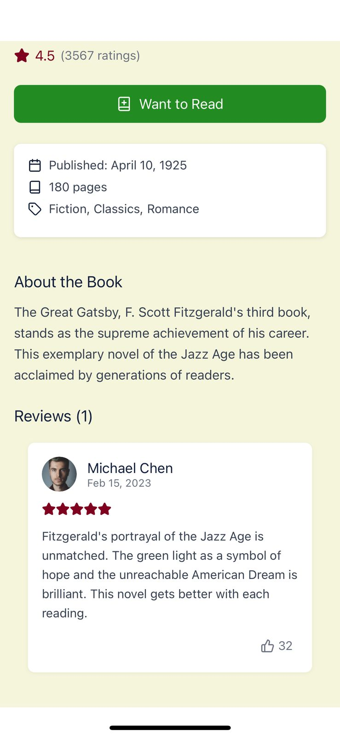

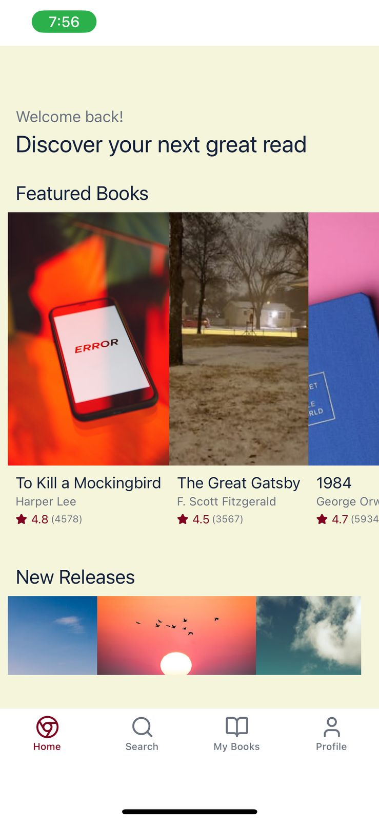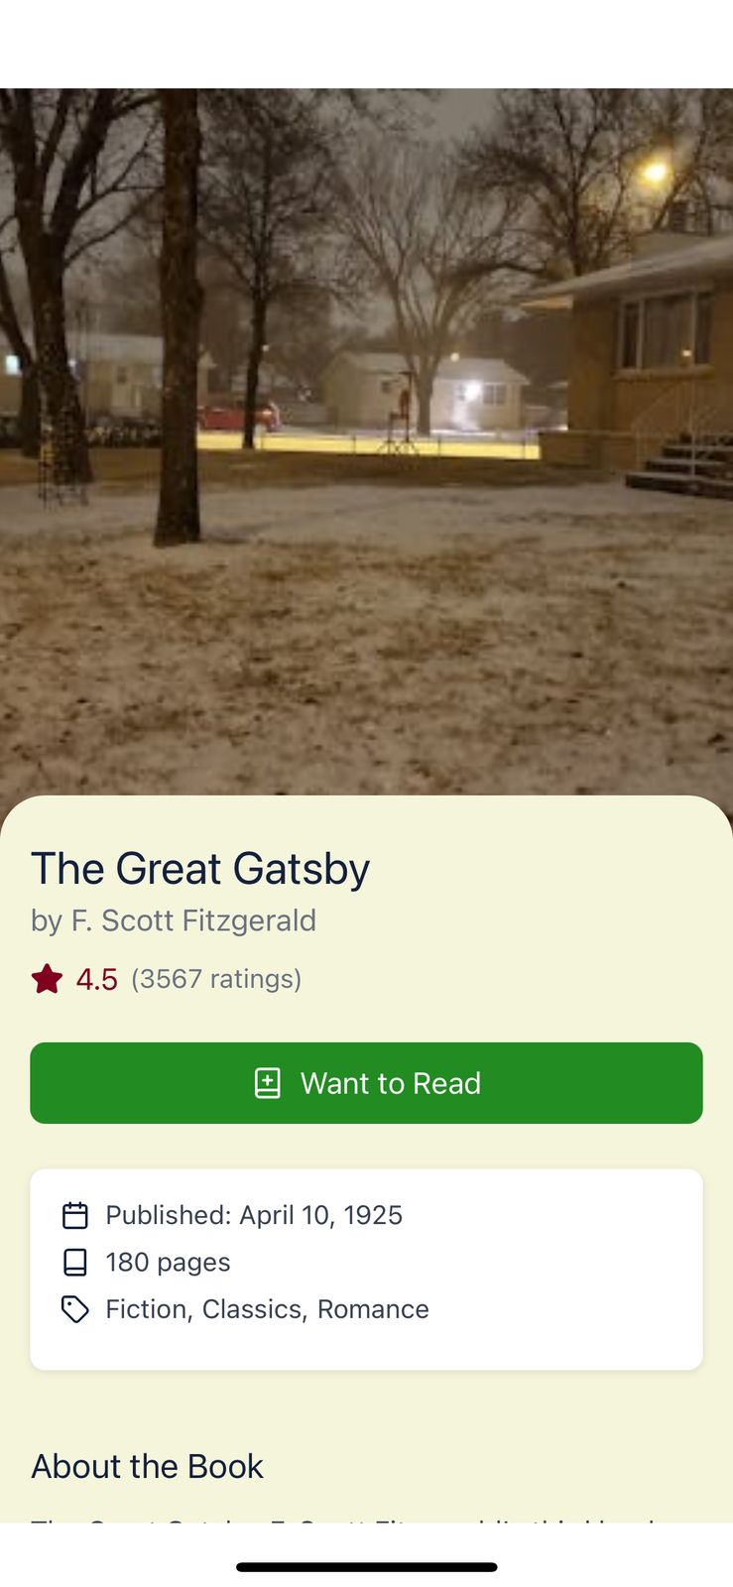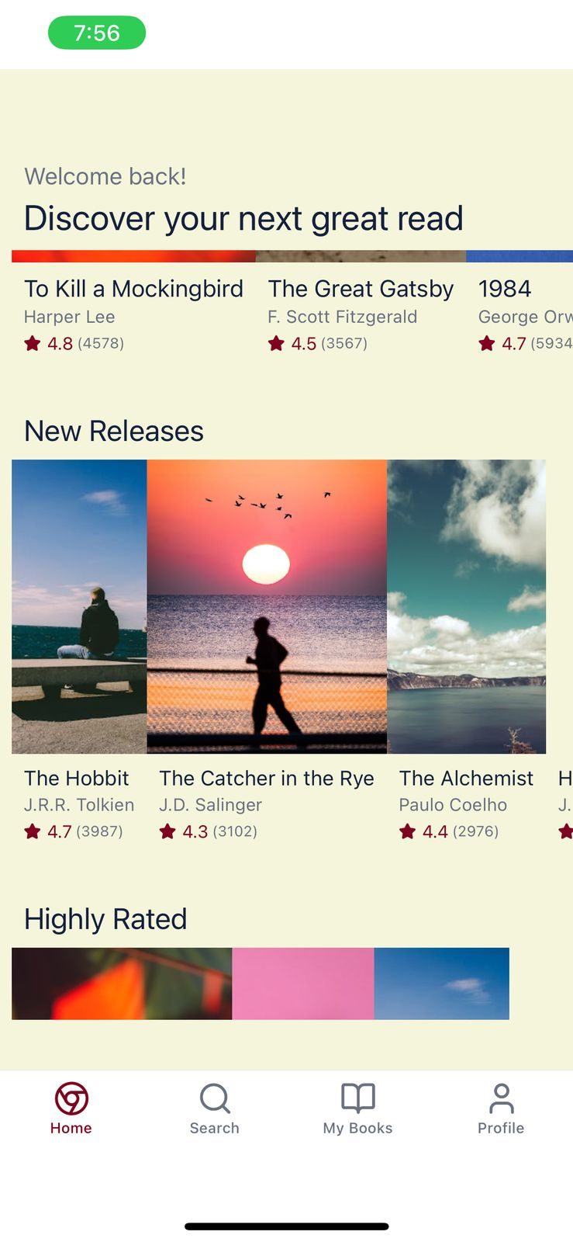

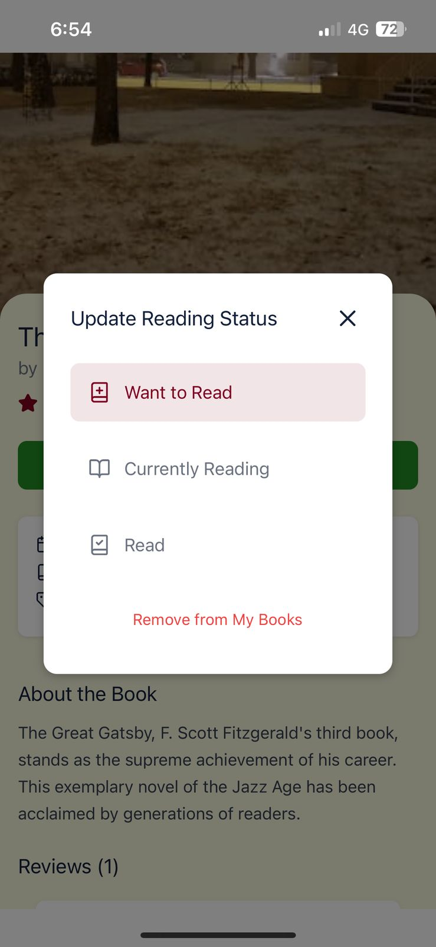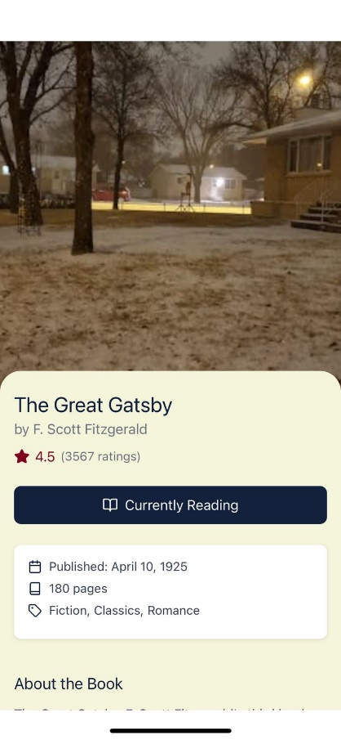



*import* { useState, useEffect } *from* 'react';

**Search.tsx:**

*import* { useState } *from* 'react';

*import* {

  View,

  Text,

  StyleSheet,

  TextInput,

  FlatList,

  TouchableOpacity

} *from* 'react-native';

*import* { SafeAreaView } *from* 'react-native-safe-area-context';

*import* { books } *from* '@/data/books';

*import* { Book } *from* '@/types';

*import* BookCard *from* '@/components/BookCard';

*import* { Search *as* SearchIcon, Tag, Sparkles } *from* 'lucide-react-native';

*export* *default* function *SearchScreen*() {

  const[*searchQuery*, *setSearchQuery*]= *useState*('');

  const[*searchResults*, *setSearchResults*]= *useState*<*Book*[]>([]);

  const[*recentSearches*, *setRecentSearches*]= *useState*<*string*[]>([

'Fantasy','J.K. Rowling','Classics'

]);

  const[*activeGenre*, *setActiveGenre*]= *useState*<*string* | *null*>(*null*);

  const *popularGenres* =[

'Fiction','Fantasy','Romance','Classics','Science Fiction',

'Mystery','Thriller','Biography','History','Self Help'

];

  const *handleSearch* =(*query*: *string*)=>{

*setSearchQuery*(*query*);

*if* (*query.trim*()===''){

*setSearchResults*([]);

*return*;

}

const *results* = *books.filter*(*book* =>

*book.title.toLowerCase*()*.includes*(*query.toLowerCase*())||

*book.author.toLowerCase*()*.includes*(*query.toLowerCase*())||

*book.genre.some*(*g* => *g.toLowerCase*()*.includes*(*query.toLowerCase*()))||

*book.isbn.includes*(*query*)

);

*setSearchResults*(*results*);

};

  const *handleGenreSelect* =(*genre*: *string*)=>{

*setActiveGenre*(*genre*);

const *genreResults* = *books.filter*(*book* =>

*book.genre.some*(*g* => *g.toLowerCase*()=== *genre.toLowerCase*())

);

*setSearchResults*(*genreResults*);

*setSearchQuery*('');

*// Add to recent searches if not already there*

*if* (!*recentSearches.includes*(*genre*)){

*setRecentSearches*(*prev* =>[*genre*,...*prev.slice*(0,4)]);

}

};

  const *handleRecentSearch* =(*query*: *string*)=>{

*handleSearch*(*query*);

*setActiveGenre*(*null*);

};

  const *clearSearch* =()=>{

*setSearchQuery*('');

*setSearchResults*([]);

*setActiveGenre*(*null*);

};

*return* (

    <SafeAreaView *style*={styles*.*container}>

      <View *style*={styles*.*header}>

        <Text *style*={styles*.*title}>Search</Text>

        <View *style*={styles*.*searchContainer}>

          <SearchIcon *size*={18} *color*="#6B7280" *style*={styles*.*searchIcon} />

          <TextInput

*style*={styles*.*searchInput}

*placeholder*="Search by title, author, or ISBN"

*value*={searchQuery}

*onChangeText*={handleSearch}

*clearButtonMode*="while-editing"

          />

        </View>

      </View>

      {searchResults*.*length > 0 ? (

        <FlatList

*data*={searchResults}

*keyExtractor*={(item) => item*.*id}

*renderItem*={({ item }) => (

            <View *style*={styles*.*resultItem}>

              <BookCard *book*={item} *size*="small" />

            </View>

          )}

*numColumns*={3}

*contentContainerStyle*={styles*.*resultsContainer}

*ListHeaderComponent*={

            <View *style*={styles*.*resultsHeader}>

              <Text *style*={styles*.*resultsTitle}>

                {activeGenre

                  ? `${activeGenre} Books (${searchResults*.*length})`

                  : `Results (${searchResults*.*length})`

                }

              </Text>

              {activeGenre && (

                <TouchableOpacity *onPress*={clearSearch}>

                  <Text *style*={styles*.*clearButton}>Clear</Text>

                </TouchableOpacity>

              )}

            </View>

          }

        />

      ) : (

        <View *style*={styles*.*content}>

          {recentSearches*.*length > 0 && (

            <View *style*={styles*.*section}>

              <View *style*={styles*.*sectionHeader}>

                <Sparkles *size*={18} *color*="#800020" />

                <Text *style*={styles*.*sectionTitle}>Recent Searches</Text>

              </View>

              <View *style*={styles*.*chipContainer}>

                {recentSearches*.map*((search, index) => (

                  <TouchableOpacity

*key*={index}

*style*={styles*.*chip}

*onPress*={() => *handleRecentSearch*(search)}

                  >

                    <Text *style*={styles*.*chipText}>{search}</Text>

                  </TouchableOpacity>

                ))}

              </View>

            </View>

          )}

          <View *style*={styles*.*section}>

            <View *style*={styles*.*sectionHeader}>

              <Tag *size*={18} *color*="#800020" />

              <Text *style*={styles*.*sectionTitle}>Popular Genres</Text>

            </View>

            <View *style*={styles*.*chipContainer}>

              {popularGenres*.map*((genre, index) => (

                <TouchableOpacity

*key*={index}

*style*={styles*.*chip}

*onPress*={() => *handleGenreSelect*(genre)}

                >

                  <Text *style*={styles*.*chipText}>{genre}</Text>

                </TouchableOpacity>

              ))}

            </View>

          </View>

        </View>

      )}

    </SafeAreaView>

  );

}

const *styles* = *StyleSheet.create*({

*container*:{

*flex*:1,

*backgroundColor*:'#F5F5DC',

},

*header*:{

*paddingHorizontal*:16,

*paddingTop*:16,

*paddingBottom*:8,

},

*title*:{

*fontFamily*:'Merriweather-Bold',

*fontSize*:28,

*color*:'#14213D',

*marginBottom*:16,

},

*searchContainer*:{

*flexDirection*:'row',

*alignItems*:'center',

*backgroundColor*:'#FFFFFF',

*borderRadius*:8,

*paddingHorizontal*:12,

*shadowColor*:'#000',

*shadowOffset*:{ *width*:0, *height*:1},

*shadowOpacity*:0.1,

*shadowRadius*:2,

*elevation*:1,

},

*searchIcon*:{

*marginRight*:8,

},

*searchInput*:{

*flex*:1,

*fontFamily*:'Lato-Regular',

*fontSize*:16,

*color*:'#374151',

*paddingVertical*:12,

},

*content*:{

*flex*:1,

*padding*:16,

},

*section*:{

*marginBottom*:24,

},

*sectionHeader*:{

*flexDirection*:'row',

*alignItems*:'center',

*marginBottom*:12,

},

*sectionTitle*:{

*fontFamily*:'Merriweather-Bold',

*fontSize*:18,

*color*:'#14213D',

*marginLeft*:8,

},

*chipContainer*:{

*flexDirection*:'row',

*flexWrap*:'wrap',

},

*chip*:{

*backgroundColor*:'#FFFFFF',

*borderRadius*:20,

*paddingVertical*:8,

*paddingHorizontal*:16,

*marginRight*:8,

*marginBottom*:8,

*shadowColor*:'#000',

*shadowOffset*:{ *width*:0, *height*:1},

*shadowOpacity*:0.05,

*shadowRadius*:1,

*elevation*:1,

},

*chipText*:{

*fontFamily*:'Lato-Regular',

*fontSize*:14,

*color*:'#374151',

},

*resultsContainer*:{

*padding*:16,

},

*resultsHeader*:{

*flexDirection*:'row',

*justifyContent*:'space-between',

*alignItems*:'center',

*marginBottom*:16,

},

*resultsTitle*:{

*fontFamily*:'Merriweather-Bold',

*fontSize*:18,

*color*:'#14213D',

},

*clearButton*:{

*fontFamily*:'Lato-Regular',

*fontSize*:14,

*color*:'#800020',

},

*resultItem*:{

*flex*:1/3,

*padding*:4,

},

});

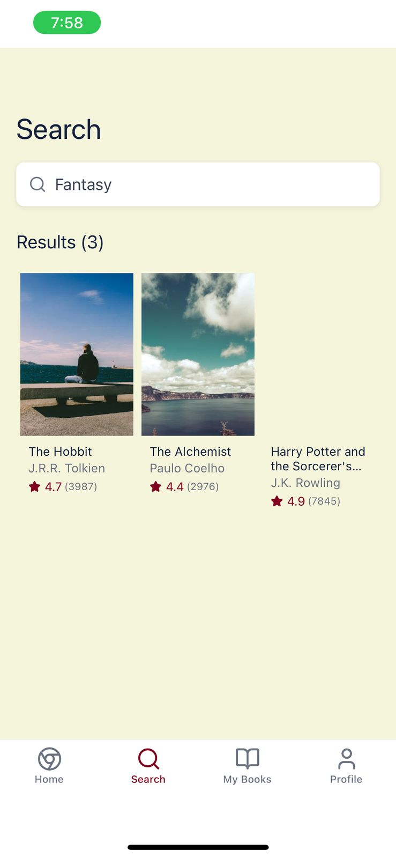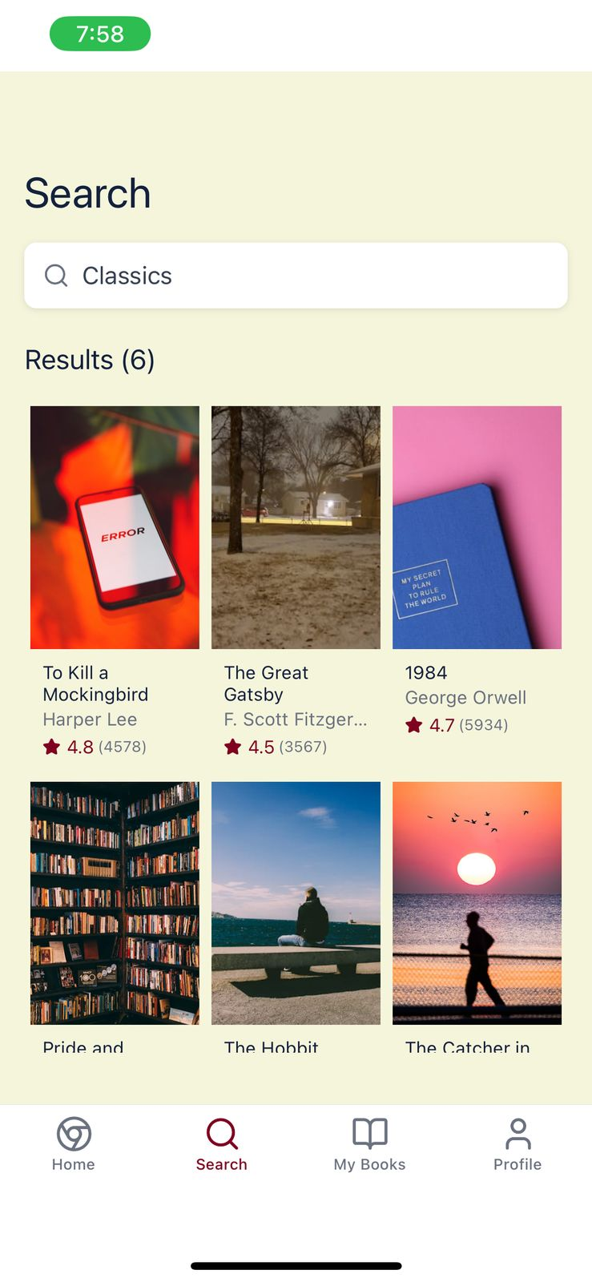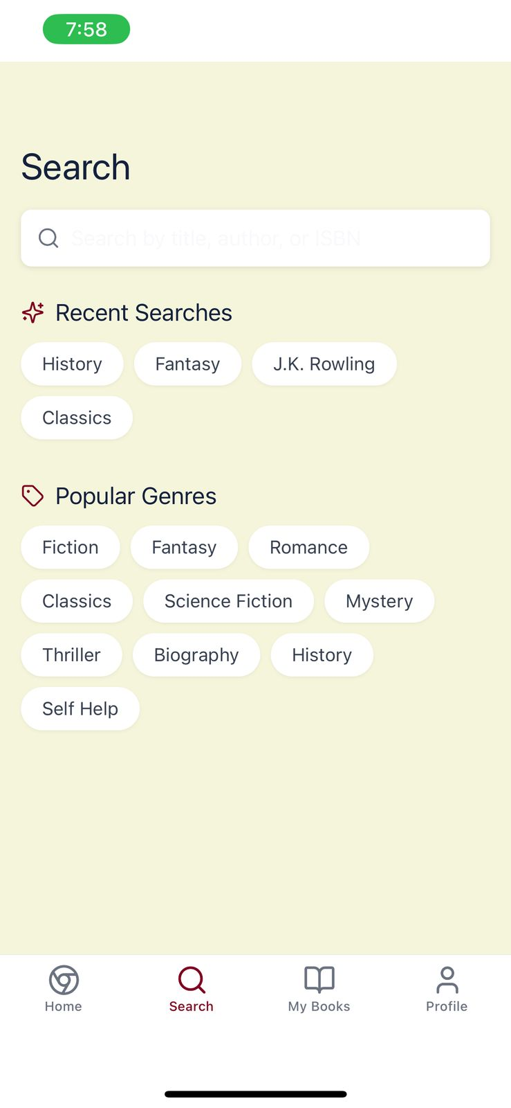

**My-books.tsk**

*import* {

  View,

  Text,

  StyleSheet,

  FlatList,

  TouchableOpacity,

  ActivityIndicator,

  ScrollView

} *from* 'react-native';

*import* { SafeAreaView } *from* 'react-native-safe-area-context';

*import* { currentUser } *from* '@/data/user';

*import* { books } *from* '@/data/books';

*import* { Book *as* BookType, ReadingStatus } *from* '@/types';

*import* BookCard *from* '@/components/BookCard';

*export* *default* function *MyBooksScreen*() {

  const[*isLoading*, *setIsLoading*]= *useState*(*true*);

  const[*currentFilter*, *setCurrentFilter*]= *useState*<*ReadingStatus* |'all'>('all');

  const[*filteredBooks*, *setFilteredBooks*]= *useState*<*BookType*[]>([]);

*useEffect*(() => {

*// Simulate loading*

    const *timer* = *setTimeout*(()=>{

*filterBooks*('all');

*setIsLoading*(*false*);

},1000);

*// Cleanup function to prevent state updates after unmount*

*return* () => *clearTimeout*(timer);

  }, []);

  const *filterBooks* =(*filter*: *ReadingStatus* |'all')=>{

*setCurrentFilter*(*filter*);

*if* (*filter* ==='all'){

const *allBooks* = *currentUser.books.map*(*userBook* =>{

const *book* = *books.find*(*b* => *b.id* === *userBook.bookId*);

*return book as BookType*;

});

*setFilteredBooks*(*allBooks*);

*return*;

}

const *filtered* = *currentUser.books*

*.filter*(*userBook* => *userBook.status* === *filter*)

*.map*(*userBook* =>{

const *book* = *books.find*(*b* => *b.id* === *userBook.bookId*);

*return book as BookType*;

});

*setFilteredBooks*(*filtered*);

};

*if* (isLoading) {

*return* (

      <View *style*={styles*.*loadingContainer}>

        <ActivityIndicator *size*="large" *color*="#800020" />

      </View>

    );

  }

*return* (

    <SafeAreaView *style*={styles*.*container}>

      <View *style*={styles*.*header}>

        <Text *style*={styles*.*title}>My Books</Text>

      </View>

      <View *style*={styles*.*filterContainer}>

        <ScrollableFilter

*options*={[

            { label: 'All', value: 'all' },

            { label: 'Want to Read', value: 'want-to-read' },

            { label: 'Currently Reading', value: 'currently-reading' },

            { label: 'Read', value: 'read' }

          ]}

*currentValue*={currentFilter}

*onChange*={(value) => *filterBooks*(value *as* ReadingStatus | 'all')}

        />

      </View>

      <FlatList

*data*={filteredBooks}

*keyExtractor*={(item) => item*.*id}

*renderItem*={({ item }) => (

          <View *style*={styles*.*bookItem}>

            <BookCard *book*={item} *size*="small" />

          </View>

        )}

*numColumns*={3}

*contentContainerStyle*={styles*.*booksContainer}

*ListEmptyComponent*={

          <View *style*={styles*.*emptyContainer}>

            <Text *style*={styles*.*emptyText}>No books in this category yet.</Text>

          </View>

        }

      />

    </SafeAreaView>

  );

}

interface FilterOption {

  label: string;

  value: string;

}

interface ScrollableFilterProps {

  options: FilterOption[];

  currentValue: string;

*onChange*: (value: string) => void;

}

function *ScrollableFilter*({ options, currentValue, onChange }: ScrollableFilterProps) {

*return* (

    <View *style*={styles*.*scrollableFilter}>

      {options*.map*((option) => (

        <TouchableOpacity

*key*={option*.*value}

*style*={[

            styles*.*filterOption,

            currentValue === option*.*value && styles*.*activeFilterOption

          ]}

*onPress*={() => *onChange*(option*.*value)}

        >

          <Text

*style*={[

              styles*.*filterText,

              currentValue === option*.*value && styles*.*activeFilterText

            ]}

          >

            {option*.*label}

          </Text>

        </TouchableOpacity>

      ))}

    </View>

  );

}

const *styles* = *StyleSheet.create*({

*container*:{

*flex*:1,

*backgroundColor*:'#F5F5DC',

},

*loadingContainer*:{

*flex*:1,

*justifyContent*:'center',

*alignItems*:'center',

*backgroundColor*:'#F5F5DC',

},

*header*:{

*paddingHorizontal*:16,

*paddingTop*:16,

*paddingBottom*:8,

},

*title*:{

*fontFamily*:'Merriweather-Bold',

*fontSize*:28,

*color*:'#14213D',

},

*filterContainer*:{

*marginVertical*:8,

},

*scrollableFilter*:{

*flexDirection*:'row',

*paddingHorizontal*:12,

*paddingVertical*:8,

},

*filterOption*:{

*paddingHorizontal*:16,

*paddingVertical*:8,

*marginHorizontal*:4,

*borderRadius*:20,

*backgroundColor*:'#FFFFFF',

},

*activeFilterOption*:{

*backgroundColor*:'#14213D',

},

*filterText*:{

*fontFamily*:'Lato-Regular',

*fontSize*:14,

*color*:'#6B7280',

},

*activeFilterText*:{

*fontFamily*:'Lato-Bold',

*color*:'#FFFFFF',

},

*booksContainer*:{

*padding*:12,

},

*bookItem*:{

*flex*:1/3,

*padding*:4,

},

*emptyContainer*:{

*padding*:24,

*alignItems*:'center',

},

*emptyText*:{

*fontFamily*:'Lato-Regular',

*fontSize*:16,

*color*:'#6B7280',

*textAlign*:'center',

},

});

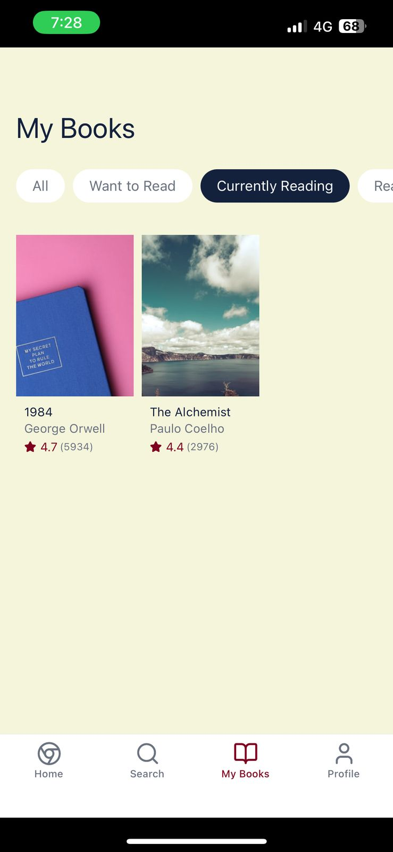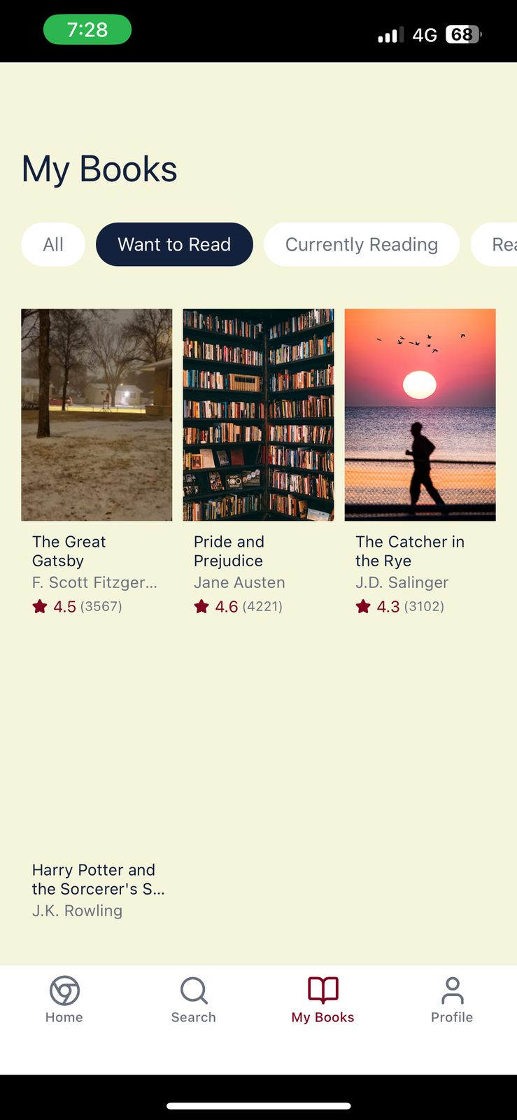

**Profile.tsk:**

*import* { View, Text, StyleSheet, Image, ScrollView, TouchableOpacity } *from* 'react-native';

*import* { SafeAreaView } *from* 'react-native-safe-area-context';

*import* { currentUser } *from* '@/data/user';

*import* { reviews } *from* '@/data/reviews';

*import* { Review } *from* '@/types';

*import* { Settings, BookOpen, Star, LogOut } *from* 'lucide-react-native';

*import* ReviewCard *from* '@/components/ReviewCard';

*export* *default* function *ProfileScreen*() {

*// Get user's reviews*

  const *userReviews* = *reviews.filter*(*review* => *review.userId* === *currentUser.id*);

*return* (

    <SafeAreaView *style*={styles*.*container}>

      <View *style*={styles*.*header}>

        <Text *style*={styles*.*title}>Profile</Text>

        <TouchableOpacity *style*={styles*.*settingsButton}>

          <Settings *size*={24} *color*="#14213D" />

        </TouchableOpacity>

      </View>

      <ScrollView

*style*={styles*.*content}

*showsVerticalScrollIndicator*={false}

      >

        <View *style*={styles*.*profileHeader}>

          <Image

*source*={{ uri: currentUser*.*avatar }}

*style*={styles*.*avatar}

          />

          <View *style*={styles*.*profileInfo}>

            <Text *style*={styles*.*name}>{currentUser*.*name}</Text>

            <Text *style*={styles*.*joinDate}>Member since {*formatDate*(currentUser*.*joinDate)}</Text>

          </View>

        </View>

        <Text *style*={styles*.*bio}>{currentUser*.*bio}</Text>

        <View *style*={styles*.*statsContainer}>

          <View *style*={styles*.*statItem}>

            <BookOpen *size*={20} *color*="#800020" />

            <Text *style*={styles*.*statValue}>{currentUser*.*booksRead}</Text>

            <Text *style*={styles*.*statLabel}>Books Read</Text>

          </View>

          <View *style*={styles*.*divider} />

          <View *style*={styles*.*statItem}>

            <BookOpen *size*={20} *color*="#14213D" />

            <Text *style*={styles*.*statValue}>{currentUser*.*booksInProgress}</Text>

            <Text *style*={styles*.*statLabel}>In Progress</Text>

          </View>

          <View *style*={styles*.*divider} />

          <View *style*={styles*.*statItem}>

            <Star *size*={20} *color*="#228B22" />

            <Text *style*={styles*.*statValue}>{currentUser*.*totalReviews}</Text>

            <Text *style*={styles*.*statLabel}>Reviews</Text>

          </View>

        </View>

        <View *style*={styles*.*section}>

          <Text *style*={styles*.*sectionTitle}>Favorite Genres</Text>

          <View *style*={styles*.*genreContainer}>

            {currentUser*.favoriteGenres.map*((genre, index) => (

              <View *key*={index} *style*={styles*.*genreBadge}>

                <Text *style*={styles*.*genreText}>{genre}</Text>

              </View>

            ))}

          </View>

        </View>

        <View *style*={styles*.*section}>

          <Text *style*={styles*.*sectionTitle}>My Reviews</Text>

          {userReviews*.map*(review => (

            <ReviewCard *key*={review*.*id} *review*={review} *showBookInfo* />

          ))}

        </View>

        <TouchableOpacity *style*={styles*.*logoutButton}>

          <LogOut *size*={18} *color*="#EF4444" />

          <Text *style*={styles*.*logoutText}>Sign Out</Text>

        </TouchableOpacity>

      </ScrollView>

    </SafeAreaView>

  );

}

function *formatDate*(dateString: string) {

  const *date* =new *Date*(*dateString*);

*return* date*.toLocaleDateString*('en-US', {

    year: 'numeric',

    month: 'long',

  });

}

const *styles* = *StyleSheet.create*({

*container*:{

*flex*:1,

*backgroundColor*:'#F5F5DC',

},

*header*:{

*flexDirection*:'row',

*alignItems*:'center',

*justifyContent*:'space-between',

*paddingHorizontal*:16,

*paddingTop*:16,

*paddingBottom*:8,

},

*title*:{

*fontFamily*:'Merriweather-Bold',

*fontSize*:28,

*color*:'#14213D',

},

*settingsButton*:{

*padding*:8,

},

*content*:{

*flex*:1,

},

*profileHeader*:{

*flexDirection*:'row',

*alignItems*:'center',

*paddingHorizontal*:16,

*paddingVertical*:16,

},

*avatar*:{

*width*:80,

*height*:80,

*borderRadius*:40,

*borderWidth*:2,

*borderColor*:'#FFFFFF',

},

*profileInfo*:{

*marginLeft*:16,

*flex*:1,

},

*name*:{

*fontFamily*:'Merriweather-Bold',

*fontSize*:22,

*color*:'#14213D',

},

*joinDate*:{

*fontFamily*:'Lato-Regular',

*fontSize*:14,

*color*:'#6B7280',

*marginTop*:4,

},

*bio*:{

*fontFamily*:'Lato-Regular',

*fontSize*:14,

*color*:'#374151',

*lineHeight*:22,

*paddingHorizontal*:16,

*marginBottom*:16,

},

*statsContainer*:{

*flexDirection*:'row',

*backgroundColor*:'#FFFFFF',

*borderRadius*:8,

*marginHorizontal*:16,

*marginVertical*:16,

*paddingVertical*:16,

*shadowColor*:'#000',

*shadowOffset*:{ *width*:0, *height*:1},

*shadowOpacity*:0.1,

*shadowRadius*:2,

*elevation*:1,

},

*statItem*:{

*flex*:1,

*alignItems*:'center',

},

*divider*:{

*width*:1,

*backgroundColor*:'#E5E7EB',

},

*statValue*:{

*fontFamily*:'Merriweather-Bold',

*fontSize*:18,

*color*:'#14213D',

*marginTop*:8,

},

*statLabel*:{

*fontFamily*:'Lato-Regular',

*fontSize*:12,

*color*:'#6B7280',

*marginTop*:4,

},

*section*:{

*marginBottom*:24,

},

*sectionTitle*:{

*fontFamily*:'Merriweather-Bold',

*fontSize*:18,

*color*:'#14213D',

*marginLeft*:16,

*marginBottom*:12,

},

*genreContainer*:{

*flexDirection*:'row',

*flexWrap*:'wrap',

*paddingHorizontal*:16,

},

*genreBadge*:{

*backgroundColor*:'#14213D',

*borderRadius*:16,

*paddingHorizontal*:12,

*paddingVertical*:6,

*marginRight*:8,

*marginBottom*:8,

},

*genreText*:{

*fontFamily*:'Lato-Regular',

*fontSize*:12,

*color*:'#FFFFFF',

},

*logoutButton*:{

*flexDirection*:'row',

*alignItems*:'center',

*justifyContent*:'center',

*paddingVertical*:12,

*marginHorizontal*:16,

*marginBottom*:32,

},

*logoutText*:{

*fontFamily*:'Lato-Regular',

*fontSize*:16,

*color*:'#EF4444',

*marginLeft*:8,

},

});

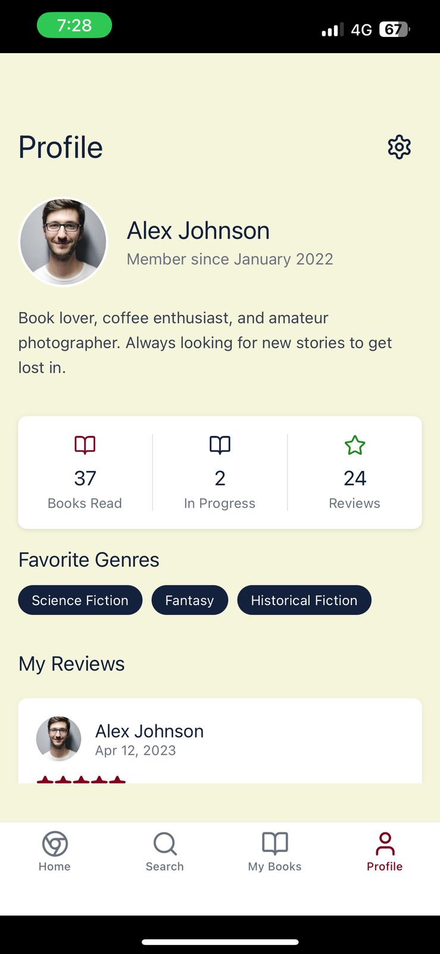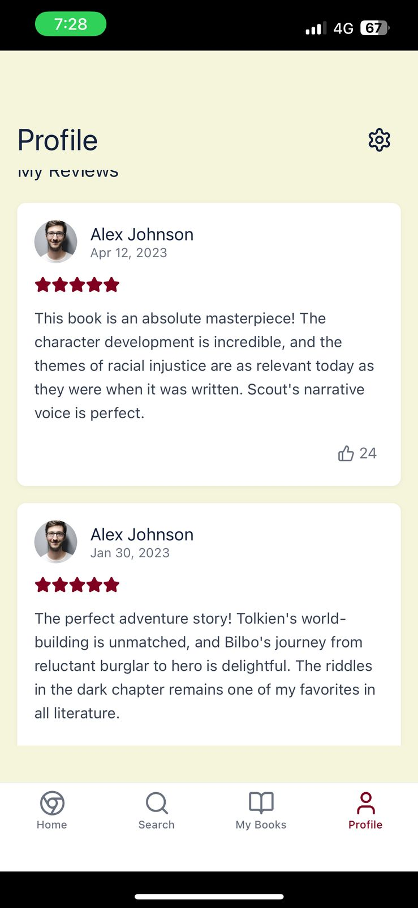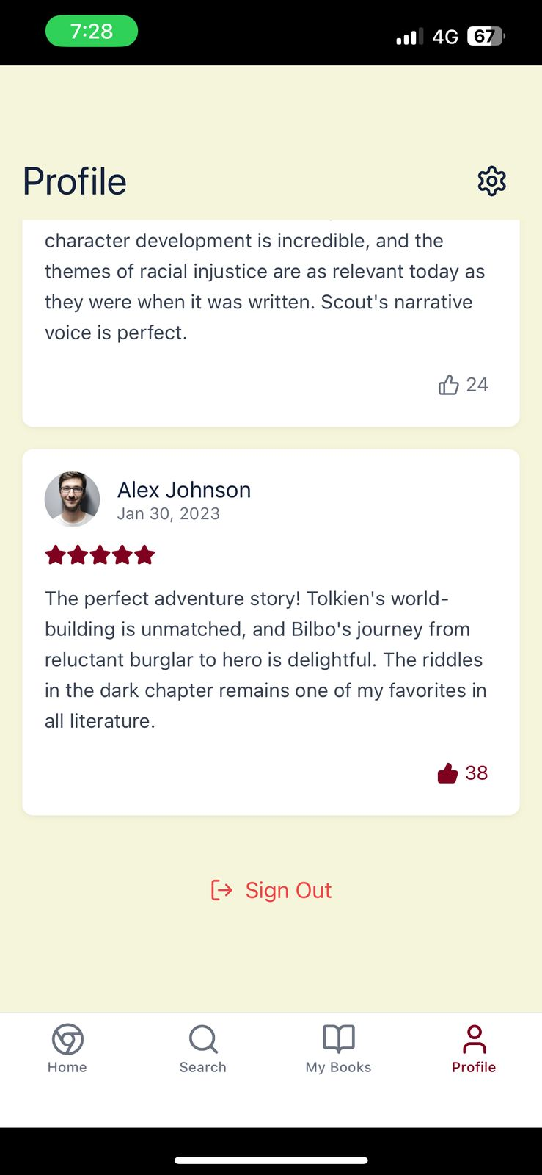

**Book>id.tsk:**

*import* { useState, useEffect } *from* 'react';

*import* {

  View,

  Text,

  StyleSheet,

  Image,

  ScrollView,

  TouchableOpacity,

  ActivityIndicator

} *from* 'react-native';

*import* { Link, useLocalSearchParams, Stack } *from* 'expo-router';

*import* { books } *from* '@/data/books';

*import* { reviews } *from* '@/data/reviews';

*import* { Book *as* BookType, Review, ReadingStatus } *from* '@/types';

*import* { currentUser } *from* '@/data/user';

*import* ReviewCard *from* '@/components/ReviewCard';

*import* ReadingStatusButton *from* '@/components/ReadingStatusButton';

*import* { X, Star, Calendar, Tag, Book } *from* 'lucide-react-native';

*export* *default* function *BookDetailScreen*() {

  const{ *id* }= *useLocalSearchParams*<{ *id*: *string* }>();

  const[*book*, *setBook*]= *useState*<*BookType* | *null*>(*null*);

  const[*bookReviews*, *setBookReviews*]= *useState*<*Review*[]>([]);

  const[*isLoading*, *setIsLoading*]= *useState*(*true*);

  const[*userBookStatus*, *setUserBookStatus*]= *useState*<*ReadingStatus*>('none');

*useEffect*(() => {

*if* (id) {

*// Simulate API fetch delay*

      const *timer* = *setTimeout*(()=>{

const *foundBook* = *books.find*(*b* => *b.id* === *id*);

*if* (*foundBook*){

*setBook*(*foundBook*);

*setBookReviews*(*reviews.filter*(*r* => *r.bookId* === *id*));

*// Check if user has this book in their list*

const *userBook* = *currentUser.books.find*(*b* => *b.bookId* === *id*);

*if* (*userBook*){

*setUserBookStatus*(*userBook.status*);

}

}

*setIsLoading*(*false*);

},800);

*return* () => *clearTimeout*(timer);

    }

  }, [id]);

  const *handleStatusChange* =(*status*: *ReadingStatus*)=>{

*setUserBookStatus*(*status*);

*// In a real app, this would update the user's book data in the backend*

};

*if* (isLoading) {

*return* (

      <View *style*={styles*.*loadingContainer}>

        <ActivityIndicator *size*="large" *color*="#800020" />

      </View>

    );

  }

*if* (!book) {

*return* (

      <View *style*={styles*.*errorContainer}>

        <Text *style*={styles*.*errorText}>Book not found</Text>

        <Link *href*="/" *asChild*>

          <TouchableOpacity *style*={styles*.*backButton}>

            <Text *style*={styles*.*backButtonText}>Go Back</Text>

          </TouchableOpacity>

        </Link>

      </View>

    );

  }

*return* (

    <>

      <Stack.Screen *options*={{

        headerShown: true,

        headerTitle: '',

        headerTransparent: true,

*headerLeft*: () => (

          <Link *href*="/" *asChild*>

            <TouchableOpacity *style*={styles*.*closeButton}>

              <X *size*={24} *color*="#FFF" />

            </TouchableOpacity>

          </Link>

        ),

      }} />

      <ScrollView *style*={styles*.*container} *showsVerticalScrollIndicator*={false}>

        <Image

*source*={{ uri: book*.*coverUrl }}

*style*={styles*.*coverImage}

*resizeMode*="cover"

        />

        <View *style*={styles*.*content}>

          <View *style*={styles*.*titleContainer}>

            <Text *style*={styles*.*title}>{book*.*title}</Text>

            <Text *style*={styles*.*author}>by {book*.*author}</Text>

            <View *style*={styles*.*ratingContainer}>

              <Star *size*={18} *color*='#800020' *fill*='#800020' />

              <Text *style*={styles*.*rating}>{book*.avgRating.toFixed*(1)}</Text>

              <Text *style*={styles*.*ratingCount}>({book*.*totalRatings} ratings)</Text>

            </View>

          </View>

          <ReadingStatusButton

*initialStatus*={userBookStatus}

*onChangeStatus*={handleStatusChange}

          />

          <View *style*={styles*.*infoContainer}>

            <View *style*={styles*.*infoItem}>

              <Calendar *size*={16} *color*="#14213D" />

              <Text *style*={styles*.*infoText}>

                Published: {*formatDate*(book*.*publishedDate)}

              </Text>

            </View>

            <View *style*={styles*.*infoItem}>

              <Book *size*={16} *color*="#14213D" />

              <Text *style*={styles*.*infoText}>

                {book*.*pageCount} pages

              </Text>

            </View>

            <View *style*={styles*.*infoItem}>

              <Tag *size*={16} *color*="#14213D" />

              <View *style*={styles*.*genreContainer}>

                {book*.genre.map*((genre, index) => (

                  <Text *key*={index} *style*={styles*.*genre}>

                    {genre}{index < book*.genre.*length - 1 ? ', ' : ''}

                  </Text>

                ))}

              </View>

            </View>

          </View>

          <View *style*={styles*.*sectionContainer}>

            <Text *style*={styles*.*sectionTitle}>About the Book</Text>

            <Text *style*={styles*.*description}>{book*.*description}</Text>

          </View>

          <View *style*={styles*.*sectionContainer}>

            <Text *style*={styles*.*sectionTitle}>Reviews ({bookReviews*.*length})</Text>

            {bookReviews*.map*(review => (

              <ReviewCard *key*={review*.*id} *review*={review} />

            ))}

          </View>

        </View>

      </ScrollView>

    </>

  );

}

function *formatDate*(dateString: string) {

  const *date* =new *Date*(*dateString*);

*return* date*.toLocaleDateString*('en-US', {

    year: 'numeric',

    month: 'long',

    day: 'numeric'

  });

}

const *styles* = *StyleSheet.create*({

*container*:{

*flex*:1,

*backgroundColor*:'#F5F5DC',

},

*loadingContainer*:{

*flex*:1,

*justifyContent*:'center',

*alignItems*:'center',

*backgroundColor*:'#F5F5DC',

},

*errorContainer*:{

*flex*:1,

*justifyContent*:'center',

*alignItems*:'center',

*padding*:24,

*backgroundColor*:'#F5F5DC',

},

*errorText*:{

*fontFamily*:'Merriweather-Bold',

*fontSize*:18,

*color*:'#14213D',

*marginBottom*:16,

},

*backButton*:{

*paddingVertical*:10,

*paddingHorizontal*:16,

*backgroundColor*:'#800020',

*borderRadius*:8,

},

*backButtonText*:{

*fontFamily*:'Lato-Bold',

*fontSize*:16,

*color*:'#FFFFFF',

},

*closeButton*:{

*width*:36,

*height*:36,

*borderRadius*:18,

*backgroundColor*:'rgba(0, 0, 0, 0.5)',

*justifyContent*:'center',

*alignItems*:'center',

*marginLeft*:16,

},

*coverImage*:{

*width*:'100%',

*height*:400,

},

*content*:{

*flex*:1,

*backgroundColor*:'#F5F5DC',

*borderTopLeftRadius*:24,

*borderTopRightRadius*:24,

*marginTop*:-24,

*paddingHorizontal*:16,

*paddingTop*:24,

*paddingBottom*:32,

},

*titleContainer*:{

*marginBottom*:16,

},

*title*:{

*fontFamily*:'Merriweather-Bold',

*fontSize*:24,

*color*:'#14213D',

},

*author*:{

*fontFamily*:'Lato-Regular',

*fontSize*:16,

*color*:'#6B7280',

*marginTop*:4,

},

*ratingContainer*:{

*flexDirection*:'row',

*alignItems*:'center',

*marginTop*:12,

},

*rating*:{

*fontFamily*:'Lato-Bold',

*fontSize*:16,

*color*:'#800020',

*marginLeft*:6,

},

*ratingCount*:{

*fontFamily*:'Lato-Regular',

*fontSize*:14,

*color*:'#6B7280',

*marginLeft*:6,

},

*infoContainer*:{

*backgroundColor*:'#FFFFFF',

*borderRadius*:8,

*padding*:16,

*marginVertical*:16,

*shadowColor*:'#000',

*shadowOffset*:{ *width*:0, *height*:1},

*shadowOpacity*:0.1,

*shadowRadius*:2,

*elevation*:1,

},

*infoItem*:{

*flexDirection*:'row',

*alignItems*:'center',

*marginBottom*:8,

},

*infoText*:{

*fontFamily*:'Lato-Regular',

*fontSize*:14,

*color*:'#374151',

*marginLeft*:8,

},

*genreContainer*:{

*flex*:1,

*flexDirection*:'row',

*flexWrap*:'wrap',

*marginLeft*:8,

},

*genre*:{

*fontFamily*:'Lato-Regular',

*fontSize*:14,

*color*:'#374151',

},

*sectionContainer*:{

*marginTop*:24,

},

*sectionTitle*:{

*fontFamily*:'Merriweather-Bold',

*fontSize*:18,

*color*:'#14213D',

*marginBottom*:12,

},

*description*:{

*fontFamily*:'Lato-Regular',

*fontSize*:15,

*color*:'#374151',

*lineHeight*:24,

},

});

**App> _layout.tsk:**

*import* { useEffect } *from* 'react';

*import* { Platform } *from* 'react-native';

*import* { Stack } *from* 'expo-router';

*import* { StatusBar } *from* 'expo-status-bar';

*import* { useFrameworkReady } *from* '@/hooks/useFrameworkReady';

*import* { useFonts } *from* 'expo-font';

*import* {

  Merriweather_400Regular,

  Merriweather_700Bold

} *from* '@expo-google-fonts/merriweather';

*import* {

  Lato_400Regular,

  Lato_700Bold

} *from* '@expo-google-fonts/lato';

*import* { SplashScreen } *from* 'expo-splash-screen';

*// Only prevent auto-hide on native platforms*

*if* (Platform*.*OS !== 'web') {

  SplashScreen*.preventAutoHideAsync*();

}

*export* *default* function *RootLayout*() {

*useFrameworkReady*();

  const[*fontsLoaded*, *fontError*]= *useFonts*({

'Merriweather-Regular': *Merriweather_400Regular*,

'Merriweather-Bold': *Merriweather_700Bold*,

'Lato-Regular': *Lato_400Regular*,

'Lato-Bold': *Lato_700Bold*,

});

*// Hide splash screen once fonts are loaded (only on native platforms)*

*useEffect*(() => {

*if* (fontsLoaded || fontError) {

*if* (Platform*.*OS !== 'web') {

        SplashScreen*.hideAsync*();

      }

    }

  }, [fontsLoaded, fontError]);

*// Return null to keep splash screen visible while fonts load*

*if* (!fontsLoaded && !fontError) {

*return* null;

  }

*return* (

    <>

      <Stack *screenOptions*={{ headerShown: false }}>

        <Stack.Screen *name*="(tabs)" *options*={{ headerShown: false }} />

        <Stack.Screen *name*="book/[id]" *options*={{ headerShown: false, presentation: 'modal' }} />

        <Stack.Screen *name*="+not-found" *options*={{ title: 'Oops!' }} />

      </Stack>

      <StatusBar *style*="auto" />

    </>

  );

}

**+not-found.tsk:**

*import* { Link, Stack } *from* 'expo-router';

*import* { StyleSheet, Text, View } *from* 'react-native';

*export* *default* function *NotFoundScreen*() {

*return* (

    <>

      <Stack.Screen *options*={{ title: 'Oops!' }} />

      <View *style*={styles*.*container}>

        <Text *style*={styles*.*text}>This screen doesn't exist.</Text>

        <Link *href*="/" *style*={styles*.*link}>

          <Text>Go to home screen!</Text>

        </Link>

      </View>

    </>

  );

}

const *styles* = *StyleSheet.create*({

*container*:{

*flex*:1,

*alignItems*:'center',

*justifyContent*:'center',

*padding*:20,

},

*text*:{

*fontSize*:20,

*fontWeight*:600,

},

*link*:{

*marginTop*:15,

*paddingVertical*:15,

},

});

**COMPONENTS:**

**Bookcards.tsx:**

*import* { View, Text, Image, StyleSheet, TouchableOpacity } *from* 'react-native';

*import* { Book } *from* '@/types';

*import* { Star } *from* 'lucide-react-native';

*import* { Link } *from* 'expo-router';

interface BookCardProps {

  book: Book;

  size?: 'small' | 'medium' | 'large';

}

*export* *default* function *BookCard*({ book, size = 'medium' }: BookCardProps) {

  const *cardStyles* ={

*small*:{

*container*: *styles.smallContainer*,

*image*: *styles.smallImage*,

*title*: *styles.smallTitle*,

},

*medium*:{

*container*: *styles.mediumContainer*,

*image*: *styles.mediumImage*,

*title*: *styles.mediumTitle*,

},

*large*:{

*container*: *styles.largeContainer*,

*image*: *styles.largeImage*,

*title*: *styles.largeTitle*,

}

};

*return* (

    <Link *href*={`/book/${book*.*id}`} *asChild*>

      <TouchableOpacity *style*={[styles*.*container, cardStyles[size]*.*container]}>

        <Image

*source*={{ uri: book*.*coverUrl }}

*style*={[styles*.*cover, cardStyles[size]*.*image]}

*resizeMode*="cover"

        />

        <View *style*={styles*.*info}>

          <Text

*style*={[styles*.*title, cardStyles[size]*.*title]}

*numberOfLines*={2}

          >

            {book*.*title}

          </Text>

          <Text *style*={styles*.*author} *numberOfLines*={1}>{book*.*author}</Text>

          <View *style*={styles*.*ratingContainer}>

            <Star *size*={12} *color*='#800020' *fill*='#800020' />

            <Text *style*={styles*.*rating}>{book*.avgRating.toFixed*(1)}</Text>

            <Text *style*={styles*.*ratingCount}>({book*.*totalRatings})</Text>

          </View>

        </View>

      </TouchableOpacity>

    </Link>

  );

}

const *styles* = *StyleSheet.create*({

*container*:{

*backgroundColor*:'#FFF',

*borderRadius*:8,

*overflow*:'hidden',

*shadowColor*:'#000',

*shadowOffset*:{ *width*:0, *height*:2},

*shadowOpacity*:0.1,

*shadowRadius*:8,

*elevation*:2,

*margin*:8,

},

*smallContainer*:{

*width*:120,

},

*mediumContainer*:{

*width*:160,

},

*largeContainer*:{

*width*:200,

},

*cover*:{

*backgroundColor*:'#F5F5DC',

*overflow*:'hidden',

},

*smallImage*:{

*height*:160,

},

*mediumImage*:{

*height*:200,

},

*largeImage*:{

*height*:260,

},

*info*:{

*padding*:8,

},

*title*:{

*fontFamily*:'Merriweather-Bold',

*color*:'#14213D',

},

*smallTitle*:{

*fontSize*:12,

},

*mediumTitle*:{

*fontSize*:14,

},

*largeTitle*:{

*fontSize*:16,

},

*author*:{

*fontFamily*:'Lato-Regular',

*fontSize*:12,

*color*:'#6B7280',

*marginTop*:2,

},

*ratingContainer*:{

*flexDirection*:'row',

*alignItems*:'center',

*marginTop*:4,

},

*rating*:{

*fontFamily*:'Lato-Bold',

*fontSize*:12,

*color*:'#800020',

*marginLeft*:4,

},

*ratingCount*:{

*fontFamily*:'Lato-Regular',

*fontSize*:10,

*color*:'#6B7280',

*marginLeft*:2,

},

});

**Booklist.tsx:**

*import* { View, Text, FlatList, StyleSheet } *from* 'react-native';

*import* BookCard *from* './BookCard';

*import* { Book } *from* '@/types';

interface BookListProps {

  title: string;

  books: Book[];

  size?: 'small' | 'medium' | 'large';

  horizontal?: boolean;

}

*export* *default* function *BookList*({

  title,

  books,

  size = 'medium',

  horizontal = true

}: BookListProps) {

*return* (

    <View *style*={styles*.*container}>

      <Text *style*={styles*.*listTitle}>{title}</Text>

      <FlatList

*data*={books}

*renderItem*={({ item }) => <BookCard *book*={item} *size*={size} />}

*keyExtractor*={(item) => item*.*id}

*horizontal*={horizontal}

*showsHorizontalScrollIndicator*={false}

*contentContainerStyle*={styles*.*listContent}

      />

    </View>

  );

}

const *styles* = *StyleSheet.create*({

*container*:{

*marginVertical*:16,

},

*listTitle*:{

*fontFamily*:'Merriweather-Bold',

*fontSize*:20,

*color*:'#14213D',

*marginLeft*:16,

*marginBottom*:8,

},

*listContent*:{

*paddingHorizontal*:8,

},

});

**readingStatusButoon.tsx:**

*import* { useState } *from* 'react';

*import* { View, Text, TouchableOpacity, StyleSheet, Modal } *from* 'react-native';

*import* { ReadingStatus } *from* '@/types';

*import* { BookOpen, BookPlus, BookCheck, X } *from* 'lucide-react-native';

interface ReadingStatusButtonProps {

  initialStatus: ReadingStatus;

*onChangeStatus*: (status: ReadingStatus) => void;

}

*export* *default* function *ReadingStatusButton*({

  initialStatus,

  onChangeStatus

}: ReadingStatusButtonProps) {

  const[*status*, *setStatus*]= *useState*<*ReadingStatus*>(*initialStatus*);

  const[*modalVisible*, *setModalVisible*]= *useState*(*false*);

  const *handleStatusChange* =(*newStatus*: *ReadingStatus*)=>{

*setStatus*(*newStatus*);

*onChangeStatus*(*newStatus*);

*setModalVisible*(*false*);

};

  const *getButtonText* =()=>{

*switch* (*status*){

*case* 'want-to-read':

*return* 'Want to Read';

*case* 'currently-reading':

*return* 'Currently Reading';

*case* 'read':

*return* 'Read';

*default*:

*return* 'Want to Read';

}

};

  const *getButtonIcon* =()=>{

*switch* (*status*){

*case* 'want-to-read':

*return* <BookPlus *size*={18} *color*="#FFF" />;

*case* 'currently-reading':

*return* <BookOpen *size*={18} *color*="#FFF" />;

*case* 'read':

*return* <BookCheck *size*={18} *color*="#FFF" />;

*default*:

*return* <BookPlus *size*={18} *color*="#FFF" />;

}

};

  const *getButtonStyle* =()=>{

*switch* (*status*){

*case* 'want-to-read':

*return styles.wantToReadButton*;

*case* 'currently-reading':

*return styles.currentlyReadingButton*;

*case* 'read':

*return styles.readButton*;

*default*:

*return styles.wantToReadButton*;

}

};

*return* (

    <>

      <TouchableOpacity

*style*={[styles*.*button, *getButtonStyle*()]}

*onPress*={() => *setModalVisible*(true)}

      >

        {*getButtonIcon*()}

        <Text *style*={styles*.*buttonText}>{*getButtonText*()}</Text>

      </TouchableOpacity>

      <Modal

*animationType*="fade"

*transparent*={true}

*visible*={modalVisible}

*onRequestClose*={() => *setModalVisible*(false)}

      >

        <View *style*={styles*.*modalContainer}>

          <View *style*={styles*.*modalContent}>

            <View *style*={styles*.*modalHeader}>

              <Text *style*={styles*.*modalTitle}>Update Reading Status</Text>

              <TouchableOpacity

*onPress*={() => *setModalVisible*(false)}

*style*={styles*.*closeButton}

              >

                <X *size*={24} *color*="#14213D" />

              </TouchableOpacity>

            </View>

            <TouchableOpacity

*style*={[styles*.*statusOption, status === 'want-to-read' && styles*.*selectedOption]}

*onPress*={() => *handleStatusChange*('want-to-read')}

            >

              <BookPlus *size*={20} *color*={status === 'want-to-read' ? '#800020' : '#6B7280'} />

              <Text

*style*={[

                  styles*.*statusText,

                  status === 'want-to-read' && styles*.*selectedText

                ]}

              >

                Want to Read

              </Text>

            </TouchableOpacity>

            <TouchableOpacity

*style*={[styles*.*statusOption, status === 'currently-reading' && styles*.*selectedOption]}

*onPress*={() => *handleStatusChange*('currently-reading')}

            >

              <BookOpen *size*={20} *color*={status === 'currently-reading' ? '#800020' : '#6B7280'} />

              <Text

*style*={[

                  styles*.*statusText,

                  status === 'currently-reading' && styles*.*selectedText

                ]}

              >

                Currently Reading

              </Text>

            </TouchableOpacity>

            <TouchableOpacity

*style*={[styles*.*statusOption, status === 'read' && styles*.*selectedOption]}

*onPress*={() => *handleStatusChange*('read')}

            >

              <BookCheck *size*={20} *color*={status === 'read' ? '#800020' : '#6B7280'} />

              <Text

*style*={[

                  styles*.*statusText,

                  status === 'read' && styles*.*selectedText

                ]}

              >

                Read

              </Text>

            </TouchableOpacity>

            {status !== 'none' && (

              <TouchableOpacity

*style*={styles*.*removeButton}

*onPress*={() => *handleStatusChange*('none')}

              >

                <Text *style*={styles*.*removeText}>Remove from My Books</Text>

              </TouchableOpacity>

            )}

          </View>

        </View>

      </Modal>

    </>

  );

}

const *styles* = *StyleSheet.create*({

*button*:{

*flexDirection*:'row',

*alignItems*:'center',

*justifyContent*:'center',

*paddingVertical*:12,

*paddingHorizontal*:20,

*borderRadius*:8,

*marginVertical*:8,

},

*wantToReadButton*:{

*backgroundColor*:'#228B22', *// Forest green*

},

*currentlyReadingButton*:{

*backgroundColor*:'#14213D', *// Navy*

},

*readButton*:{

*backgroundColor*:'#800020', *// Burgundy*

},

*buttonText*:{

*fontFamily*:'Lato-Bold',

*fontSize*:16,

*color*:'#FFFFFF',

*marginLeft*:8,

},

*modalContainer*:{

*flex*:1,

*justifyContent*:'center',

*alignItems*:'center',

*backgroundColor*:'rgba(0, 0, 0, 0.5)',

},

*modalContent*:{

*width*:'80%',

*backgroundColor*:'#FFFFFF',

*borderRadius*:12,

*padding*:24,

*shadowColor*:'#000',

*shadowOffset*:{ *width*:0, *height*:2},

*shadowOpacity*:0.25,

*shadowRadius*:3.84,

*elevation*:5,

},

*modalHeader*:{

*flexDirection*:'row',

*justifyContent*:'space-between',

*alignItems*:'center',

*marginBottom*:16,

},

*modalTitle*:{

*fontFamily*:'Merriweather-Bold',

*fontSize*:18,

*color*:'#14213D',

},

*closeButton*:{

*padding*:4,

},

*statusOption*:{

*flexDirection*:'row',

*alignItems*:'center',

*padding*:16,

*borderRadius*:8,

*marginVertical*:8,

},

*selectedOption*:{

*backgroundColor*:'rgba(128, 0, 32, 0.1)', *// Light burgundy*

},

*statusText*:{

*fontFamily*:'Lato-Regular',

*fontSize*:16,

*color*:'#6B7280',

*marginLeft*:12,

},

*selectedText*:{

*fontFamily*:'Lato-Bold',

*color*:'#800020',

},

*removeButton*:{

*alignItems*:'center',

*padding*:16,

*marginTop*:8,

},

*removeText*:{

*fontFamily*:'Lato-Regular',

*fontSize*:14,

*color*:'#EF4444', *// Red*

},

});

**ReviewCard.tsx:**

*import* { View, Text, Image, StyleSheet, TouchableOpacity } *from* 'react-native';

*import* { Review } *from* '@/types';

*import* { ThumbsUp, Star } *from* 'lucide-react-native';

*import* { useState } *from* 'react';

interface ReviewCardProps {

  review: Review;

  showBookInfo?: boolean;

}

*export* *default* function *ReviewCard*({ review, showBookInfo = false }: ReviewCardProps) {

  const[*liked*, *setLiked*]= *useState*(*false*);

  const[*likeCount*, *setLikeCount*]= *useState*(*review.likes*);

  const *handleLike* =()=>{

*if* (*liked*){

*setLikeCount*(*likeCount* -1);

} *else* {

*setLikeCount*(*likeCount* +1);

}

*setLiked*(!*liked*);

};

  const *formatDate* =(*dateString*: *string*)=>{

const *date* =new *Date*(*dateString*);

*return date.toLocaleDateString*('en-US',{

*year*:'numeric',

*month*:'short',

*day*:'numeric'

});

};

*return* (

    <View *style*={styles*.*container}>

      <View *style*={styles*.*header}>

        <Image

*source*={{ uri: review*.*userAvatar }}

*style*={styles*.*avatar}

        />

        <View *style*={styles*.*userInfo}>

          <Text *style*={styles*.*userName}>{review*.*userName}</Text>

          <Text *style*={styles*.*date}>{*formatDate*(review*.*date)}</Text>

        </View>

      </View>

      <View *style*={styles*.*ratingContainer}>

        {[1, 2, 3, 4, 5]*.map*((star) => (

          <Star

*key*={star}

*size*={16}

*color*='#800020'

*fill*={star <= review*.*rating ? '#800020' : 'transparent'}

          />

        ))}

      </View>

      <Text *style*={styles*.*reviewText}>{review*.*text}</Text>

      <View *style*={styles*.*actionContainer}>

        <TouchableOpacity

*style*={styles*.*likeButton}

*onPress*={handleLike}

        >

          <ThumbsUp

*size*={16}

*color*={liked ? '#800020' : '#6B7280'}

*fill*={liked ? '#800020' : 'transparent'}

          />

          <Text *style*={[

            styles*.*likeCount,

            liked && styles*.*likedText

          ]}>

            {likeCount}

          </Text>

        </TouchableOpacity>

      </View>

    </View>

  );

}

const *styles* = *StyleSheet.create*({

*container*:{

*backgroundColor*:'#FFF',

*borderRadius*:8,

*padding*:16,

*shadowColor*:'#000',

*shadowOffset*:{ *width*:0, *height*:1},

*shadowOpacity*:0.05,

*shadowRadius*:2,

*elevation*:1,

*marginVertical*:8,

*marginHorizontal*:16,

},

*header*:{

*flexDirection*:'row',

*alignItems*:'center',

*marginBottom*:12,

},

*avatar*:{

*width*:40,

*height*:40,

*borderRadius*:20,

*marginRight*:12,

},

*userInfo*:{

*flex*:1,

},

*userName*:{

*fontFamily*:'Lato-Bold',

*fontSize*:16,

*color*:'#14213D',

},

*date*:{

*fontFamily*:'Lato-Regular',

*fontSize*:12,

*color*:'#6B7280',

},

*ratingContainer*:{

*flexDirection*:'row',

*marginBottom*:12,

},

*reviewText*:{

*fontFamily*:'Lato-Regular',

*fontSize*:14,

*color*:'#374151',

*lineHeight*:22,

},

*actionContainer*:{

*flexDirection*:'row',

*justifyContent*:'flex-end',

*marginTop*:12,

},

*likeButton*:{

*flexDirection*:'row',

*alignItems*:'center',

*padding*:6,

},

*likeCount*:{

*fontFamily*:'Lato-Regular',

*fontSize*:14,

*color*:'#6B7280',

*marginLeft*:4,

},

*likedText*:{

*color*:'#800020',

},

});

## **Conclusion:**

## The Book Reviewing Application successfully demonstrates the core functionalities of a mobile app using React Native. It provides a structured layout for users to register, login, browse books, review them, and view developer information. This project helped in understanding mobile UI development, state management, form handling, and navigation in React Native. Future enhancements can include Firebase integration for data persistence, real-time updates, and user authentication**.**